**The Influence of Nursing Labor Support on the Reduction of Cesarean Sections**

Cheryl Larry-Osman, MS, RN, CNM, CNS-C

University of Detroit Mercy

11/30/2020

**Abstract**

**Background:** In the United States, childbirth is the leading reason for hospitalization, with approximately 4 million women giving birth annually, the majority of whom will receive care and support from a nurse. A cesarean section is a major abdominal surgery and accounted for approximately 33% of births in 2013. In comparison to vaginal births, cesarean births have a higher association with healthcare costs, as well as maternal and newborn morbidity. One of the approaches to reduce cesarean birth rates is to increase the woman’s access to nonmedical interventions during labor, such as continuous labor and delivery support. Research suggests that nurses are likely influential in the birth outcome of a woman, and personal beliefs can impact how a nurse supports vaginal birth during labor. Consequently, increasing nursing knowledge of labor support techniques can improve overall birth experiences and outcomes.

**Design:** This study is a descriptive mixed-method design, conducted at a large urban hospital. The study participants included a convenience sample of 75 eligible Labor and Delivery staff nurses.

**Methods:** Quantitative measures analyzed data for the total cesarean section rates, and the nulliparous, term, singleton, vertex (NTSV) cesarean birth rates, collected in April and May 2019 (pre-intervention), and January and February 2020 (post-intervention). Additional quantitative measures included use of the survey tool “Intrapartum Nurse’s Beliefs Relate to Birth Practice” (IPNBBP), to analyze nurse beliefs related to normal birth in comparison to medicalized birth. Qualitative measures of the IPNBBP tool included thematic analysis of two-open ended questions about the individual nurses’ beliefs related birth practice.

**Intervention:** The project intervention is an 8-hour interactive hands-on labor support class aimed at merging contextual (mind) learning focusing on “why” and “when”, and kinesthetic (hand/body) learning focusing on “what” and “how”.

**Results:** The pre- and post- total cesarean section rates respectively were 28.55% to 32.45 %, a 3.9% increase. The NTSV cesarean birth rates pre- and post- intervention averaged 21.5% and 20.5% respectively, a 1.0% decrease. There were N=69 nurses who completed the pre-intervention IPNBBP survey, and N=34 nurses who completed the post-intervention survey. No significant differences are observed between the pre-post scores for medicalized birth (0.0510) or normal birth (0.5439). However, the difference between the pre and post intervention is marginally significant in medicalized birth. The IPNBBP survey also included 30 elements related to intrapartum nurse experience. Seven elements (unmedicated vaginal birth, ambulation in labor, intermittent fetal monitoring, laboring down, use of breathing and relaxation techniques, hydrotherapy, and encouraging upright positioning during labor & birth) were incorporated into the labor support class. Upon comparison of pre- and post- intervention data, experience using the 7-elements, except for laboring down which stayed the same at 100%, increased by 2.73%-5.8%. Qualitative thematic analysis of the pre- and post- intervention survey responses for the two-open ended questions about the individual nurses’ beliefs related birth practice, identified 18-common themes.In further analysis, the top-5 most common themes, collectively, include support, safety, natural/normal birth, teach/educate, and helping.

**Conclusions:** Labor support education and training can increase nurse beliefs related to normal birth in comparison to medicalized birth, and can enhance the skills of labor and delivery nurses, and improve the overall maternal, newborn, family, and clinician birth experience and outcomes.

The impact on the cesarean birth rate takes time and continued evaluation to see changes. The outcome of reducing cesarean birth must include ongoing education of entire clinical team.

**Introduction**

In the United States, childbirth is the leading reason for hospitalization, with approximately 4 million women giving birth annually (Lyndon, Simpson, Spetz, 2017), the majority of whom will receive care and support from a nurse.

Cesarean sections are the most common surgical procedure in the United States, accounting for approximately 33% of births in 2013 (1 in every 3 women) (Bell, Joy, Gullo, Higgins, and Stevenson, 2017). Although there is not an “ideal rate”, the organizational and regulatory suggestions range from a cesarean section target of 10% (Healthy People 2020), to 15% per the World Health Organization (WHO), and up to 26.2 % (California Maternal Quality Care Collaborative). One of the approaches to reduce cesarean birth rates is to increase the woman’s access to nonmedical interventions during labor, such as continuous labor and delivery support. This speaks to the interventions used in nursing practice and the unique role of nurses in supporting women in labor. (Obstetric Care Concensus No. 1, 2014; Sauls, 2004).

Labor support is the intentional human interaction between a perinatal nurse and the laboring woman that assists with positive coping during the process of labor and birth. (Adams and Sauls, 2014; Sauls, 2004). Recorded events in nearly all societies throughout the ages, display laboring women being helped and comforted, in a manner often referred to as “mothering the mother”.

The intentional human interactions (labor support) of the labor and delivery nurse are grouped into four dimensions of providing non-medical care throughout labor (Sauls, 2004; Simpkin, 2004; Butts and Rich, 2020; AWHONN, 2019):

* Emotional Support: The ability to subjectively participate and share in the laboring client’s feelings (reassurance, encouragement, and guidance).
* Tangible/Physical Support: The performance of tasks to meet the physical needs of the laboring client (coping techniques, use of touch, massage, heat and cold, hydrotherapy, positioning and movement).
* Informational Support: A process of exchanging information to meet the learning and knowledge needs of the laboring client (childbirth educator, explanation of procedures, and shared decision making).
* Advocacy: The process of interpreting the woman’s wishes during the intrapartum period and acting on her behalf to ensure the centrality of her role in decisions about her care (advocates for the mothers’ rights for health and safety through informed decision-making, self-determination, self-advocacy, anticipatory guidance, advice, and support).

Labor and delivery nurses are an integral part of the clinical team caring for women during the period of childbirth and incorporate various supportive techniques and interventions to assist women in their birth journey. Labor support has a patient-centered focus of treating the laboring women with kindness, respect, dignity, and cultural sensitivity throughout their birthing experience. (Lawrence, et. al. (2012). Labor and Delivery nurses have the ethical responsibility to incorporate decisions about intervention based on the woman’s personal values and preferences after she has received adequate information to make an autonomous informed choice. (AWHONN, 2019). The ethical principle of beneficence, obligates the clinical team to ‘do what is good’ by protecting and promoting the pregnant woman’s health-related interests; while balanced with the ethical principal of nonmaleficence, ‘first, do no harm’, to assess the risks and benefits of all care decisions (Butts & Rich, 2020; DiGiovanni, 2010).

The benefits of continuous labor support include: (AWHONN, 2018; CMQCC, 2016); Obstetric Care Consensus No. 1, 2014):

Less likely to:

* have an epidural or other “regional” analgesia.
* use any type of pain medication (including narcotics).
* give birth by cesarean section.
* give birth by vacuum extraction or forceps.
* be dissatisfied with or give a negative rating to their childbirth experience.

Benefits of:

* slight reduction in the length of labor.
* improved maternal satisfaction (coping during labor and level of personal control during childbirth).
* medical benefits for both mom and baby.

For most women, the short-term benefits of normal physiologic birth include emerging from childbirth feeling physically and emotionally healthy and powerful as mothers. (Consensus, 2013). Long-term outcomes include beneficial side effects for the woman’s physical and mental health and capacity to mother, enhanced infant growth and development, and potentially diminished incidence of chronic disease. Together, these outcomes are beneficial to the family and society through enhanced family functioning and cost-effective care.

In 2018, there were 2617 babies born at Henry Ford Hospital. The total cesarean section rate was 27.5%, and the rate for nulliparous, term, singleton, vertex (NTSV) cesarean births was 24%. Implementation of a project to increase the skill set and use of labor support techniques by the labor and delivery nurses presents an opportunity to reduce the cesarean section rate, improve the maternal birth experience, reduce costs, assess the influence birth beliefs related to birth and impact medical benefits for the maternal-newborn dyad.

**Background/Significance**

A cesarean section is a major abdominal surgery. In comparison to vaginal births, cesarean births have a higher association with healthcare costs, as well as maternal and newborn morbidity. In 2014, the American College of Obstetricians and Gynecologists (ACOG) and the Society for Maternal Fetal Medicine (SMFM) produced the Obstetric Care Consensus Statement on “Safe Prevention of the Primary Cesarean Delivery”. Several elements related to the care of women in labor were highlighted, as well as the need to balance birth related risks and benefits. The major themes included:

1) the active phase of labor may not start until 6 centimeters dilated, as opposed to the historical number of 4 centimeters; 2) active phase arrest of labor should not be an indication for cesarean delivery until no cervical change has occurred for at least 4-hours or more with adequate contractions or 6-hours or more with inadequate contractions and cervical change; and 3) a cesarean birth should not be considered until the nullipara has pushed for at least 3-hours and a multipara has pushed for at least 2-hours, and longer durations may be appropriate on an individual basis if progress is being documented. (Obstetric Care Concensus No. 1, 2014).

Cesarean delivery is abdominal surgery with risks and benefits, yet it is established as the safest route of delivery for certain complex conditions, such as placenta previa and uterine rupture. However, potential consequences include surgical complications, admission to neonatal intensive care, and higher costs compared to vaginal birth. (CDC, National Vital Statistics Reports, 63, Number 1, 1/23/2014).

In the hospital setting, the average length of stay is 24-48 hours for a vaginal birth, and 36-96 hours for a cesarean birth. The cost associated with each is not only reflected in the length of stay, yet also in the associated elements from the route of birth (i.e., daily room charges, medications, supplies, clinical staff, etc.). Many insurance companies utilize a global billing system that pays the hospital one set amount to cover birth expenses (vaginal or cesarean). Cost savings occur when appropriate care is provided, and the total amount of individually allocated patient global billing funds were not all utilized. More cost is associated with cesarean birth by the nature of the clinical procedure; thus, cost savings occur with vaginal births.

The opportunity for the labor nurse to impact birth outcomes have both patient (mom/baby dyad) and financial implications. Research suggests that nurses are likely influential in the birth outcome of a woman, and personal beliefs can impact how a nurse supports vaginal birth during labor. Consequently, increasing nursing knowledge of labor support techniques can improve overall birth experiences and outcomes.

**Clinical Questions**

1. In labor nurses (P), how would increasing the knowledge of labor support skills (I) compared to traditional skills (C) influence the cesarean section rate (O)?
2. In labor nurses (P), how would increasing the knowledge of labor support skills (I) compared to traditional skills (C) influence birth beliefs related to birth practice (O)?

**Literature Review**

A review of the literature was conducted and consisted of material including quantitative and qualitative studies, labor and delivery units in hospital settings, labor nurses included in the discussion, and women having a cesarean birth. The literature revealed that labor nurses not only believe they can influence birth outcomes, also suggests that the use of labor support techniques can influence vaginal and cesarean birth. (Aschenbrenner, et. al. (2016), Simpson and Lyndon, (2017); Edmonds and Jones, (2013).

Perspectives of Labor Nurses

Literature that focused on labor nurses perceived influence on birth outcomes has been favorable. Simpson and Lyndon (2017) conducted focus two groups to see if labor nurses felt their care influenced the birth outcome of a woman, ie., a cesarean birth. The outcomes demonstrated: 1) nurses agreed nursing can influence the mode of birth, and 2) multiple strategies were categorized into 3-main themes: support, advocacy, and interactions with physicians. The authors concluded that nurses are likely influential in the birth outcome of a woman to have a cesarean by taking an active role in labor support to avoid cesarean sections. However, opportunities for improving the nurse-physician communication exist. Edmonds and Jones (2013) examined the role of the labor and delivery nurse in a nurse-managed practice model and nurses’ perceived ability to influence decision about mode of delivery and outcomes. The nurses shared narratives of their care experiences caring for laboring women. The overarching theme was related to negotiating for more time which was defined as a form of nurse-physician interaction. All the nurse participants perceived time & time-bound practices as influential in the delivery mode outcomes (i.e. time pressure). According to the research done by Aschenbrenner, et. al. (2016), labor support is a key role of labor and delivery nurses, leading to greater maternal satisfaction, fewer cesarean births, shorter duration of labor, and less use of oxytocin and analgesia. An interesting finding was that the personal birth and work experience influenced nurses’ attitudes about & intent to provide labor support.

The birth experience is followed closely, both locally and nationally. Cesarean section rates are one of the data tracking points at birthing institutions. Researchers are looking at the impact of the cesarean section rate in the United States and seeking best practice strategies to improve outcomes. A common theme in the literature has been the use of labor support techniques to impact the reduction of cesarean birth. In 2016, Wilson-Leedy, et. al. conducted a before and after retrospective cohort study to evaluate the rate of primary cesarean delivery after adopting labor management guidelines. The Interventions included: 1) Active labor defined as 6 cm dilatation. 2) During period of labor arrest, advocating for longer durations of expectant management of labor before cesarean delivery. The overall cesarean section rate fell from 26.9% to 18.8% after the guideline implementation. In conclusion, the postguideline cesarean section rate among nulliparous women attempting vaginal delivery was substantially reduced in association with decreased frequency in the diagnosis of arrest of dilation at less than 6 cm. Another study looking at reducing the cesarean section rate was conducted by Bell, et. al. (2017). The researcher utilized a systematic approach to safely reduce nulliparous cesarean birth rates. The study sites implemented the Patient Safety Bundle on the Safe Reduction of Primary Cesarean Births (2015) by the Council on Patient Safety in Women’s Health Care. The bundle consisted of 4-primary sections: readiness, recognition and prevention, response, and reporting and systems learning. Nursing staff and providers were educated on these guidelines.Labor support classes were also provided to the nurses and covered: maternal positioning, use of peanut balls/birthing balls, aromatherapy, music therapy, massage, ambulation showering or bathing, and delayed pushing in the 2nd stage of labor. The results yielded a nulliparous, term, singleton, vertex (NTSV) cesarean section rate decrease from 27.9% to 19.7%. (33 fewer women, with a cost savings of approximately $165,000-330,000). The researchers demonstrated that implementing a systematic approach for care of nulliparous women is associated with a decrease in term, singleton, vertex cesarean birth. A team approach to care was demonstrated, and it was recognized that nurses have a significant influence on women’s mode of delivery.

**Problem Statement**

The primary purpose of the project is to achieve a reduction in the cesarean section rate of a birthing unit by incorporating a Hands-On Labor Support Class for Labor & Delivery nurses, to increase their skills and knowledge of labor support techniques utilized during the first and second stage of labor. The secondary objective is to compare birth beliefs of Labor and Delivery nurses related to birth practice before and after attending a Labor Support Class. The anticipated benefits for the Patient include enhanced birth experience using labor support techniques and having a vaginal birth in the presence of non- clinical factors (Consensus, 2016; Bell, Joy, Gullo, Higgins, and Stevenson, 2017). The anticipated benefits for the Nurse include: increased knowledge of labor support techniques, improved communication with patients, providers, and peers (Aschenbrenner, et al., 2013). Anticipated benefits to the Hospital include cost savings related to billing for a vaginal birth versus cesarean birth (Bell, Joy, Gullo, Higgins, and Stevenson, 2017; CMQCC, 2016; Concensus, 2016). The overall goal of the project is to enhance the maternal, newborn, family, and clinician birth experience and outcomes.

**Theoretical Framework**

The Theory of Planned Behavior (TPB) was the theoretical framework selected to explore the links between beliefs of labor nurses and their birth practice behavior. (Figure 1). TPB is a social behavior theory developed by Icek Ajzen in 1985. It improved on the Theory of Reasoned Action (TRA) which Ajzen co-developed with Martin Fishbein in 1980 to predict an individual’s intention to engage in a behavior based on the concepts of attitude and subjective norms. Ajzen refined the TRA by adding a third influencing factor called the perceived behavioral control which improved the predictability of the model. The cornerstone of TPB is on the relationship between behavior and beliefs, attitudes, subjective norms, and intentions. (Ajzen, 1991). TPB essentially links an individual’s personal beliefs as predictors of their behavior, and answers the question, “Why do we do what we do and act the way we act?”.

According to Ajzen, beliefs about any given behavior are the prevailing determinants about of a person’s intentions and actions. (Ajzen, 1991). TPB states that there are three kinds of beliefs: behavioral beliefs (assumed to influence attitudes toward a behavior); normative beliefs (constitute the underlying determinants of subjective norms), and; control beliefs (provide the basis for perceptions of behavioral control). The Labor and Delivery nurse incorporates decision making into birth experiences with every mother. Guiding each decision is a set of beliefs related to birth practice, which if identified, may lead to improvement in subsequent birth practice and improved maternal/fetal outcomes. (Adams and Sauls, 2014).

There are three main concepts of the Theory of Planned Behavior: Behavioral Beliefs and Attitudes toward Behavior, Normative Beliefs and Subjective Norms, and Control Beliefs and Perceived Behavioral Control. (Ajzen, 1991; Adams and Sauls, 2014).

* Behavioral Beliefs identify an individual’s Attitude as reflected in beliefs regarding the degree to which a positive or negative value is placed on the behavior. Attitude answers the question: What do I think about the behavior? For example, a Labor and Delivery nurse may choose to incorporate upright positioning during labor because of the belief regarding the physiologic benefits of gravity to aid in fetal decent.
* Normative Beliefs influence Subjective Norms and refers to a person’s belief that peers or significant others will approve or disapprove the behavior. Subjective Norm answers the question “What do others think about the behavior?”. For example, when incorporating upright positioning to enhance the physiologic benefits of gravity, the labor and delivery nurse may suggest ambulation. However, past negative experiences with colleagues not approving out-of-bed positions may cause doubt in one’s personal beliefs.
* Control Beliefs refers to a person’s belief of their ability (ease/difficulty) to perform a given behavior (Perceived Behavioral Control). It is conceptually related to the concepts of self-efficacy or self-confidence and answers the question “Can I do it?” (wiki, new resource). For example, the Labor and Delivery nurse must have a strong sense of self-confidence when incorporating ambulation as an upright position during labor.

The decision to go through with a planned behavior is more likely if responses to all three factors are positive. Negative responses, however, more likely lead to the decision to not go through with that behavior. Consequently, all three of these factors (attitude, subjective norm, perceived behavioral control) combine to form an intention, which is an individual’s desire to then perform the behavior (Ajzen, 1991; Peters and Templin, 2010).

Actual Behavioral Control refers to the extent to which a person has the skills and resources necessary to perform the behavior in question and elicits the self-confidence that “I can do it”. For example, the labor and delivery nurse’s intention to incorporate ambulation as an upright position during labor is enhanced if resources such as fetal monitoring telemetry is available on the unit, if there is knowledge on how to use a doppler ultrasound, and/or if there has been formal education on out-of-bed labor positioning.

**Figure 1: Theory of Planned Behavior Model, Icek Ajzen, 1991.**

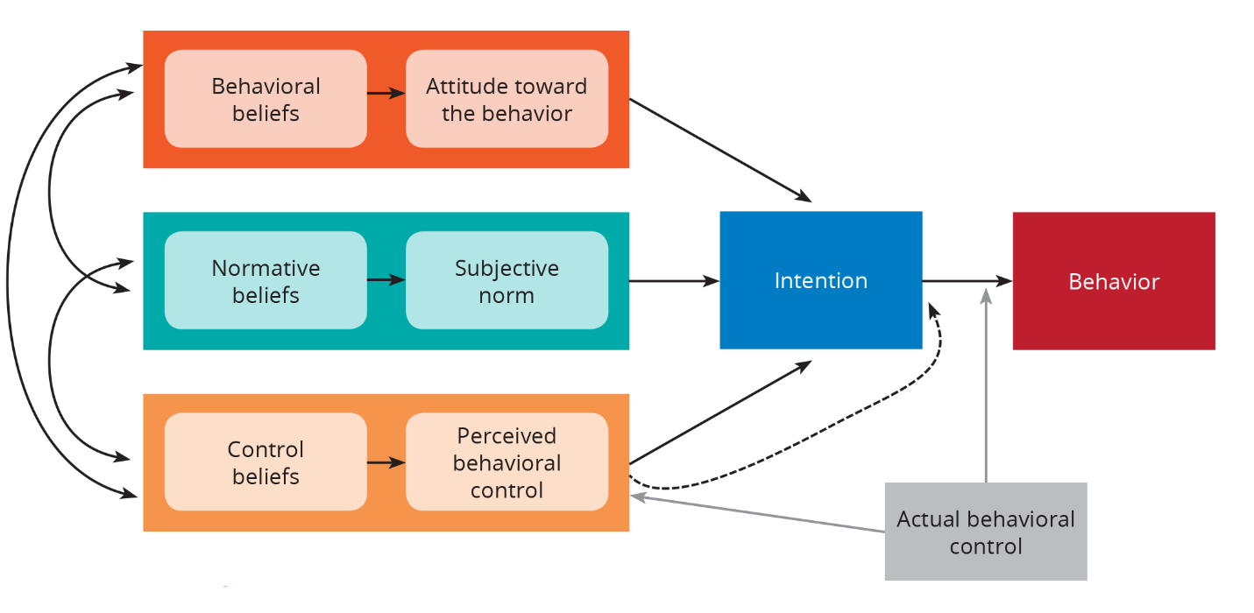

**Organizational Assessment**

The organizational stakeholders required to complete the change include the Labor and Delivery Unit Leadership: Nurse Manager, Director of Obstetric Services, Assistant Clinical Nurse Manager, Clinical Nurse Specialist (author’s position), Unit Educator, Maternal Child Health Administrator. In addition, the Labor and Delivery Unit staff members include: Senior Staff Physicians, Maternal Fetal Medicine Physicians, OBGYN Residents, Certified Nurse Midwives, Nurses (primary influencers for project), OB Technicians, and Unit Clerks. (Table 1).

The target population vary in work experience as labor nurses (new grads to 35+ years) and generationally (millennials to baby boomers). The method will be an interactive hands-on labor support class aimed at merging kinesthetic (hand/body) learning focusing on “what” and “how”, with contextual (mind) learning focusing on “why” and “when”. The overall all process improvement strategies will enhance/clarify current knowledge, develop new techniques, provide latest information, and increase confidence in the care of laboring women thus influencing birth outcomes and impacting the cesarean section rate.

Approximately 9900+ pregnant patients present annually to Henry Ford Hospital Labor and Delivery: 1/3 are admitted after being evaluated in Triage, and the remaining 2/3 are discharged. As mentioned previously, in 2018 there were 2617 births. The unit consists of 12 Labor, Delivery, Recovery beds (LDR), 5-bed triage, 2 operating rooms, 2-bed recovery room. The labor nurses rotate through all patient care areas. Care is provided for women presenting with normal/low-risk pregnancies, as well as with complex/high-risk maternal and fetal conditions.

The patient population is drawn largely from the surrounding urban geographical location and consists of African American, Hispanic, Caucasian, Middle Eastern (primarily Arab and Bengali). Language access services available. The staff population (professionals) is also diverse and although not equal in measure, it does compliment the patient population.

**Table 1. Organizational Assessment.**

|  |  |  |  |
| --- | --- | --- | --- |
| **TEAM MEMBER** | **POSITIONS** | | **AVAILABILITY** |
| Labor and Delivery Nurses   * Target population * Primary influencers | 75 | | 11-day shift  10-night shift  Nurse/Patient Staffing Ratio: 1-2 |
| OB Senior Staff | 15 | | 1-day shift and 1-night shift  (+ gynecology coverage) |
| Certified Nurse Midwifes (CNM) | 20 | | 2-day shift and night shift |
| Maternal Fetal Medicine | 6 | | 24- hour availability for consults |
| OBGYN Residents | 16 | | 1-Senior and 1-Junior on day shift  (+ gynecology coverage) |
| OB Techs | 7 | | 2-day shift and night shift |
| Anesthesia | varies | | 24- hour availability |
| Neonatology/NICU  (MD, Neonatal Nurse Practitioners, RNs) | varies | | 24-hour availability |
| Lactation Consultants | 3 | | 16-hour availability |
| Pharmacy | 2+ | | 7am-11pm unit-based availability  11pm-7am-central pharmacy |
| Unit Clerks | 9 | | 2-day shift and night shift |
| Social Work | 2 | | Monday-Friday-unit based  Off-shift & weekends hospital based |
| Medical Students  Nursing Students | varies | | As scheduled per school |
| **NURSING LEADERSHIP** | | | |
| Nurse Administrative Manager | | Day shift + 24-hour availability | |
| Assistant Clinical Manager | | Off shift + availability as needed | |
| Clinical Nurse Specialist | | Day shift + availability as needed | |
| Unit Educator | | Day shift + off-shift as indicated | |
| Nursing Administrator | | Day shift + 24-hour availability | |

Potential barriers to the success of the project include increased documentation demands; potential cost/staffing constraints to support education offerings due to financial directive set by the health system; staffing shortages; rapid turnover (millennial nurses often leave after a couple years to explore other areas of nursing); low staff interest in labor support education; decreases in birth volume; low staff/patient interest in completing post-intervention assessments/surveys. To assist in the strategic planning for the project, a SWOT Analysis was performed to identify Strengths, Weaknesses, Opportunities, and Threats. (Table 2).

**Table 2. SWOT ANALYSIS: Henry Ford Hospital Labor & Delivery Unit**

|  |  |
| --- | --- |
| **S:**  **STRENGTHS**  **S:**  **STRENGTHS** | **INTERNAL**   * Magnet Hospital Designation * Baby Friendly Breastfeeding Certified Hospital * Level 1 Trauma Center * Level 3 Maternity Care (Subspecialty Care of complex medical conditions) * Nursing Research and Development Department which facilitates grant funding for nursing research * HFH Research and Evidence-Based Practice Council as part of Shared Governance. * Internal Research Grant for nurses * Center for Nursing Research and Evidence-Based Practice (CNRE) with 2-Nurse Scholars to assist nurses. * HFHS Research and Biostatistics Department to conduct data analysis. * Instructional Technologist * Care for a diverse patient population (culture, language, social) * Diverse staff population (culture, language, social) * Care for women with normal/low-risk pregnancies * Care for women with complex high-risk pregnancies   + Maternal co-morbidities   + Fetal co-morbidities * Monthly OB Collaborative Practice Meeting (OB RNs, OB Providers, Anesthesia) * Monthly Maternal Child Health Collaborative Practice Meetings with OB providers/RNs, NICU providers/RNs, Pharmacy, Social Work. * Monthly Maternal Critical Care Conferences/Meetings with Maternal Fetal Medicine, OB providers/RNs, Anesthesia, Cardiology, and ancillary medical services, such as Neurology, Hematology/Oncology. * Monthly Perinatal Conference/Meeting with OB, Maternal Fetal Medicine, NICU, Genetics, Radiology * Collaboration with multidisciplinary team * Monthly System Perinatal Collaborative Meeting with all 5-HFHS birthing hospitals * Unit Leadership: Nurse Manager, Director of Obstetric Services, Assistant Clinical Nurse Manager, Clinical Nurse Specialist, Unit Educator, Maternal Child Health Administrator * Staff members: Senior Staff Physicians, Maternal Fetal Medicine Physicians, OBGYN Residents, Certified Nurse Midwives, RNs, OB Technicians, Unit Clerks, Lactation Consultants * 24/7 NICU and Anesthesia support * Management support of education attainment (degree advancement, conference attendance, in-services) * Obstetric RN Orientation Course Series for new RNs (fetal monitoring, normal pregnancy, high-risk pregnancy, postpartum, normal newborn, operating room, labor support, OB emergency simulations (OB Hemorrhage & Shoulder Dystocia) * Pipeline for Advanced Practice Nurses (CNM, FNP, NNP) * Professional Nurse Advancement Ladder * Labor and delivery nurses are an integral part of a woman’s birth experience. * Development and communication of multidisciplinary plans of care for high-risk pregnant patients * Language access services (telephonic/in-person) * AWHONN Intermediate and Advanced Fetal Monitoring Classes * Michigan maternity participation/partnerships: Alliance for Innovation in Maternal Health (AIM) for reducing pregnancy complication, Obstetrics Initiative (OBI)-quality improvement initiatives. Southeast Michigan Perinatal Quality Collaborative (SEMPQIC). * National partnerships: Institute for Healthcare Improvement (IHI) Better Maternal Outcomes   **EXTERNAL:**   * Professional growth opportunities in nursing at HFHS * Pipeline for Advanced Practice Nurses (ie., Midwifery Service) * On-site RN to BSN, MSN, DNP programs with the University of Detroit Mercy * Nursing leadership holds memberships in local, state, and national professional organizations |
| **W:**  **WEAKNESSES** | **INTERNAL**   * Staffing challenges * Competing priorities/goals (hospital, projects, etc.) * Nurse turnover (advancing education, resignation) * Technology/documentation demands can interfere with the “touch” aspect of labor support * Labor support techniques not consistently used with high-risk pts * Most incumbent nurses have not had a labor support class in years * Aging workforce of experienced OB nurses * Retention of millennial talent * Minimal number of RNs with certifications (fetal monitoring, in-patient obstetrics): 11 of 75 nurses (15%).   **EXTERNAL**   * Aging nursing workforce * Retention of Millennial talent * Reimbursement and payment changes * Continuous regulatory changes |
| **O:**  **OPPORTUNITIES** | * Increase professional certification (fetal monitoring, in-patient obstetrics) * Increase knowledge of labor support skills to enhance maternal, newborn, family birth experience. * Enhance nurse-provider communication * Provide education for incorporating labor support techniques when caring for patients with complex high-risk pregnancy conditions. * Provide labor support skills education & monitor cesarean section rates * Enhance multi-lingual resources (education material-print & visual) * Better use of technology to support hands-on care by labor nurses |
| **T:**  **THREATS** | * Increased documentation demands * Potential cost/staffing constraints to support education offerings * Staffing shortages * Rapid turnover (millennial nurses often leave after a couple years to explore other areas of nursing) * Low staff interest in labor support education * Decrease in birth volume * Impact of COVID pandemic during timeframe of post-intervention survey |

**Methods/Design Implementation Plan**

**Project Description**

The project will be an interactive hands-on labor support class aimed at merging contextual (mind) learning focusing on “why” and “when”, and kinesthetic (hand/body) learning focusing on “what” and “how”. It was partially funded by a nursing grant from Henry Ford Hospital. The overall process improvement strategies will enhance and clarify current knowledge, develop new techniques, provide the latest information, and increase confidence in the care of laboring women, thus influencing birth outcomes and impacting both the Nulliparous, Term, Singleton, Vertex (NTSV) Cesarean Birth Rate, and; the Total Cesarean Section Rate.

**Project Design**

The project will be of a descriptive mixed-method design.

1. Quantitative outcomes will include the following PRE and POST information using Anova repeated measures for:
   1. Data x 2-months of the total cesarean section rates.
   2. Date x 2-months of the nulliparous, term, singleton, vertex cesarean birth rates (NTSV).
2. Quantitative measures from the “Intrapartum Nurse’s Beliefs Relate to Birth Practice” (IPNBBP) Tool, authored by Ellise D. Adams, PhD, CNM. **(Appendix 1).**
   1. Section 1:
      * Includes non-identifiable demographics, nursing education and certification, intrapartum nurse experience, and current work environment.
   2. Section 2: Total 28 Items:

* 11 items measuring the concept: Birth beliefs related to medicalized birth.
  + Score range 11-33.
    - 17 items measuring the concept: Birth beliefs related to normal birth.
      * Score range 68-102.

1. Qualitative measures from the IPNBBP Tool:
   1. Section 3: Two-open ended questions about the individual nurses’ beliefs related birth practice.
      1. According to my birth beliefs related to birth practice, the birth process is:
      2. According to my birth beliefs related to birth practice, my role as an intrapartum nurse in the birth process is:

According to Dr. Ellise Adams, “normal birth beliefs” are described as follows: birth is a physiologic life event & unique to each laboring woman; a process not bound by time and parameters; occurs in a variety of setting (birth center/home); can be spontaneous; may incorporate a variety of birth attendants; is a supportive environment; clinicians trust the birth process; clinicians promote normal birth; technology is not always necessary, and clinicians use liberal labor support techniques. Medicalized birth beliefs are described as: labor & birth must occur in a clinical setting; continuous fetal/uterine monitoring occurs, and birth is a pathological process where complication can be catastrophic, and interventions are needed to prevent them.

**Outcome Measures**

After the labor support class intervention, evaluate:

1. The NTSV cesarean birth rate.
2. Total cesarean section rate.
3. Nurse beliefs related to normal birth in comparison to medicalized birth.

**Approvals/Certifications**

1. Intrapartum Nurse’s Beliefs Related to Birth Practice (IPNBBP), authored by Ellise D. Adams, PhD, CNM Survey tool/instrument (comparing medicalized birth and normal birth beliefs). Approval to use tool granted 6/3/2019.
2. CITI Training Certificate: 1/30/2020 – 1/29/2023
3. Complete Institutional Review Board (IRB) Application for Human Subjects for Henry Ford Health System (HFHS). Approval: 2/27/2020.
4. University of Detroit Mercy (UDM). Approval: 3/3/2020.

**Funding Sources**

* 2018-2019: Henry Ford Hospital Nurses’ Research Grant Award: $900. The Influence of Nursing Labor Support on Reducing the Cesarean Section Rate. (**Appendix 2**).
* Recipient: Cheryl Larry-Osman, Author/Primary Investigator (PI).

**Setting, Sample, Sample Criteria for the IPNBBP Survey Tool**

* Setting: Pre-survey: Henry Ford Health System Simulation Center (HFHS)

Detroit, MI.

Post-survey: Henry Ford Hospital (HFH), Labor and Delivery Unit and the High-Risk Pregnancy Unit, Detroit, MI

* Sample: Convenience sample of 75 Labor & Delivery RNs at Henry Ford

Hospital who attended a labor support class during the study period.

* Sample Period: Pre-intervention survey period: Prior to each labor support class:

6/25/2019, 7/2/2019, 7/9/2019, 7/23/2019, 8/20/2019, 12/10/2019

Post-intervention survey period: 2 months after last labor support class: March 1, 2020 – March 31, 2020

* Inclusion Criteria: HFH L&D RNs who attended a Labor Support Class.
* Exclusion Criteria: HFH L&D RNs who did not attend a Labor Support Class.
* Participation: Voluntary participation by completion of the survey. Completion

of the survey is considered agreement to participate.

* Opt-Out: Participants could opt-out at any time without repercussions nor

impact on employment status.

**Data Analysis Plan: IPNBBP Survey Tool**

**Quantitative Analysis: IPNBBP Tool**

* Primary Investigator (Author: Cheryl Larry-Osman, MS, RN, CNM, CNS-C)
* No personal identifiers requested.
* All data is un-identifiable and aggregate.
* The design of the study does not let us match a nurse’s pre survey score to her post survey score.
* A two sample Students’ t-test for analysis of the total score on the IPNBBP survey as well as the two sub scales, birth beliefs related to medicalized birth and birth beliefs related to normal births.
* Sample Size Justification:
  + Ed Peterson, PhD, HFHS Biostatistician
  + Kylie Springer, MS, HFHS Biostatistician
  + 75 pre surveys previously gathered during the educational intervention. It is assumed that not all nurses will complete a post survey.
  + A conservative estimate of 80% participation will be used to estimate the post survey cohort of 60 individuals. In order to estimate the standard deviation, we will anticipate we take one-sixth of the range of scores. This translates to 23.3 for the total score, 9.2 for the medicalized belief, and 14.2 for the normal birth beliefs. The test with 75 and 60 subjects, with a two-sided 0.05 alpha value, will be able to detect an effect size of 0.49. In this setting, the effect size is the detectable difference in means divided by its standard deviation. This translates to being able to detect a difference in means of 11.4 in the total score, 4.5 in medicalized beliefs and 7.0 in normal birth.

**Qualitative Analysis: IPNBBP Tool**

* Primary Investigator (Author: Cheryl Larry-Osman, MS, RN, CNM, CNS-C)
* HFH Maternal Child Health
  + Wendy Mackenzie, MScN, RNC, Unit Educator, Labor and Delivery Unit
  + Mesha Farrington, BSN, RNC-MNN, Unit Educator, Mother Baby Unit
  + Katherine Balten, MSN, RN, AGCNS-BC, HN-BC, Clinical Nurse Specialist, Mother Baby Unit
* Theme analysis for interpretation of two open-ended questions about the individual nurses’ beliefs related birth practice.

**Documentation of Informed Consent** (**Appendix 3**)

* The survey was provided with a cover letter stating that participation is voluntary for eligible RNs who participated in the Labor Support Classes and took the pre-survey.
* There is minimal risk.
* Participants may choose to opt-out or withdraw at any time without any repercussion.
* Completion of the survey is considered agreement to participate.

**Communication**

* The PI posted flyers on the L&D Unit about the research call for voluntary participation of eligible L&D RNs**. (Appendix 4).**
* Additional pertinent information to be shared in aggregate at subsequent staff meetings, presentation, unit postings and huddles.

**Incentive to Participate**

* As an incentive to participate, labor nurses were offered the option to enter a drawing for a $25 Visa gift card. (Appendix).
* A total of eight $25 gift cards were awarded during the study period.
* Gift cards funded by the HFH Nursing Grant: $200.00

**Data and Safety Monitoring: IPNBBP Survey Tool**

* PI responsible for monitoring the safety of the study
* Survey completion duration: Approximately 10-15 minutes to complete.
* Staff surveys voluntarily completed.
* The PI collected all completed surveys and placed them in a locked office.
* The survey's will be destroyed upon data analysis and subsequent publication.
* Pre-intervention: survey period:
  + 6-classes: 6/25/2019, 7/2/2019, 7/9/2019, 7/23/2019, 8/20/2019, 12/10/2019
  + Staff completed surveys immediately prior to the labor support class they attended.
* Post-intervention survey period:
  + March 1, 2020 thru March 31, 2020 (4-weeks).
  + Staff completed surveys during their scheduled shift.
  + The staff placed all completed surveys in a locked box in the breakroom on the L&D Unit or High Risk Pregnancy Unit. (Note: both units are staffed by the L&D RNs).
  + The PI monitored for survey completion every 1-3 days.

**Confidentiality of the Volunteers/Participants**

* The surveys not numbered and unable to be traced back to any participant.
* Data has no personal identifiers and cannot be traced back to participants.

**Potential Benefits of Participation**

* Participants: Research suggests that nurses are likely influential in the birth outcome of a woman. Personal beliefs can impact how a nurse supports vaginal birth during labor.
* Society:Literature supports better maternal and fetal outcomes with vaginal birth. Increased knowledge of the nurse can improve birth outcomes.

**Potential Risks in Participation**

* The research involves completion of a survey.
* It is anticipated minimal risk.
* The potential risk could be survey fatigue as it takes approximately 10-15 minutes to complete, however participants can opt-out at any time.
* Participation is voluntary and without any impact on employment status.

**Data Collection/Measures: Total Cesarean Section Rate & NTSV Cesarean Birth Rate**

**PRE-Labor Support Class Intervention:**

* April 2019
* May 2019

**POST-Labor Support Class Intervention:**

* January 2020
* February 2020

**Formulas: Total Cesarean Section Rate & NTSV Cesarean Birth Rate**

* Total Cesarean Section (C/S) Rate: Number of cesarean sections divided by total number of births. (Determined from electronic and manual filtering of birth logs).
* Total NTSV Cesarean Birth Rate: Number of NTSV cesarean sections divided by the total number NTSV cesarean births. (Determined by electronic and manual filtering of birth logs).
* Cesarean and NTSV Data Analytics: Linda McMath, MSN, RN, OBIX System Manager/OBIX Clinical Lead, Henry Ford Hospital

**Intervention: Interactive Hands-on Labor Support Class**

* PI-primary content developer/instructor/facilitator (Author: Cheryl Larry-Osman, MS, RN, CNM, CNS-C).
* Co-facilitators:
  + Wendy Mackenzie, MScN, RNC, Unit Educator, Labor and Delivery Unit
  + Mesha Farrington, BSN, RNC-MNN, Unit Educator, Mother Baby Unit
  + Katherine Balten, MSN, RN, AGCNS-BC, HN-BC, Clinical Nurse Specialist, Mother Baby Unit
* Class Format: Bridge kinesthetic and contextual learning.
* 8-hour paid workday for RN attendance at the labor support class. A great display of HFH financial investment in staff and goal to enhance labor support skills.
  + Dates: 6/25/2019, 7/2/2019, 7/9/2019, 7/23/2019, 8/20/2019, 12/10/2019
* RN Goal:
  + To enhance the knowledge & confidence of labor and delivery nurses performing labor support.
  + To increase nursing satisfaction in the care of laboring women.
  + To strengthen labor nurses as the primary “staff person” influencers incorporating labor support techniques into care during childbirth.
  + To enhance labor support techniques which impact nurse-patient communication, nurse-provider communication, and nurse-nurse communication.
* Patient Goal:
  + To increase the woman’s access to nonmedical interventions during labor, as provided by continuous labor and delivery support.
  + To reduce the risk of a cesarean birth.
  + To increase patient satisfaction in the birth experience.

**Labor Support Class Content**

* 1. Labor Support and Management PowerPoint Lecture: Contextual Learning **(Appendix 5)**.
     + Define labor management and communication
     + Discuss approaches to supporting women in labor
     + Discuss alternatives/complementary therapies for pregnancy and childbirth
  2. Comfort Menu PowerPoint Lecture: Contextual Learning **(Appendix 6)**.
     + Aromatherapy, music therapy, coloring, books, playing cards, other distraction techniques
  3. **Coping Scale PowerPoint Lecture: Contextual Learning** **(Appendix 7)**.
  4. Hands-on Techniques: Kinesthetic Learning (**Appendix 8. Participant Pictures**)
  + Maternal positioning in and out of birthing bed, breathing techniques, use of peanut balls/birthing balls, aromatherapy, music therapy, massage, ambulation, hydrotherapy, delayed pushing in the second stage of labor, use of the coping scale in assessing discomfort in labor, birth affirmations, and What Is Your Why?

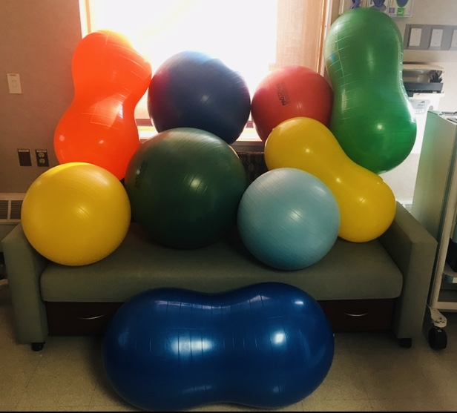

* 1. Class Handouts **(Appendix 9)**.
     + AWHONN Continuous Labor Support
     + Positions for Laboring Out of Bed
     + Birth Positions
     + Respectful Maternity Care
     + Labor Support Articles
     + Labor Coping Scale
  2. Video: Hill Rom Birth Bed Positions
  3. Supplies: Partially funded by HFH Nursing Grant
     + Birth balls
     + Peanut balls
     + Robozo
     + Aromatherapy (list scents)
     + Yoga mats
     + Sheets

**Additional Maternal Child Health Labor Support Education**

1. OBGYN Senior Staff Meeting, Henry Ford Hospital: 3rd Quarter 2019, 20 minutes.
2. OBGYN Resident Education: 30 minutes of didactic information related to labor support. 8/28/2019.
3. Obstetric Technician Education, 11/26/2019, 30-minutes.
4. Women’s Health Services Grand Rounds, Henry Ford Hospital, One Ford Place: MD/DO/CNM/RN attendees, 12/4/2019, 20 minutes.

**RESULTS**

**SECTION 1: IPNBBP SURVEY QUANTITATIVE DATA**

**HFHS Biostatistical IPNBBP Survey Tool Data Analysis Report (Appendix 10).**

**Table 3. Demographics, Personal Birth Experiences, Nursing Education, Certifications.**

|  |  |  |  |  |  |
| --- | --- | --- | --- | --- | --- |
| **Variable** | | | **Pre (N=69)** | | **Post (N=34)** |
| **Age** | | (20-69 years) | 37.93 | | 37.15 |
| **Race** | | White | 44 (63.77%) | | 23 (67.65%) |
| Black | 15 (21.74%) | | 7 (20.59%) |
| Hispanic | 0 | | 0 |
| American Indian | 1 (1.45%) | | 0 |
| Pacific | 1 (1.45%) | | 0 |
| Two or More | 3 (4.35%) | | 2 (5.88%) |
| Other | 4 (5.80%) | | 5 (5.88%) |
| **Method of Birth** | | Vaginal | 34 (49.28%) | | 17 (50%) |
| Cesarean Section | 9 (13.04%) | | 6 (17.65%) |
| Forceps | 2 (2.90%) | | 1 (2.94%) |
| Vacuum | 2 (2.90%) | | 0 |
| N/A | 27 (39.13%) | | 14 (41.18%) |
| **Location of Birth** | Home | | 2 (2.9%) | | 0 |
| Hospital | | 39 (56.52%) | | 20 (58.82%) |
| Birth Center | | 2 (2.90%) | | 0 |
| N/A | | 26 (37.68%) | | 14 (41.18%) |
| Other | | 0 | | 0 |
| **Opinion of Birth Experience** | Positive | | 35 (50.72%) | | 15 (44.12%) |
| Negative | | 13 (18.84%) | | 6 (17.65%) |
| No Opinion | | 1 (1.45%) | | 0 |
| N/A | | 26 (37.68%) | | 15 (44.12%) |
| Other | | 1 (1.45%) | | 0 |
| **Variable** | | | **Pre (N=69)** | | **Post (N=34)** |
| **Years as Labor Nurse** | 1 month-45 years | | 7.53 | | 8.52 |
| **Education** | PhD/DNP/Doc Prac | | 0 | | 0 |
| MSN | | 3 (4.35%) | | 3 (3.82%) |
| Masters | | 1 (1.45%) | | 1 (2.94%) |
| BSN | | 45 (65.22%) | | 26 (76.47%) |
| Associates | | 22 (31.88%) | | 8 (23.53%) |
| Diploma | | 4 (5.80%) | | 0 |
| Other | | 2 (2.90%) | | 0 |
| **Certifications** | EFM | | | 32 (46.38%) | 20 (58.82%) |
| Intrapartum | | | 15 (21.74%) | 6 (17.65%) |
| Birth Education | | | 8 (11.60%) | 1 (2.94%) |
| Midwifery | | | 1 (1.45%) | 1 (2.94%) |
| CNS/CNP | | | 0 | 0 |
| Doula | | | 1 (1.45%) | 0 |
| Certified NA | | | 14 (20.29%) | 0 |
| Certification Other | | | 2 (2.90%) | 0 |

**Table 4. Intrapartum Nurse Experience (30 Survey Elements)**

|  |  |
| --- | --- |
| Elective inductions of labor | Doula |
| Augmented labors | Use of breathing & relaxation techniques* |
| Cesarean birth | Hydrotherapy* |
| Elective cesarean birth | Water birth |
| Epidural anesthesia | Encouraging upright positioning during labor & birth* |
| Unmedicated vaginal birth* | Certified nurse midwives |
| Forceps delivery | Certified midwives |
| Vacuum extraction | Certified professional midwives |
| Episiotomy | Lay midwives |
| Ambulation for labor* | Obstetricians |
| Continuous fetal monitoring | Family physicians |
| Intermittent fetal monitoring* | OB medical students & residents |
| Laboring down* | Freestanding birth centers |
| Birth plans | Home birth |
| Use of closed glottis pushing | Use of open glottis pushing |

***\* Survey Elements Reviewed in Labor Support Class***

**Table 5. Intrapartum Nurse Experience 7-Elements Reviewed in Labor Support Class**

|  |  |  |  |  |
| --- | --- | --- | --- | --- |
|  | **Labor Support Class Elements** | **Pre (N-69)** | **Post (N-34)** | **%**  **Increase** |
| **1.** | Unmedicated Vaginal Birth | 67 (97.10%) | 34 (100%) | **2.9%** |
| **2.** | Ambulation for Labor | 65 (94.2%) | 33 (97.06%) | **2.86%** |
| **3.** | Intermittent fetal monitoring | 66 (95.65%) | 34 (100%) | **4.35%** |
| **4.** | Laboring Down | 69 (100%) | 34 (100%) | = |
| **5.** | Use of breathing & relaxation techniques | 65 (94.2%) | 34 (100%) | **5.8%** |
| **6.** | Hydrotherapy | 26 (37.68% | 14 (41.18%) | **3.5%** |
| **7.** | Encouraging upright positioning during labor & birth | 59 (85.51%) | 30 (88.24%) | **2.73%** |

**RESULTS**

**SECTION 2: IPNBBP SURVEY QUANTITATIVE DATA**

**Table 6. P-Value, Medicalized and Normal Birth Scores**

|  |  |  |
| --- | --- | --- |
| **Variable** | **P-value** |  |
| **Total Score** | 0.3209 |  |
| **Medicalized Birth Scores** | 0.0510 | No significant statistical difference   * Marginal significance noted |
| **Normal Birth Scores** | 0.5439 | No significant statistical difference |

Testing the differences between pre and post intervention are performed using the Flinger-Policello test. Statistical significance is set at p<0.05. All analyses are performed using SAS 9.4 (SAS Institute Inc., Cary, NC, USA).

**Table 6** displays the Flinger Policello test statistics and p-values for the differences between the pre and post scores for the Total Scores, the Medicalized Birth Belief scores, and the Normal Birth Belief scores. No significant differences are observed between the pre-post scores for medicalized birth (0.0510) or normal birth (0.5439). However, the difference between the pre and post intervention is marginally significant in medicalized birth.

**Table 7. Score Distribution: Medicalized Birth Beliefs**

|  |  |  |  |  |  |
| --- | --- | --- | --- | --- | --- |
|  | **Variable** | **N**  **Observed** | **Mean** | **Minimum** | **Maximum** |
| **Pre-Intervention** | Medicalized | 69 | 50.59 | 33.00 | 66.00 |
| **Post-Intervention** | Medicalized | 34 | 47.62 | 30.00 | 65.00 |

Medicalized Birth Beliefs score range for IPNBBP tool (11-33). The Pre-intervention average score for medicalized birth beliefs is 50.59, with a range of 33-66. Based on the labor support tool, this range does not indicate that the intrapartum/labor nurse’s beliefs are more closely associated with the elements of medicalized birth. Post intervention, the average score goes down slightly for medicalized birth beliefs, with a range of 30-65. The difference between the pre- and post-intervention is marginally significant. (**See Figure 2).**

**Table 8. Score Distribution: Normal Birth Beliefs**

|  |  |  |  |  |  |
| --- | --- | --- | --- | --- | --- |
|  | **Variable** | **N**  **Observed** | **Mean** | **Minimum** | **Maximum** |
| **Pre-Intervention** | Normal | 69 | 84.13 | 29.00 | 102.00 |
| **Post-Intervention** | Normal | 34 | 86.06 | 73.00 | 100.00 |

Normal Birth Belief score range for IPNBBP tool 68-102. The average score goes slightly up from pre (84.13) to post (86.06). A big change is noted in the range from pre (29-102) to post (73-100). **(See Figure 2).**

**Figure 2.** **Quantitative Score Distribution, IPNBBP, Pre- and Post-**

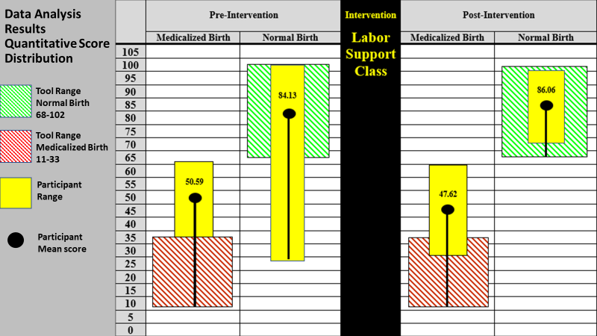

**RESULTS**

**SECTION 3: IPNBBP SURVEY QUALITATIVE DATA**

In Section 3, two open-ended questions allow the intrapartum/ labor & delivery nurse to express their beliefs related to birth practice in a narrative manner. Data from these open-ended questions were subjected to theme analysis for interpretation of common topics, words, and ideas which appeared repeatedly in the responses. See **Appendix 11** for complete pre/post responses.

**Questions:**

1. According to my birth beliefs related to birth practice, the birth process is:
2. According to my birth beliefs related to birth practice, my role as an intrapartum nurse in the birth process is:

Qualitative thematic analysis of the pre- and post- intervention survey responses for the two-open ended questions about the individual nurses’ beliefs related birth practice, identified 18-common themes. **(Table 9).** The top-5 pre-intervention (N=69 participants) themes included: support, safety, normal/natural birth, teach/educate, families, and advocacy. (Table__). The top-5 post-intervention (N=34 participants) themes included: safety, support, helping, normal/natural birth, and teach/educate. (Table__).

**Table 9. Total Pre- and Post- Survey Common Themes Summary**

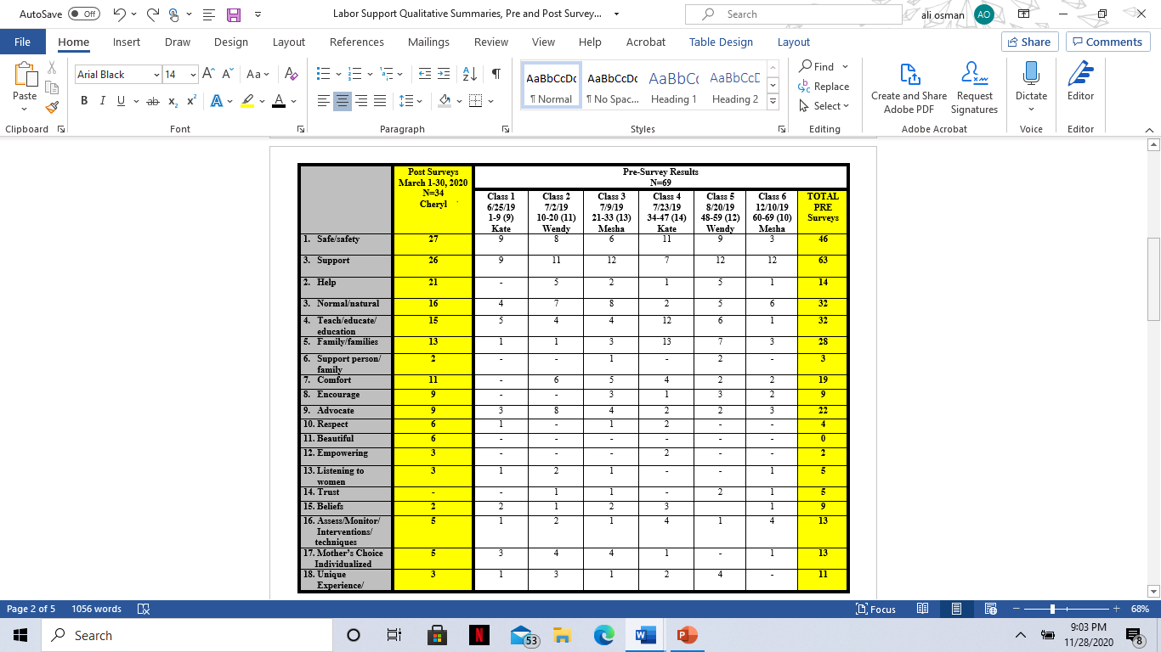

**Table 10. Top 5 Pre- and Post- Qualitative Survey Themes.**

|  |  |
| --- | --- |
| **Top Pre-Intervention Themes** | **Top Post-Intervention Themes** |
| 1. Support 2. Safety 3. Normal/Natural Birth/Teach/Educate 4. Families 5. Advocacy | 1. Safety 2. Support 3. Helping 4. Normal/Natural Birth 5. Teach/Educate |

In further analysis, the top-5 most common themes, by highest combined totals in pre- and post- responses, include support, safety, natural/normal birth, teach/educate, and helping. **(Table 11)**.

**Table 11. Top 5 Pre/Post Intervention Common Themes by Highest Combined Totals.**

|  |
| --- |
| Top 5 Pre/Post Intervention Common Themes |
| 1. Support (89) 2. Safety (73) 3. Natural/normal (48) 4. Teach/educate (47) 5. Helping (35) |

**Figure 3. Word Cloud of Top 5 Pre/Post Intervention Common Themes by highest combined totals.**

**Results: Quantitative  
Total Cesarean Section Rate**

**NTSV Cesarean Section Rate**

**Table 12. Results: Cesarean Section and NTSV Cesarean Birth Rates**

|  |  |  |  |  |  |
| --- | --- | --- | --- | --- | --- |
|  | **Pre-Intervention** | | **Post-Intervention** | | **%**  **Difference**  **Pre-Post** |
| April 2019 | May 2019 | Jan 2020 | Feb 2020 |  |
| **Monthly Deliveries** | 197 | 250 | 218 | 201 |
| **Total Deliveries** | **447** | | **419** | |
| **Total C/S Rate** | 27.9%  (n=55) | 29.2% (n=73) | 26.1%  (n=57) | 32.8%  (n=66) | **Total C/S**  **3.9% higher** |
| **Total C/S’s** | 128 | | 123 | |
| **Ave. C/S Rate** | **28.55%** | | **32.45%** | |
| **NTSV C/S Rate** | 24% | 19% | 29% | 12% | **Total NTSV C/S**  **1.0% lower** |
| **Ave. NTSV**  **C/S Rate** | **21.5%** | | **20.5%** | |

Total C/S rate for both 2-month pre- and post- intervention were averaged at 28.55% and 32.45%, respectively. **(Table 12)**. Although there is not an “ideal rate”, the organizational and regulatory suggestions range from a cesarean section target of 10% (Healthy People 2020), 15% (World Health Organization (WHO), and 26.2 % (California Maternal Quality Care Collaborative). The total C/S rates for both time intervals were above all three suggested targets and display a 3.9% increase in pre- and post- intervention comparisons.

The NTSV cesarean birth rates pre- and post- intervention averaged 21.5% and 20.5% respectively. **(Table 12)**. The NTSV cesarean birth rates for both time intervals were above the 10% (Healthy People 2020) and the 15% (World Health Organization (WHO). However, both rates were below the 26.2 % (California Maternal Quality Care Collaborative) and display a 1% decrease in pre- and post- intervention comparisons.

**CLINICAL IMPLICATIONS**

**Clinical Implications: IPNBBP Survey Tool**

In analysis of the data for Medicalized Birth, the difference between the pre (50.59) and post (47.62) intervention is marginally significant for the study participants birth beliefs related to medicalized birth. (Graph 2). Both pre- and post- averages are also above the tool range for medicalized birth (tool range 11-33). Therefore, the range DOES NOT indicate that the intrapartum/Labor and Delivery nurse’s beliefs are more closely associated with the elements of a medicalized birth.

In analysis of the data for Normal Birth, overall, the nurse’s beliefs pre (84.13) and post (86.06) are more closely associated with elements of a normal birth (tool range 68-102). The post survey results significantly changed to fall more narrowly within the range of normal birth. (**Figure 4**). The normal birth pre scores range from 29-102, and post scores range from 73-100.

**Figure 4. IPNBBP Quantitative Score Distribution (with normal birth range display).**

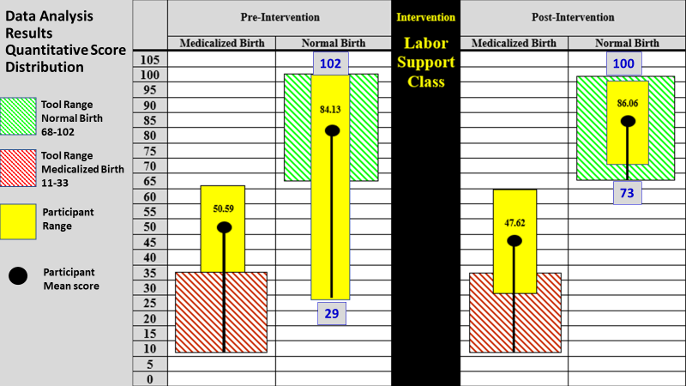

**Clinical Implications  
IPNBBP Survey: Intrapartum Nurse Experience Results**

The IPNBBP survey included 30 elements related to intrapartum nurse experience. Seven elements were incorporated in the labor support class intervention, and include un-medicated vaginal birth, ambulation in labor, intermittent fetal monitoring, laboring down, use of breathing and relaxation techniques, hydrotherapy, and encouraging upright positioning during labor & birth. Upon comparison of pre- and post- intervention data, experience using all elements, except for laboring down which stayed the same at 100%, increased by 2.73%-5.8%. The increase demonstrates the positive influence of the labor support class in enhancing the skills of labor and delivery nurses.

**Clinical Implications   
NTSV Cesarean Birth & Total Cesarean Section Rate**

The NTSV cesarean rate decreased by 1%, and the total C/S rate increased by 3.9%. The impact on the cesarean birth rate takes time and continued evaluation to see changes. The outcome of reducing cesarean birth must include ongoing education of entire clinical team.

**Barriers/Limitations**

Several barriers/limitations occurred during the completion of the project. The national and global impact of COVID-19 created an unforeseen barrier in multiple ways, including, completion of the post-survey in March 2020, total cesarean section data collection, NTSV cesarean birth data collection, data analysis pause by the HFHS biostatistics team due to critical focus on COVID-19 research only. The survey completion timeframe was approximately 15 minutes which could be a barrier during the work hours based on unit/patient acuity. Information Technology (IT) and timing barriers existed creating an inability to provide an electronic survey. Lastly, pre- and post- participation was tabulated as aggregate data which limited the ability to capture individual changes.

**Sustainability**

There will be a multi-pronged approach to sustainability, including items internal and external to Henry Ford Hospital.

* Continuing to track total C/S and NTSV cesarean birth rates
* Annual RN Staff Education: The plan is to use the content of the labor support course for future annual nursing skills fairs
* New Hire Orientation: Include the updated information from the project in new hire RN orientation classes for Henry Ford Health System labor nurses.
* Childbirth Education (CBE) Class Instructors: The instructors for the HFHS Childbirth Education Classes are some of the labor nurses included in the project. The labor support techniques taught in the class can be utilized to enhance the education provided to parents in the CBE Class.
* Labor Support Grant: Modeled after the authors project, HFHS received a $5000 grant from the Obstetrics Initiative (OBI) to provide labor support education/training for the health system. The ultimate goal is to support physiologic birth and reduce the cesarean section rate.
* Conference presentations
* Journal Publication

**Impact**

Obstetrics Initiative (OBI) is a Collaborative Quality Initiative (CQI) funded by Blue Cross Blue Shield of Michigan/Blue Care Network. It is comprised of 75 Michigan maternity hospitals. The first initiative is supporting physiologic vaginal birth and safely lowering the cesarean delivery rate among low-risk (for cesarean delivery) patients. The author’s project is being used as the model to develop a Labor Support Toolkit for the 75-participating birthing in the state of Michigan.

* Planning/Development: 3rd Quarter/4th Quarter2020. Ongoing
* Go-live, 1st Quarter 2021
* Planning team: RNs from HFHS and other birthing hospitals from multiple areas in the State of MI. Bi-monthly meetings.
* Train the trainer (Clinical Nurse Specialists, Educators, Childbirth Instructors, Experienced RNs, etc.).
* Exploring use of data collection tool, such as INPBBP Survey (undecided).
* Three Phase Labor Support Education Approach:
  + Phase 1: Pre-learning: What is Labor Support/RN Role? (Self-directed learning).
  + Phase 2: Facilitated virtual class via Web-Ex: What/Why Labor Support?
  + Phase 3: Facilitated Hands-on Labor Support Techniques at individual sites: How?

**Conclusion**

A belief system related to birth practice is developed and refined through knowledge acquisition, cultivating professional behaviors, interactions within the birth environment, exposure to a variety of birth practices, and reflection on the value of nursing (Adam, JPNN). A personal set of beliefs related to birth practice establishes accountability to peers, patients, and society at large while also providing meaning to the work of the perinatal nurse within the context of the birth environment. (Adam, JPNN). Labor support education and training can increase nurse beliefs related to normal birth in comparison to medicalized birth, can enhance the skills of labor and delivery nurses, and improve the overall maternal, newborn, family, and clinician birth experience and outcomes.

**Labor Support Class Pictures**



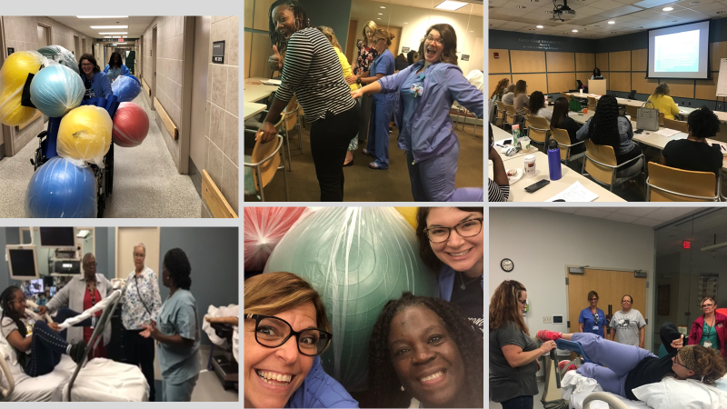

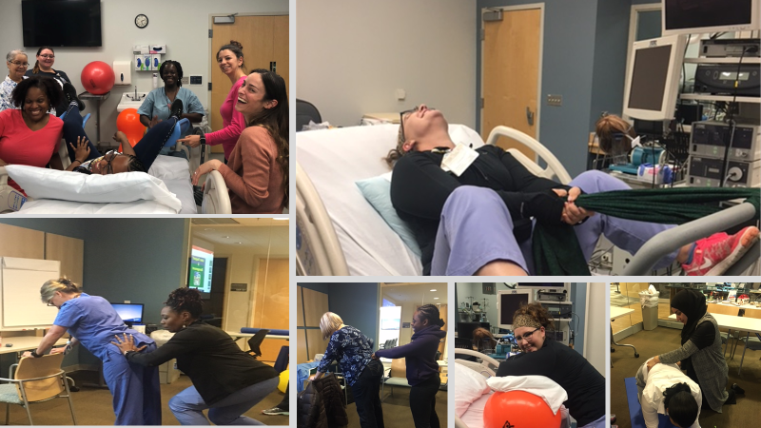

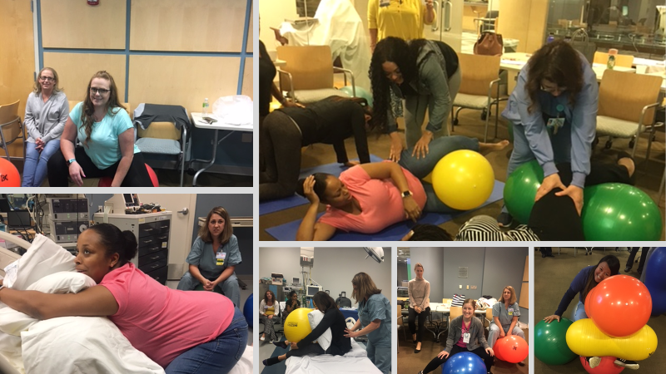

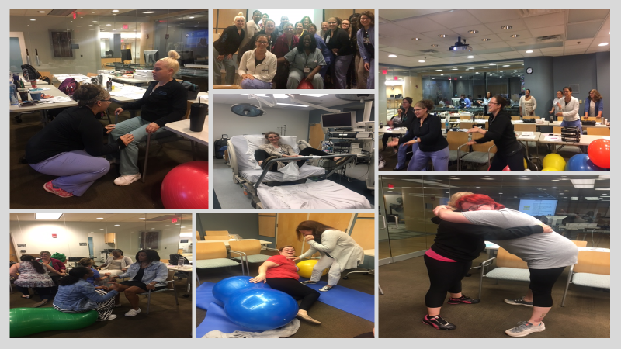

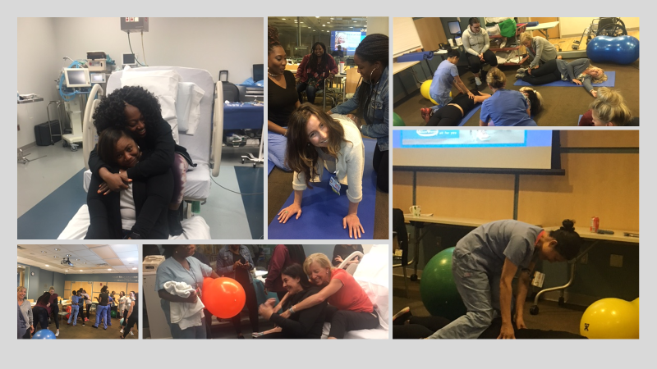

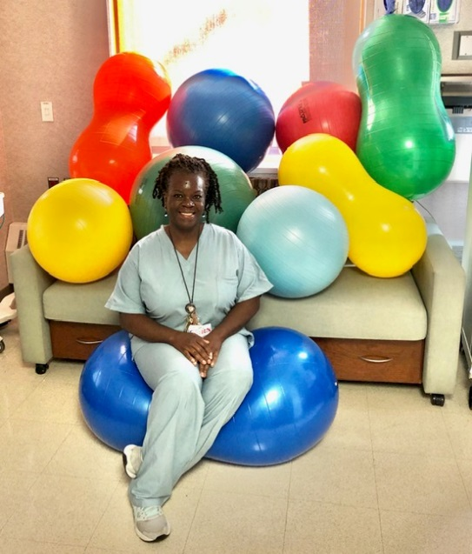

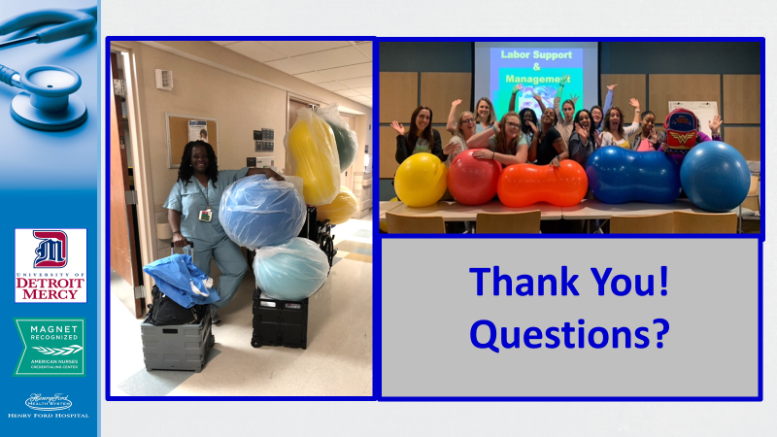

**References**

Adams, E. (2017). Workplace challenges: the impact of personal beliefs and the birth

environment. JPNN, 31 (1), 20-31.

Adams, E., and Sauls, D. (2014). Reliability and validity of an instrument to measure the beliefs

of intrapartum nurses. JPNN, 28(2), 127-134.

Adams, E., and Sauls, D. (2014). Development of the intrapartum nurses’ beliefs related to birth

practice scale. J Nurs Meas., 22, 1-10.

Ajzen, I. (1991). The theory of planned behavior. Organizational behavior and human decision

processes, 50, 179-211.

Aschenbrenner, A.P., Hanson, L, Johnson, T. S., Kelber, S.T. (2016). Nurses’ own birth

experiences influence labor support attitudes and behaviors. JOGNN, 45, 491-501.

Association of Women’s Health, Obstetric and Neonatal Nurses. (2018). Position statement:

continuous labor support for every woman. JOGNN, 47, 73-74.

Association of Women’s Health, Obstetric and Neonatal Nurses. (2019). Standards for

professional nursing practice in the care of women and newborns (8th ed.). Washington,

DC: Author.

Bell, D. B., Joy, S., Gullo, S., Higgins, R., and Stevenson, E. (2017). Implementing a Systematic

Approach to Reduce Cesarean Birth Rated in Nulliparous Women. Obstetrics and Gynecology, 130 (5), 1082-1089.

Butts, J., and Rich, K. (2020). Nursing ethics: across the curriculum and into practice. (5th Ed).

Jones and Bartlett.

California Maternal Quality Care Collaborative (CMQCC): Toolkit to support vaginal birth and

Reduce Primary Cesarean. (2016).

Center for Disease Control and Prevention (CDC), National Vital Statistics Reports, Volume 63,

Number 1, Primary Cesarean Delivery Rates, by State: Results from Revised Birth Certificate, 2006-20012. 1/23/2014.

DiGiovanni, L. (2010). Ethical issues in obstetrics. Obstet Gynecol Clin N Am, 37, 345-357.

Edmonds, J.K., and Jones, E.J. (2013). Intrapartum nurses’ perceived influence on delivery mode

decisions and outcomes. JOGNN, 42, 3-11.

Gams, B., Neerland, C., Kennedy, S. (2018). Reducing primary cesareans: an innovative

multipronged approach to supporting physiologic labor and vaginal birth. JPNN, 33 (1), 52-60.

Glenn, L., Stocker-Schnieder, J., McCune, R., McClelland, M., and King, D. (2014). Caring

nurse practice in the intrapartum setting: nurse’s perspectives on complexity, relationships and safety. JAN, 70 (9), 2019-2030.

Healthy People 2020. <https://www.cdc.gov/nchs/healthy_people/hp2020.htm>

Lawrence. H., Copel, J., O’Keeffe, D., Bradford, W., Scarrow, P., Kennedy, H., Grobman, W.,

Johnson, C., Simpson, K., Lyndon, A., Wade, K., Peddicord, K., Bingham, D., and Olden, C. (2012). Patient Safety Series. Quality patient care in labor and delivery: a call to action. AJOG.

Lyndon, A., Simpson, K., Spetz, J. (2017). The analysis of US stakeholder views on the influence

of labour nurses’ care on birth outcomes. BMJ Qual Saf. 26, 824-831.

Northhouse, P.G. (2016). Leadership: Theory and Practice (7th ed). Thousand Oaks, CA: Sage

Publications.

Peters, R., and, Templin, T. (2010). Theory of planned behavior, self-care motivation, and blood

pressure self-care. Res Theory Nurs Pract., 24(3), 172-186.

Safe Prevention of the primary cesarean delivery. (2014). Obstetric Care Concensus No1.

American College of Obstetrician and Gynecologists. Obstetrics and Gynecology, 123, 693-711.

Sauls, D. The labor support questionnaire: development and psychometric analysis. (2004). J

Nurs Meas., 12 (2), 123-132.

Simpson, K. R., and Lyndon A. Labor nurses’ views of their influence on cesarean birth. (2017).

MCN, pg. 81-87.

Simkin, P. (2014). Preventing Primary Cesareans: Implications for Laboring Women, Their

Partners, Nurses, Educators, and Doulas. BIRTH, 41(3), 220-222.

Simpkin, P., and Bolding, A. (2004). Update on nonpharmacologic approaches to relieve labor

pain and prevent suffering. J Midwifery Womens Health, 49, 489-504.

Wilson-Leedy, J.G., DiSilvestro, A. J., Repke, J.T., and Pauli, J.M. (2016). Reduction in the

Cesarean Delivery Rate After Obstetric Care Concensus Guideline Information. Obstetrics and Gynecology, 128 (1), 145-152.

Joint Commission on Accreditation of Healthcare Organizations. Cesarean Sections. [www.jointcommission.org](http://www.jointcommission.org)

World Health Organization (WHO). Cesarean Section Rates. [www.who.com](http://www.who.com)

**The Influence of Nursing Labor Support on the Reduction of Cesarean Sections**

**APPENDIX 1-11 (attached)**

1. Intrapartum Nurse’s Beliefs Relate to Birth Practice (IPNBBP) Tool, authored by Ellise D. Adams, PhD, CNM.
2. Henry Ford Hospital Internal Nurses’ Research Grant Award: $900.
3. Documentation of Informed Consent.
4. Unit flyer call for voluntary participation.
5. Labor Support and Management PowerPoint Lecture: Contextual Learning.
6. Comfort Menu PowerPoint Lecture: Contextual Learning.
7. Comfort Menu PowerPoint Lecture: Contextual Learning.
8. Hands-on Techniques: Kinesthetic Learning-Participant pictures.
9. Class Handouts.
   * AWHONN Continuous Labor Support
   * Positions for Laboring Out of Bed
   * Birth Positions
   * Respectful Maternity Care
   * Labor Support Articles
   * Labor Coping Scale
10. HFHS Biostatistical IPNBBP Survey Tool Data Analysis Report.
11. IPNBBP Survey Qualitative Participant Pre- and Post- Responses Data.