Quality Improvement Project In The Emergency Department Based On The Colorado ALTO

Project

Bianca Skowronski MSN, FNP-BC

University of Detroit Mercy

Introduction

According to the Centers for Disease Control and Prevention (CDC), (2018) “in 2017, 70,000 drug overdose deaths occurred in the United States of which 68% of those deaths were from prescription opioids” (p.1). During this time the United States Department of Health and Human Services declared the opioid crisis a national public health emergency. Being the deadliest drug crisis in America’s history, it has been said that physicians, dentists, and advanced practice providers are not only the root cause but also the leaders in attacking this epidemic (Centers for Disease Control and Prevention, 2018). A new NIH analysis of drug overdose deaths shows that America’s opioid epidemic is huge and national, and affecting the lives of all racial and ethnic groups, not just in cities and suburbs but also in small towns and rural areas (NIH, 2019).
Healthcare providers for years would prescribe their patients opioids for the management of their acute and chronic pain. By definition pain can be defined as an unpleasant feeling conveyed to the brain by neurons (Kumar & Elacarasi, 2016). The discomfort that the patient experiences signals actual or potential injury to the human body. It is a physical awareness, perception and subjective interpretation of discomfort. According to the Centers for Disease Control and Prevention (2018) an opioid can be defined as prescription medications that are prescribed by doctors and advanced practice providers to treat moderate to severe pain, but also have serious risks and side effects. When prescribed an opioid, healthcare providers educate patients on the common side effects such as drowsiness, nausea, vomiting, and constipation. However, in the face of acute pain and management, long term considerations were not a priority. Emergency departments (EDs) scope is to treat the acute pain and to address the issue at hand (Gratton, 2017). However, with America facing the deadliest opioid epidemic in history, emergency healthcare providers are now considering the possibility of misuse or relapse as this is a common cycle they see on a daily basis (Gratton, 2017). When prescribed and used appropriately, opioids do play an important and vital role in the management of acute pain (Centers for Disease Control and Prevention, 2018). But it has been found that prescribing higher doses for longer periods can ultimately lead to addiction (Centers for Disease Control and Prevention, 2018). Excluding cancer patients, palliative care, and end of life care, the CDC confirms that a patient prescribed an opioid longer than seven days doubles their chances of becoming addicted (Centers for Disease Control and Prevention, 2018). Acute pain usually comes on suddenly and is contributed to something specific such as broken bones, injuries, dental work, burns or cuts, surgery etc. Acute pain usually does not last longer than six months and goes away when there is no longer an underlying cause for the pain (Cleveland Clinic, 2017).
Facing America’s opioid epidemic is a process and battle in which health care providers need to find the proper balance between educating the patient and management of their pain. There are alternative treatment options available that emergency health care providers need to start using for pain management instead of solely using an opioid of the management of acute pain.
Background & Significance
In 1995, the president of the American Pain Society campaigned to entitle “pain” as the “fifth vital sign.” Shortly afterwards, the Veterans Affairs health system along with the Joint Commission (TJC) embraced the “fifth vital sign” which led to an increase of opioid prescribing. Introducing the fifth vital sign required healthcare providers to address and take action when patients reported pain (Scalpel, 2016). Pharmaceutical companies reassured healthcare providers that their were minimal risks and that patients would not become addicted to prescription opioid pain relievers. This however led healthcare providers to prescribe opioids at greater rates. Healthcare providers were prescribing high dose opioids for an extended period of time which ultimately led to misuse of opioids and eventually led to addiction (National Institute on Drug Abuse, 2018). Over time health care providers realized that they were contributing to America’s opioid epidemic and started to refrain from prescribing larger quantities. Without getting their monthly prescription of opioids, patients were forced to seek elsewhere which led to street access of prescription opioids and eventually turned to heroin (Kolodny, et al., 2015).
In 2015, 81,326 emergency departments across the United States reported unintentional heroin overdoses with 3 out of 4 patients reporting to have misused opioid prescriptions prior to turning to heroin. With health care providers starting to enforce strict protocols and policies in regards to prescribing opioids, addicts were forced to turn elsewhere. Stealing family member’s prescriptions, buying opioids on the street, and eventually turning to heroin was a common cycle. With heroin only costing between fifteen to twenty dollars for 0.1 gram, addicts were able to obtain their “high” at a more economical cost as opposed to prescription drugs. With the rise in prescription opioids and heroin addictions over the last few years, ED healthcare providers and others need to make an impact and decrease addictive opioid prescribing and find alternatives for pain control and prescribe opioids as the last resort.
In 2017 the “Colorado Hospital Association (CHA) and its partners developed the Colorado Opioid Safety Pilot, a study that was conducted in 10 hospital emergency departments (EDs) over a six- month span with a goal of reducing the administration of opioids in the those EDs by 15 percent. The cohort of 10 participating sites achieved an average of 36 percent reduction in the administration of opioids during those six months as well as a 31.4 percent increase in the administration of alternatives to opioids (ALTO)” (Colorado ALTO project, 2019, p.1). Based on the success with the Colorado ALTO project the hope is to reproduce and implement this program in various EDs across the United States. The goal is to reduce opioid exposure, prevent addiction or relapsing from occurring and ultimately improve America’s epidemic.
Clinical Question
Will providing an educational tool based on the quality improvement Colorado ALTO project, to the emergency department staff at Detroit Receiving Hospital (DRH) increase their knowledge and show an interest in implementing the Colorado ALTO project for the management of acute pain in the DRH ED?
Literature Review
Over the last 10 years, significant advances have been made to improve the
understanding of the neurobiological aspect of pain. As an opioid-sparing strategy,
multimodal is defined as using a combination of pharmacologic agents to target multiple
receptors known to mediate pain transmission as a means of treating the acute pain
episode without including an opioid (LaPietra, Motov, & Rosenberg, 2016). Often times, patients coming into the ED who are experiencing pain are adamant about having medications administered that relieve pain as soon as possible. Often times these fast-acting medication pain relievers are known as opioids. The discussion of multimodal therapy in the ED needs to embrace acute pain management and reflect current practices. Recently, emergency physicians and advanced practice providers have used a multimodal approach in treating conditions such as low back pain, headaches, and even abdominal pain with the use of non-opioid analgesics and muscle relaxants (LaPietra, Motov, & Rosenberg, 2016).
Emergency departments across the United States have formally introduced ALTO programs, such as in New Jersey and Colorado. These specific programs were designed to decrease the use of opioids by implementing the multimodal pain management approach with the goal of reducing the exposure to opioids. This specific approach has led to the development of specific pain receptor sites targeted by specific analgesia for the management of acute pain in the ED. This approach allows for broader utilization of a combination of non-opioid analgesics and a more refined use of opioids. The combination of non-opioid analgesics acting on different target sites will result in greater analgesia and reduce the doses of each individual medication that may lead to fewer side effects and shorter length of stay (LaPietra, Motov, & Rosenberg, 2016).
Being the deadliest drug crisis in America’s history, healthcare providers nationwide are looking for alternative treatments for the management of acute pain. In 2016, St. Joseph Regional Medical Center in New Jersey launched an ALTO program which targeted five common conditions: renal colic, sciatica, headaches, musculoskeletal pain, and extremity fractures. Specific medications were chosen based on specific pain receptor sites. Instead of administrating opioids for the management of acute pain, providers used alternative therapies such as trigger point injections, ultrasound guided nerve blocks, nitrous oxide, nonsteroidal anti-inflammatory drugs and muscle relaxants. In a six-month period St. Joseph Regional Medical Center successfully treated more than 300 patients with non-opioid alternatives. The Chairman of Emergency Medicine and Medical Director for St. Joseph’s Healthcare System, Mark Rosenberg, DO, MBA, FACEP explained how the ALTO program is not just about prescribing but how it also focuses on providing psychosocial support and education to patients. Dr. Rosenberg stated that “patients are very satisfied with the ALTO program, and it’s worth investing the time because patients leave the department feeling better about their experience. In fact, improved patient satisfaction has encouraged providers to spend extra time with patients because they get to see the positive patient response” (Brooks, 2016). According to Brooks (2016) administration has noted that implementing ALTO therapies typically takes longer to deliver compared to prescribing opioids however it does not adversely affect the patient flow in the emergency department. The goal for implementing the ALTO project is not only to use alternative to opioids for the management of acute pain but it is also needed in order to prevent acute pain from becoming chronic which can lead to poor outcomes including addiction (Brooks, 2016).
When patients come into an emergency department in pain, opioids have been the drug of choice for years. Due to the severity of the opioid epidemic that is plaguing the United States, healthcare providers are being encouraged to prescribe and administer alternative medications for pain management. In a qualitative review of past and current descriptive studies of emergency department pain practice as well as clinical trials, “the qualitative review considers increasing the use of non-opioid and multimodal analgesic therapies, such as migraine therapies, regional anesthesia, sub dissociative-dose ketamine, nitrous oxide, intravenous lidocaine and gabapentinoids, as well as broad programmatic initiatives promoting the use of non-opioid analgesics and nonpharmacological interventions” (Todd, 2017, p.193). The results of this particular study supports the use of migraine therapies, regional anesthesia, nitrous oxide and sub dissociative-dose ketamine. However, the use of intravenous lidocaine, gabapentinoids and various other non-pharmacological interventions remain sparse (Todd, 2017). Additional research is indicated to determine the safety and efficacy of non-opioid approach to emergency department analgesia (Todd, 2017).
For years the choice of analgesic to treat acute pain in the emergency department was never a tough decision to make. However, with America facing the deadliest epidemic in history providers are thinking twice before prescribing pain medications. In a randomized clinical trial conducted at two emergency departments in New York, evaluated 416 patients between the ages of 21 to 64 with moderate to severe acute extremity pain. The 416 patients were broken down into four groups and each group received a different analgesic combination. Group one in particular did not receive any opioid therapy (ibuprofen and acetaminophen) whereas groups two through four received either acetaminophen with oxycodone, acetaminophen with hydrocodone, or acetaminophen with codeine. Of the 416 patients randomized, 411 were analyzed with a baseline mean numeric rating score (NRS) pain score of 8.7. At the 2- hour mark, the mean NRS pain score decreased by 4.3 in group one (ibuprofen and acetaminophen group), 4.4 in group two (acetaminophen -oxycodone), 3.5 in group 3 (hydrocodone and acetaminophen) and 3.9 in group 4 (acetaminophen-codeine). “In conclusion, for non-addicted patients presenting to the ED with acute extremity pain, there were no statistically significant or clinically important differences in pain reduction at 2 hours among single-dose treatment with ibuprofen and acetaminophen or with 3 different opioid and acetaminophen combination analgesics” (Chang, Bijur, Esses, Barnaby, & Baer, 2017). If non-opioid combination analgesic provides comparable pain relief obtained by oral opioids, health care providers would be more likely to discharge patients and prescribe the same non-opioid combinations analgesics that were received in the emergency department (Chang, Bijur, Esses, Barnaby, & Baer, 2017).
Across the United States, acute pain complaints are commonly treated in the emergency department. Emergency departments are in the process of using alternative treatment options opposed to opioids for the management of acute pain. But what happens once the patient is discharged home? Short courses of opioids has been presumed to be safe, however a patient prescribed an opioid longer than seven days doubles theirs chances of becoming addicted (Centers for Disease Control and Prevention, 2018). In a retrospective cohort study that was conducted in an urban academic ED evaluated all patients discharged with an acute painful condition during a 5-month period (Hoppe, Kim & Heard, 2015). This particular study evaluated opioid naïve patients (no opioid prescription during the year before the visit) who filled an opioid prescription or received a prescription but did not fill it compared to those who did not receive a prescription. This study was able to validate that patients prescribed opioids for longer than seven days double their changes in becoming addicted. “Four thousand eight hundred one patients were treated in the emergency department for an acute painful condition. Of those 52% were opioid naive and 48% received an opioid prescription. Among all opioid-naive patients, 775 (31%) received and filled an opioid prescription, and 299 (12%) went on to recurrent use” (Hoppe, Kim & Heard, 2015, p. 493). This particular study concluded that opioid naïve ED patients prescribed opioids for the management of acute pain puts the patient at risk for additional opioid use at the one-year mark. Even though emergency health care providers contribute to a small proportion of the total number of opioid prescriptions dispensed in the ED, providers need to be more aware of not only what they are prescribing while the patient is in the ED but also what they are prescribing once the patient is discharged home. This is imperative in order for the healthcare provider to not contribute to a patient’s addiction or exacerbate an addict’s problem.
America’s opioid epidemic is affecting the lives of millions of individuals. Health care providers take an oath to do “no harm” to their patients. The opioid crisis is causing detrimental harm and essentially killing thousands who are addicted to opioids. Health care providers need to be aware of the ever-changing situation and taking a more proactive role. After the negligence from pharmaceutical companies regarding addiction, health care providers are not only the root cause but also the leaders in attacking this epidemic. Educating patients, screening patients, and using alternative drug therapies such implementing the ALTO program for the management of acute pain in the Emergency Department is indicated. These are just a few ways health care providers can make a difference in facing America’s opioid epidemic. Refer to Appendix A for a literature review.
Project Purpose
It has been proven that implementing an ALTO program in the emergency department has shown a reduction in the administration of opioids and an increase in the administration of alternatives to opioids (Colorado ALTO Project, 2019). The purpose of this project is to complete the educational phase of the Colorado ALTO project at DRH’s ED by leading providers through an evidence-based educational intervention promoting non-opioid acute pain management strategies and to decrease opioid prescribing and gain buy-in for future implementation.
Theoretical Framework
The model that will be used to implement the Colorado ALTO project will be the Model for Improvement developed by Associates in Process Improvement. “The model is not meant to replace change models that organizations may already be using, but rather to accelerate improvement. This model has been used very successful by hundreds of health care organizations in many countries to improve many different health care processes and outcomes” (IHI,2021). The Model for Improvement is broken down by three fundamental questions: What are we trying to accomplish? How will we know that a change is an improvement? and What change can we make that will result in improvement? In order to answer these three questions the Plan-Do-Study-Act (PDSA) cycle is utilized by learning from each test and refining the change.
In this case by providing an educational intervention to the staff at DRH based on the Colorado ALTO project, we are trying to accomplish increasing knowledge, showing interest, and gaining buy-in to implement the Colorado ALTO project for the management of acute pain in the ED. How will we know that a change is an improvement will be based on the pre and post assessment surveys. Lastly, the change that we will make resulting in this improvement will be increasing the providers knowledge on using alternative treatment options for the management of acute pain with the hope of decreasing the amount of opioids used or prescribed in the ED for the management of acute pain. This essentially will improve America’s opioid epidemic.
Organizational Assessment
Detroit Receiving Hospital (DRH) is a level one trauma center located in midtown Detroit, Michigan. Detroit Receiving Hospital offers many specialty services ranging from trauma, orthopedics, neurosciences, nephrology, pulmonology, endocrine, geriatrics, urology and emergency. After a SWOT analysis was performed, refer to Appendix C, analyzing DRH’s emergency department there are certain protocols in place for the management of acute pain based on specific injuries and disease processes. For example, for patients who come into the emergency department with acute injuries specifically fractures, health care providers have thirty minutes after the patient is registered to order an analgesic. If the patient meets criteria to be discharged home after experiencing an injury the health care provider is encouraged to only prescribe a three-day supply of opioids. It is also highly encouraged that the health care provider reviews the Michigan Automated Prescription System (MAPS) prior to prescribing followed by the patient signing the start opioid form. The start opioid form includes the opioid being prescribed, the dosing along with an educational summary on how there is a risk of becoming addicted to opioids for the management of acute pain. After the patient reviews the form with the ED staff both the healthcare provider and patient sign the form. Reviewing a patient’s MAPS score allows providers to review previous controlled substance prescriptions, confirm if the patient may be drug seeking, followed by educating the patient that addiction can occur when prescribed opioids. Lastly, the DMC also implemented a chronic pain policy which states ED health care providers are not allowed to prescribe opioids for chronic pain. The patient must be referred to the pain management clinic for follow up care.
DRH does address certain types of pain, injuries and diseases but there are no specific protocols in place for the management of acute pain in the ED. As mentioned above, our country is experiencing one the deadliest drug crisis in America’s history and health care providers need to start making adjustments on how they are practicing in order to alleviate the opioid epidemic. Providing an educational tool to the staff based on the Colorado ALTO project will eventually lead to the decrease in opioids prescribed and administered for the management of acute pain in the emergency department. Knowing that DRH has already started implementing protocols to help reduce the opioid exposure, DRH should be very successful in implementing this policy. Implementing this type of policy will have a positive effect on hundreds and even thousands of patients. If we decrease the exposure of opioids it can prevent an addiction or even relapse from occurring. The cost factors for this particular intervention should be controlled due to the fact the medications are already readily available. Making the transition from using opioids for the management of acute pain to alternatives therapies such as ketorolac, cyclobenzaprine, acetaminophen etc. are most of the time cheaper over versus prescribing opioids. Ultimately, support is needed from all stakeholders which would include administration, registered nurses, coordinators, communication and marketing, IT, pharmacists, ED attending physicians, residents, physician assistants, nurse practitioners and even patients to make this a successful project and to be sustainable policy and practice.
Methods
Evaluating DRH’s ED providers prescribing practices will be conducted in two ways, by the group and individually. To evaluate the group, chart audits will be conducted with the assistance of the IT team at DRH using a data extraction sheet (Appendix D). Lastly to evaluate individual prescribing practices, a pre and post assessment survey will be completed (Appendix E). This will provide a foundation during the first phase of implementing the Colorado ALTO project into practice. The long term goal is to implement alternative treatment options for the management of acute pain for patient in the ED with the hope of ED providers at DRH reducing their prescribing of opioids. The aim is to decrease the exposure of opioids and to ultimately impact America’s opioid epidemic.
Educational Intervention
This Doctor of Nursing Practice (DNP) quality improvement (QI) project will be to provide an educational intervention to the ED providers (emergency physician attendings, residents, nurse practitioners and physician assistants) at DRH’s emergency department which would be based on the educational phase of the Colorado ALTO project and its implementation. A quality improvement project involves an effort among health care providers and stakeholders to identify and manage problems in the health care system, in this case reducing the number of opioids administered and prescribed in the ED for acute pain and increase alternatives to opiates in order to impact the opioid epidemic. Dr. James Paxton MD,MBA, FACEP FAHA, director of clinical research at DRH, granted and approved this quality improvement project to be performed at DRH followed by reviewed by the UDM IRB and deemed not subject research (Appendix G).
Pre and Post Assessment
DRH ED providers will be evaluated based on a group as a whole and individually. A pre-assessment will be conducted based on a chart audits of the health care providers prescribing practices in the ED. With the assistance of the IT department at DRH, IT staff will utilize a data extraction sheet based on the following criteria listed in (Appendix D). The data will be extracted over a one-month period, specifically February of 2020. After the data is extracted, it will be provided to the principle investigator to analyze and utilize in the educational presentation. The data will provide a baseline percentage of opioids used in the ED based on the chief complaints and diagnoses listed in Appendix D. Before releasing the data to the ED providers during the presentation, a survey will be conducted before and after the presentation based on individual reported percentages of the amount of opioids ordered in the ED based on the specific chief complaints. Due to the COVID-19- pandemic, all staff meetings are conducted over zoom to prevent exposure. For this reason, the pre assessment survey, using Survey Monkey, was sent out two weeks prior to the scheduled presentation date February 19th 2021. This allowed ED providers a chance to respond and collect data in a timely manner. Email reminders were sent out weekly to remind ED providers to complete the survey. Refer to Figure 1 for the specific questions that were asked in the pre assessment survey.
Circle the percentage group that applies to your OPIATE prescribing practices in the ED based on the chief complaints listed below:

Renal Colic: 0-25% / 26%-50% / 51%-75% / 76%-100%

Headache: 0-25% / 26%-50% / 51%-75% / 76%-100%

Musculoskeletal pain: 0-25% / 26%-50% / 51%-75% / 76%-100%

Acute and Chronic Radicular Lower Back Pain: 0-25% / 26%-50% / 51%-75% / 76%-100%

Chronic abdominal pain gastroparesis, cyclic vomiting: 0-25% / 26%-50% / 51%-75% / 76%-100%

Figure 1

Fifue

After the pre assessment survey was conducted an educational intervention presentation was conducted on Friday, February 19th 2021 at 8:00am to the ED providers during their monthly staff meeting. This presentation introduced the Colorado ALTO project along with providing insight to the ED providers on the percentage of opioids prescribed for acute pain in the ED at DRH. Refer to Appendix H for the presentation presented to the ED providers at DRH.
Following the presentation, the ED providers were then evaluated to determine if the educational material was successful and beneficial. A post assessment survey was conducted and sent out immediately after the presentation using Survey Monkey. Email reminders were sent out weekly to remind ED providers to complete the post survey. Refer to Figure 2 for the specific questions that were asked in the post assessment survey.

After listening to the presentation based on the Colorado ALTO project did the presentation increase knowledge on the topics discussed?: Please select YES or NO

Yes or No

After listening to the presentation based on the Colorado ALTO project what is the likeliness to implement the ALTO project into practice: Please circle either NOT LIKELY, SOMEWHAT LIKELY, or VERY LIKELY

Not Likely / Somewhat Likely / Very Likely

Figure 2

Lastly, a post assessment was conducted based on chart audits of the health care providers prescribing practices in the ED one month after the educational intervention was conducted. Again with the assistance of the IT department at DRH, IT staff utilized a data extraction sheet based on the following criteria listed in Appendix D. The data was extracted from February 20th 2021 to March 20th 2021.

Analysis and Results
Pre and Post Assessment Audit
As mentioned above a data extraction tool was created based on the Colorado ALTO project chief complaints. With the help of the IT department at DRH, data was extracted from February 2020 based on specific ICD codes, age and opiate medications administered. Refer to Figure 3.

DATA EXTRACTION FROM THE MONTH OF
February of 2020

Specific ICD 10 codes based on diagnosis and chief complaint: N20.0 (Renal colic), R10.9 (Flank pain), 10.9, Unspecified abdominal pain, K 31.84 (Gastroparesis), R11.15
(Cyclic vomiting), R11.2 (Nausea and vomiting), R51 (Headache), G43.909 (Migraine), M54.5 (Low back pain), M79.1 (Muscle pain), M54.16 (Acute or chronic radicular LBP),
M79.601 / M79. 602 (Arm pain), M79.606 (Leg pain), M25.559 (Hip pain),
M79.64 (Finger pain), M79.64 (Hand pain), M25.539 (Wrist pain), M25.529 (Elbow pain), M25.519 (Shoulder pain), M25.569 (Knee pain), M25.579 (Ankle pain), M79.673 (Foot pain), M79.676 (Toe pain)

Age: 18-65yrs

Opiate medications used based on chief complaint and diagnosis: Codeine, Fentanyl (Actiq, Duragesic, Fentora, Abstral, Onsolis), Hydrocodone & Acetaminophen (Lorcet, Norco, Vicodin), Hydromorphone (Dilaudid), Demerol, Methadone, Morphine, Oxycodone (OxyContin) Oxycodone & Acetaminophen (Percocet), Tramadol

Figure 3

After the data was extracted, it was evaluated by the principle investigator who analyzed and found that 260 patients were evaluated in the emergency department at DRH in February of 2020 based on Figure 3. Of those 260 patients 58 had at least one opioid administered in the ED which accounts for 22.31%. Refer to Figure 4 as an example page that was provided by the IT department.

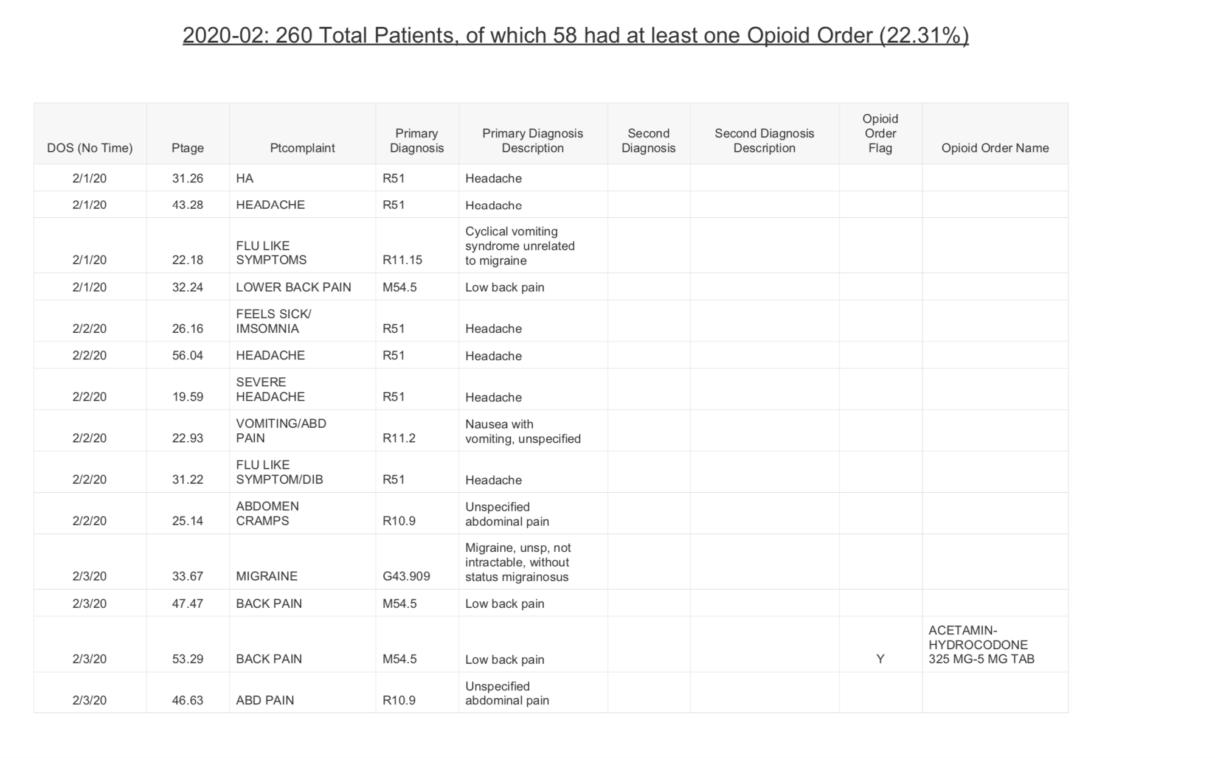
Figure 4
After an educational intervention was presented to the ED providers at DRH on February 19^{h} 2021 another data extraction was performed one month after the presentation. With the assistance of the IT department at DRH, the data was extracted from Figure 3 during the days of February 20th 2021 until March 20th 2021. The data was evaluated by the principle investigator who analyzed and found that 233 patients were evaluated in the emergency department at DRH from February 20th 2021 until March 20th 2021. Of those 233 patients 78 had at least one opioid administered in the ED which accounts for 33.48%. Refer to Figure 5 as an example page that was provided by the IT department.

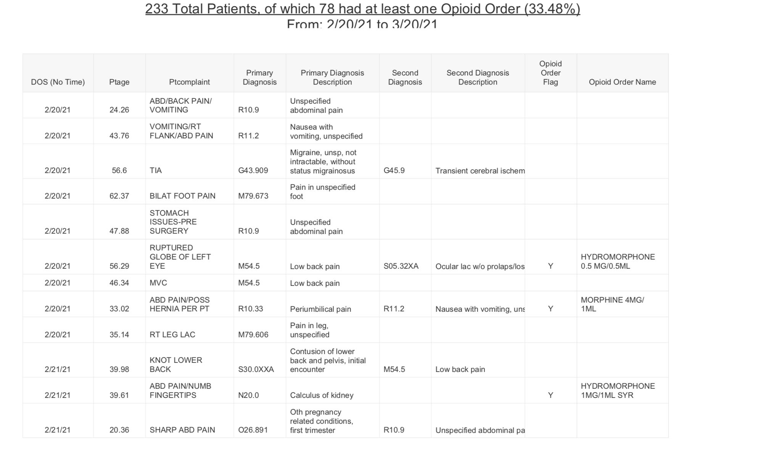
Figure 5
After reviewing the pre assessment audit, providing an educational intervention and reviewing the post assessment audit it was found there was a slight increase of opioids administered in the ED at DRH. This however was most likely due to the fact there were twenty more patients evaluated in the ED from February 20th 2021 through March 20th 2021 compared to the month of February 2020. Lastly, the Colorado ALTO was not formally implemented at DRH. Many steps still need to be conducted over several months in order to execute the implementation phase of the Colorado ALTO project successfully.

Pre and Post Assessment Survey
Before the data was distributed to the group during the staff meeting a pre survey using Survey Monkey was conducted two weeks prior to the educational intervention based on personal prescribing practices from the five chief complaints of the Colorado ALTO project. Refer to Figure 1. DRH emergency department has seventy-eight healthcare providers, specifically seventy-five attending physicians, two physician assistants and one nurse practitioner. Of the seventy- eight healthcare providers that are employed thirty-four health care providers completed the pre survey. Based on the questions asked, Figure 6 shows that most health care providers at DRH prescribe between 0 to 50% opioids for the management of renal colic, headache, musculoskeletal pain, acute and chronic radicular lower back pain, chronic abdominal pain, gastroporesis, and cyclic vomiting.

After the pre survey was conducted an educational intervention was performed during the DRH staff meeting on February 19th 2021. After the educational intervention was conducted a post survey using Survey Monkey was sent out to the staff based on Appendix E, of which fourteen health care providers responded. Figure 7 showed that majority of the health care providers said the educational intervention increased their knowledge on the topics discussed (85.71%).
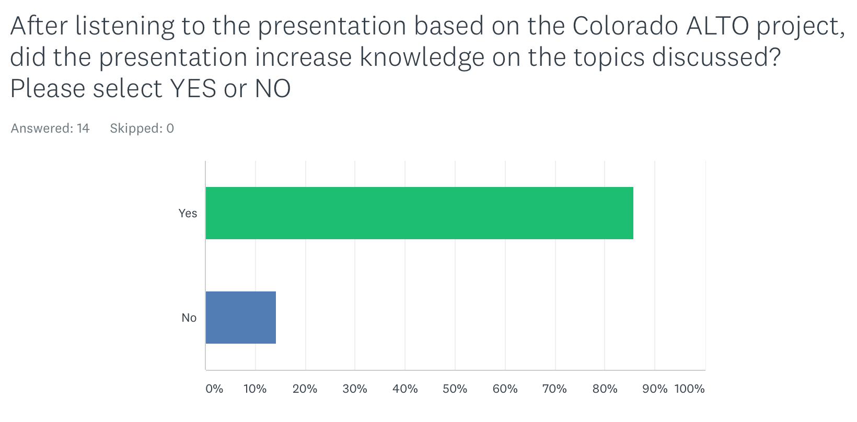
Figure 7

Lastly Figure 8 showed that 100% of respondents were either in favor of “somewhat likely” or “very likely” to implement the Colorado ALTO project into practice. No respondents responded “not likely”.
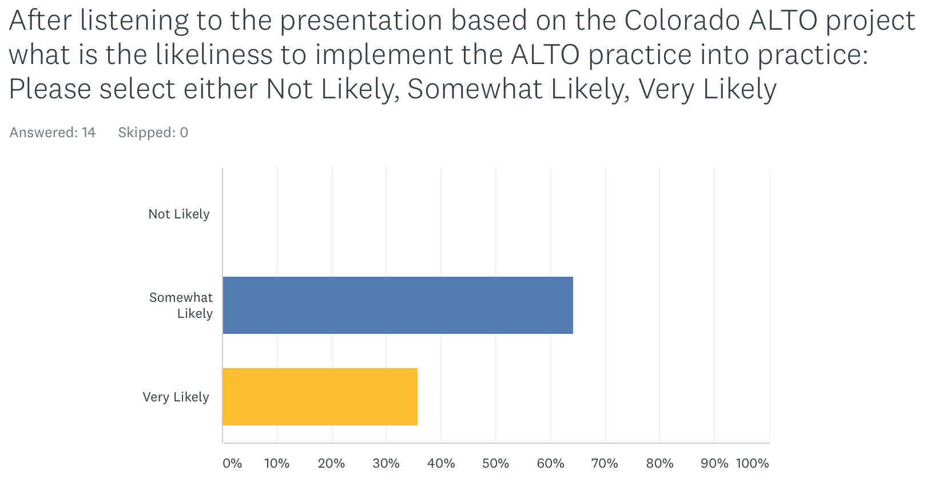
Figure 8
Limitations
When conducting the “Quality Improvement Project In The Emergency Department

Based On The Colorado ALTO Project” many limitations were identified in March of 2020, the COVID-19 pandemic affected many educational institutions causing a delay with research projects due to limited access to health care systems. Unfortunately, due to this many research projects were put on hold to reduce the number of individuals entering in and out of the hospital. For this reason, staff meetings were subjected to Zoom conference calls with no in person interaction. Realistically, this project would have been conducted in person in which the same amount of pre and post surveys would have been completed. Due to the COVID-19 pandemic this could not be obtained.
Other limitations that played a factor with this quality improvement project would include in the beginning of the pandemic many patients were fearful to go to the ED to be seen for common chief complaints (i.e. headaches, abdominal pain, back pain, nausea, vomiting and musculoskeletal pain) because they did not want to be exposed to COVID-19. However, over time when the COVID-19 tolls were decreasing and patients felt more comfortable going to the ED we noticed an increase, which caused longer wait times in the ED. Patients would be waiting up to five plus hours in the lobby to be seen. Many patients were not open to receiving alternative treatment options for the management of acute pain due to the fact they were waiting for long periods of time. This essentially lead to ED health care providers to administer an initial opioid.

Clinical Question Answered
Providing an educational presentation based on the quality improvement Colorado ALTO project, did increase the knowledge for the staff at DRH. The educational tool showed interest from the staff with the intent of implementing the Colorado ALTO project for the management of acute pain in the ED.
Recommendations:
This Quality Improvement project was executed successfully with the assistance of using the Model of Improvement and Plan-Do-Study-Act (PDSA) cycle. The Model of Improvement and PDSA provided a foundation on how to address and improve ED healthcare providers prescribing practices. Many providers do not want to be told what to do, in this particular case told what to prescribe. This particular model allowed providers to receive insight with alternative options that could be used to decrease the amount of opioids prescribed in the ED. It was an educational eye opener that did prove that providers are open to using alternative treatment options for the management of acute pain in the ED.
Some recommendations that can be incorporated into this particular study would include to fully implement the Colorado ALTO project into practice. With the assistance of the Model of Improvement and PDSA the Colorado ALTO project can be implemented and executed efficiently. The Colorado ALTO project is divided into a series of steps: education, training and development, project launch (implementation) and evaluation. The phase that was mainly focused on for this quality improvement DNP project was the education phase. The education phase involved the early phase of planning. Part of the education phase included an introduction to all stakeholders to all aspects of the Colorado ALTO project in preparation for buy-in and full implementation.
Following the education phase, which was this quality improvement project, training and development will be underway which involves scheduling and attending meetings with stakeholders including lead nursing staff, pharmacists, chief residents, physician attendings, and advanced practice providers and identifying their roles in the Colorado ALTO project. Refer to Appendix I for examples. During this phase is also where unanswered questions can be answered along with making sure the staff is provided the necessities and tools that are needed in order for this project to be successful.
Following the training and development phase, the implementation phase will be launched. It is critical during this phase to have everyone on the same page in order to have this be a successful project. Flyers will be posted all throughout the department specifically by the physicians and advanced practicing providers charting stations, in the pharmacy and in the various modules, refer to Appendix F for an example. Doing this will remind the health care providers when they are placing the appropriate orders for their patients on what types of medications to utilize based on the chief complaint. Some barriers that might occur during this phase will include compliance from the health care providers, not willing to make a change or adapting to new policies, patient’s medical history, allergies, laboratories studies etc. Evaluation is an important part of QI and a plan needs to be in effect for evaluation during the planning phases of the PDSA cycles.
In conclusion, this quality improvement project was helpful on my personal prescribing practices in the ED. After performing hours and hours of research and actually implementing most of these treatment options into practice I can honestly say that these alternative treatment options are beneficial. The first step in using these alternative treatment options is educating the patients on the literature and explaining how these medications work effectively. If we take the time and actually sit down with our patients, instead of running in and out of the exam room, they are more open and receptive to trying new things. Moving forward, as mentioned above, the hope is to formally implement the Colorado ALTO project into practice followed by publishing the data that is collected. Formally implementing the Colorado ALTO project will not only educate the seventy- eight ED healthcare providers at DRH but will also educate the other ED health care providers at the various other DMC ED’s including, Huron Valley, Harper Hospital, Sinai Grace and Children’s Hospital of Michigan.

Appendix A: Literature Review
Author | Title | Setting / Population / Sample / Time Period | Intervention | Results | Researcher Interpretation
LaPietra, Alexis, M; Motov, Rosenberg, / Medical Sciences-Orthopedics and Traumatology, Medical Science, Pediatrics, 2016 | Alternative to Opioids for Acute Pain Management In the Emergency Department Journal Article | Specific programs were designed to decrease the use of opioids: i.e Renal Colic, Musculoskeletal pain, Acute and Chronic Radicular LBP, Gastroparesis, Cyclic Vomiting, & Headache | Specific pain receptor sites targeted by specific analgesia for the management of acute pain in the ED. | The combination of non-opioid analgesics acting on different target sites will result in greater analgesia and reduce the doses of each individual medication that may lead to fewer side effects and shorter length of stay. | Broader utilization of a combination of non-opioid analgesics and a more refined use of opioids.
Brooks, D | Innovative program targets five common pain syndromes with non-opioid alternatives. | St. Joseph Regional Medical Center in New Jersey evaluated 300 patients in a six month period | Used alternative therapies such as trigger point injections, ultrasound guided nerve blocks, nitrous oxide, nonsteroidal ant-inflammatory drugs and muscle relaxants | Treated 300 patients successfully with non-opioid alternatives. | The ALTO program is not just about prescribing but how it also focuses on providing psychosocial support and education to patients.
Todd, K. H | A review of current and emerging approaches to pain management in the emergency department | 819 patients that perceived need for and administration of an analgesic in the Emergency Department | A quality review of past and current descriptive studies of emergency department pain practice, as well as clinical trials of emerging pain treatment modalities. | The results of this particular study supports the use of migraine therapies, regional anesthesia, nitrous oxide and sub dissociative-dose ketamine. However, the use of intravenous lidocaine, gabapentinoids and various other non-pharmacological interventions remain sparse | Clinicians who successfully integrate these skills into practice will likely realize higher levels of patient satisfaction, enhanced treatment compliance, and self-management of pain.
Chang, Bijur, Esses, Barnaby, & Baer | Effect of a single dose of oral opioid and non-opioid analgesics on acute extremity pain in the emergency department | Two emergency departments in New York, evaluated 416 patients between the ages of 21 to 64 with moderate to severe acute extremity pain. | The 416 patients were broken down into four groups and each group received a different analgesic combination. Group one in particular did not receive any opioid therapy (ibuprofen and acetaminophen) whereas groups two through four received either acetaminophen with oxycodone, acetaminophen with hydrocodone, or acetaminophen with codeine. | For non-addicted patients presenting to the ED with acute extremity pain, there were no statistically significant or clinically important differences in pain reduction at 2 hours among single-dose treatment with ibuprofen and acetaminophen or with 3 different opioid and acetaminophen combination analgesics” | If non-opioid combination analgesic provides comparable pain relief obtained by oral opioids, health care providers would be more likely to discharge patients and prescribe the same non-opioid combinations analgesics that were received in the emergency department
Hoppe, Kim & Heard | Association of emergency department opioid initiation with recurrent opioid use | Four thousand eight hundred one patients treated in the emergency department for an acute painful condition | Four thousand eight hundred one patients were treated in the emergency department for an acute painful condition. Of those 52% were opioid naive and 48% received an opioid prescription. Among all opioid-naive patients, 775 (31%) received and filled an opioid prescription, and 299 (12%) went on to recurrent use” | This particular study concluded that opioid naïve ED patients prescribed opioids for the management of acute pain puts the patient at risk for additional opioid use at the one-year mark. | Even though emergency health care providers contribute to a small proportion of the total number of opioid prescriptions dispensed in the ED, providers need to be more aware of not only what they are prescribing while the patient is in the ED but also what they are prescribing once the patient is discharged home.

Appendix B
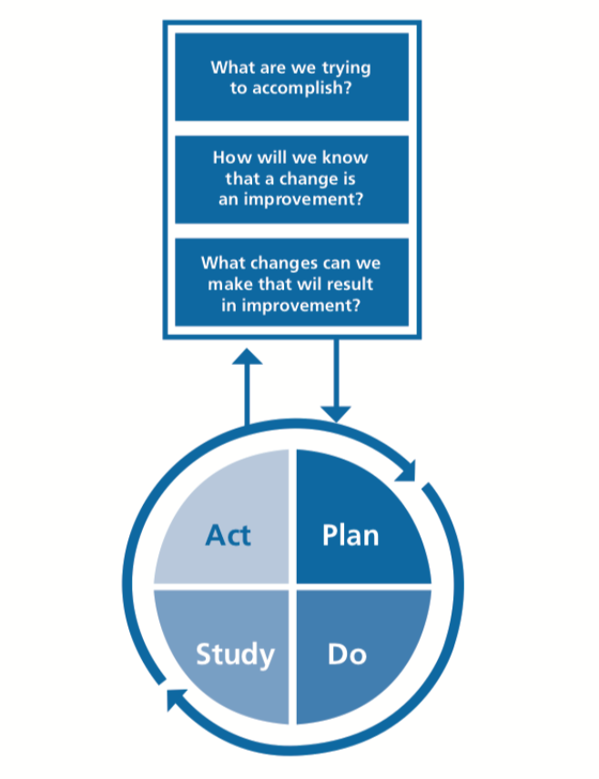

Appendix C

STRENGTHS  - Internal team and expertise (Research committee at DRH’s Emergency Department)  - Resources (personal, UDM, DMC)  - Geographic advantage  - Chronic Pain Policy  - Sickle Cell Policy  - Thirty-minute Analgesic Administration | WEAKNESS  - No “formal” acute pain protocol / policy for the management of acute pain in the Emergency Departments  - Extensive monitoring (moving patients)  - Cost  - Education / preference on prescribing  - Patient’s Medical History  - Legal/liability implications  - Readmission
OPPORTUNITIES  - Partnerships with other hospitals (Detroit Receiving, Harper / Sinai Grace / Children’s / Huron Valley Hospital)  - Need for product in hospitals, particularly ER  - Support from Emergency Attending’s, Residents, Physician Assistants, Nurse Practitioners and Pharmacists.  - Increasing patient satisfaction scores  - Reducing the exposure to opioids  - Safer/more effective patient care  - Funding: Grant/Investment | THREATS  - Health system competitors implementing new protocols  - Not being up to date on the latest research  - Recognition

Appendix D
DATA EXTRACTION FROM THE MONTH OF
February of 2020

Specific ICD 10 codes based on diagnosis and chief complaint: N20.0 (Renal colic), R10.9 (Flank pain), 10.9, Unspecified abdominal pain, K 31.84 (Gastroparesis), R11.15
(Cyclic vomiting), R11.2 (Nausea and vomiting), R51 (Headache), G43.909 (Migraine), M54.5 (Low back pain), M79.1 (Muscle pain), M54.16 (Acute or chronic radicular LBP),
M79.601 / M79. 602 (Arm pain), M79.606 (Leg pain), M25.559 (Hip pain),
M79.64 (Finger pain), M79.64 (Hand pain), M25.539 (Wrist pain), M25.529 (Elbow pain), M25.519 (Shoulder pain), M25.569 (Knee pain), M25.579 (Ankle pain), M79.673 (Foot pain), M79.676 (Toe pain)

Age: 18-65yrs

Opiate medications used based on chief complaint and diagnosis: Codeine, Fentanyl (Actiq, Duragesic, Fentora, Abstral, Onsolis), Hydrocodone & Acetaminophen (Lorcet, Norco, Vicodin), Hydromorphone (Dilaudid), Demerol, Methadone, Morphine, Oxycodone (OxyContin) Oxycodone & Acetaminophen (Percocet), Tramadol

Appendix E
Pre and Post Survey Questions
Pre Presentation

Circle the percentage group that applies to your OPIATE prescribing practices in the ED based on the chief complaints listed below:

Renal Colic: 0-25% / 26%-50% / 51%-75% / 76%-100%

Headache: 0-25% / 26%-50% / 51%-75% / 76%-100%

Musculoskeletal pain: 0-25% / 26%-50% / 51%-75% / 76%-100%

Acute and Chronic Radicular LBP: 0-25% / 26%-50% / 51%-75% / 76%-100%

Chronic abdominal pain gastroparesis, cyclic vomiting: 0-25% / 26%-50% / 51%-75% / 76%-100%

Post Presentation

After listening to the presentation based on the Colorado ALTO project did the presentation increase knowledge on the topics discussed?: Please select YES or NO

Yes or No

After listening to the presentation based on the Colorado ALTO project what is the likeliness to implement the ALTO project into practice: Please circle either NOT LIKELY, SOMEWHAT LIKELY, or VERY LIKELY

Not Likely / Somewhat Likely / Very Likely

Appendix F
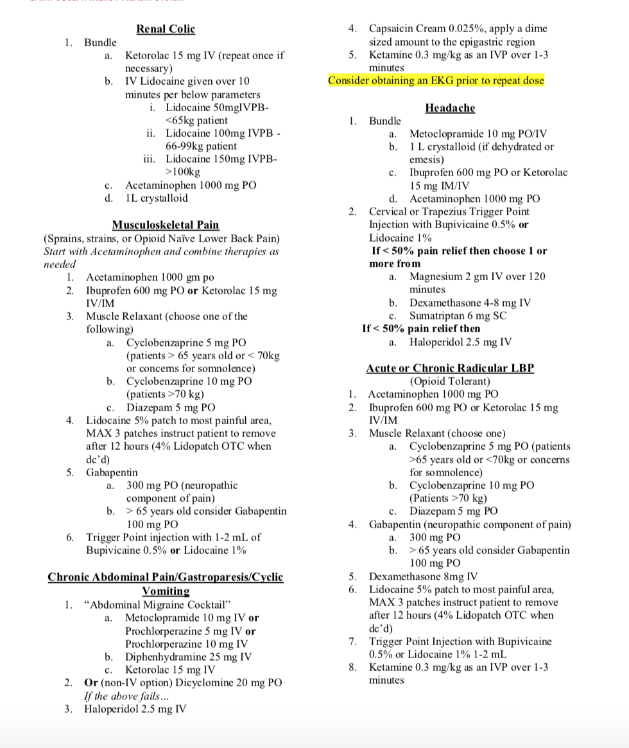

Appendix G
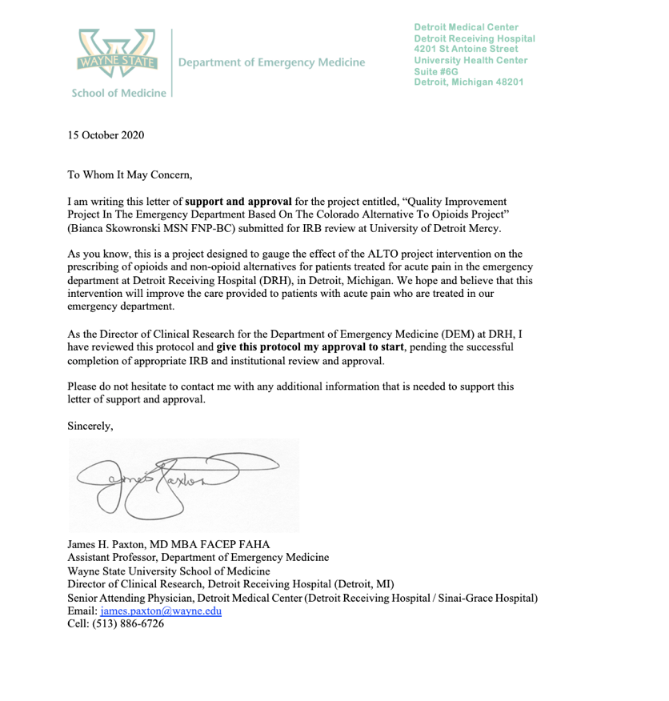
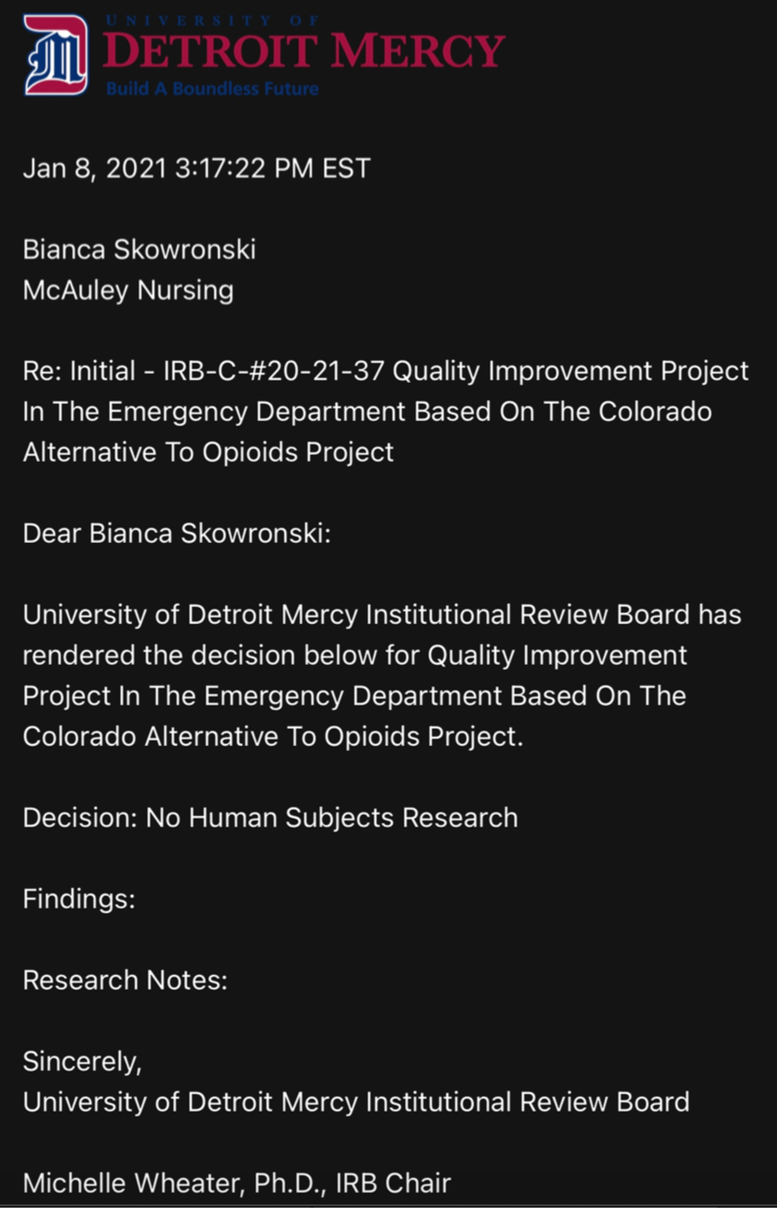
Appendix H

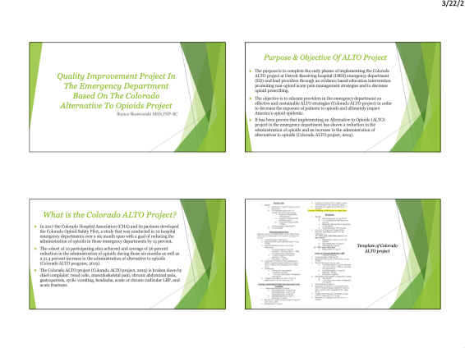

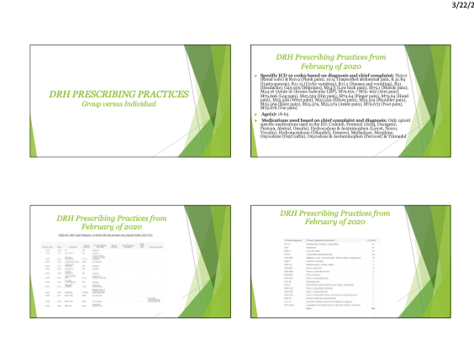

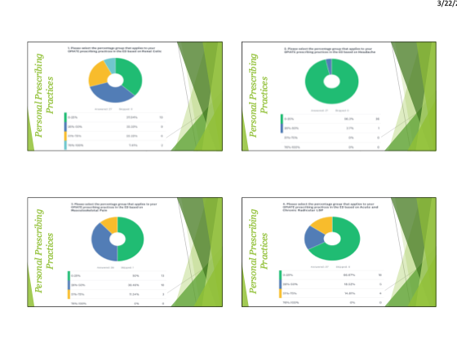

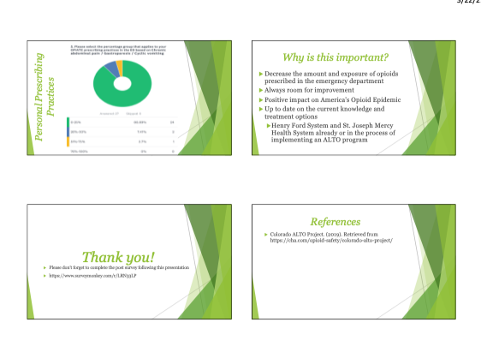

Appendix I
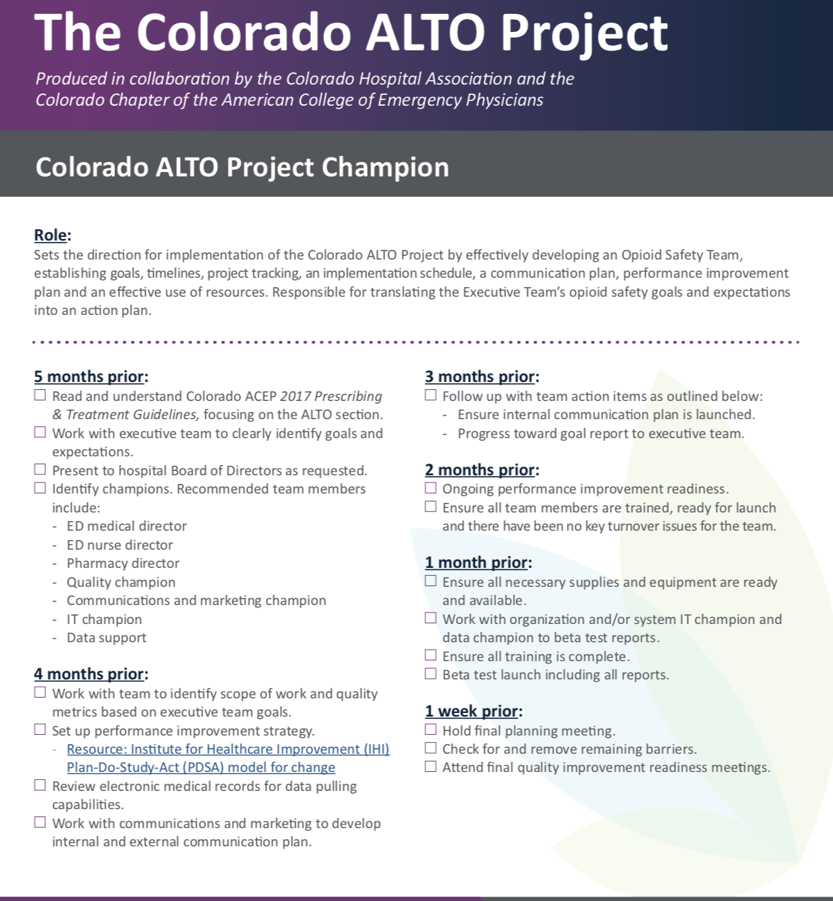
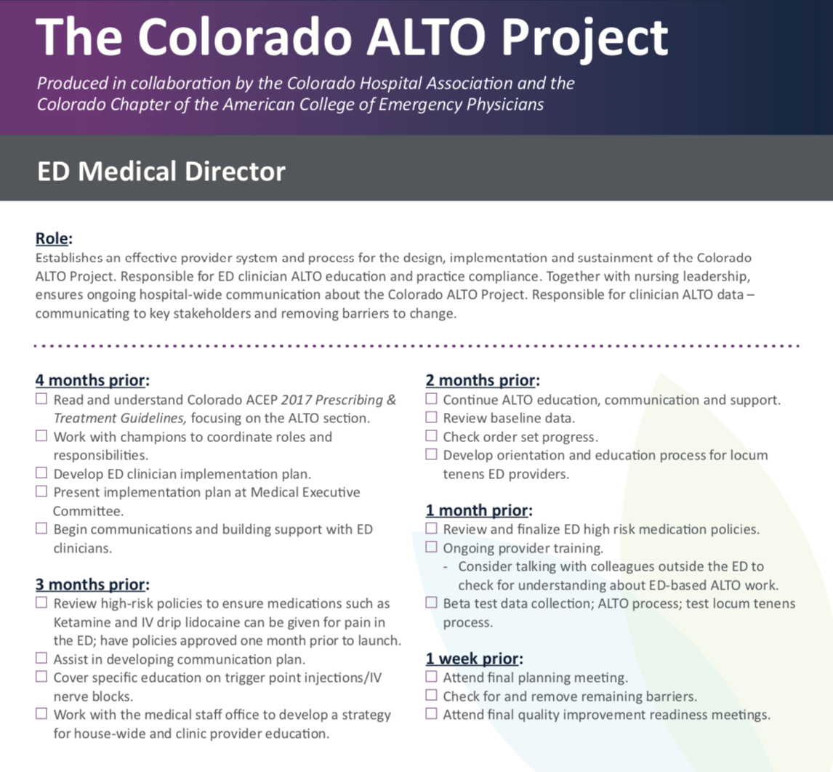
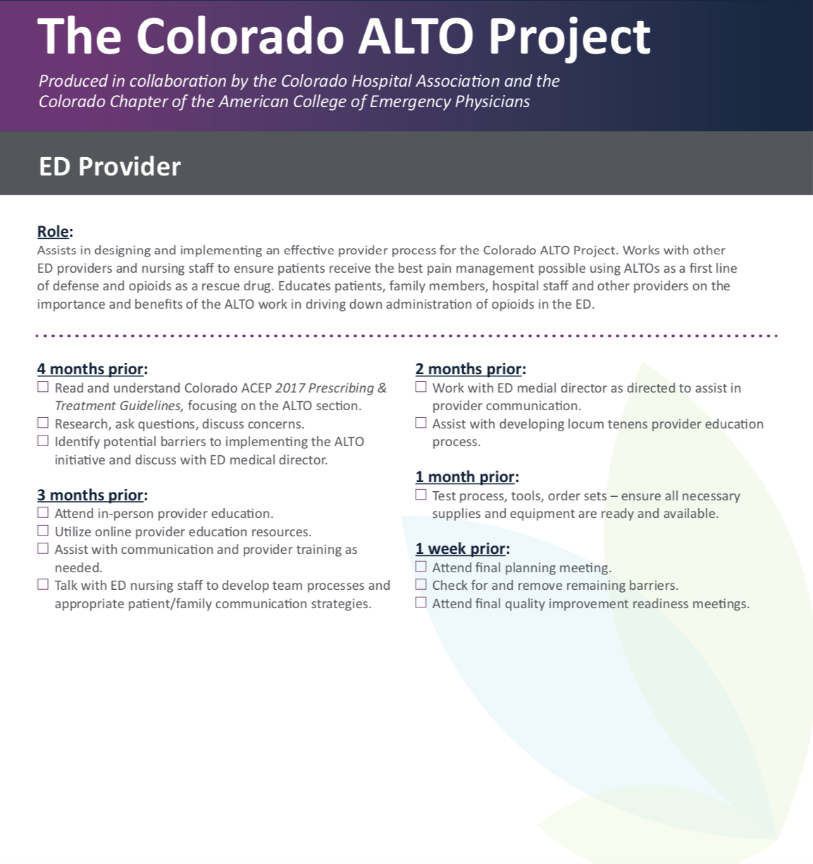

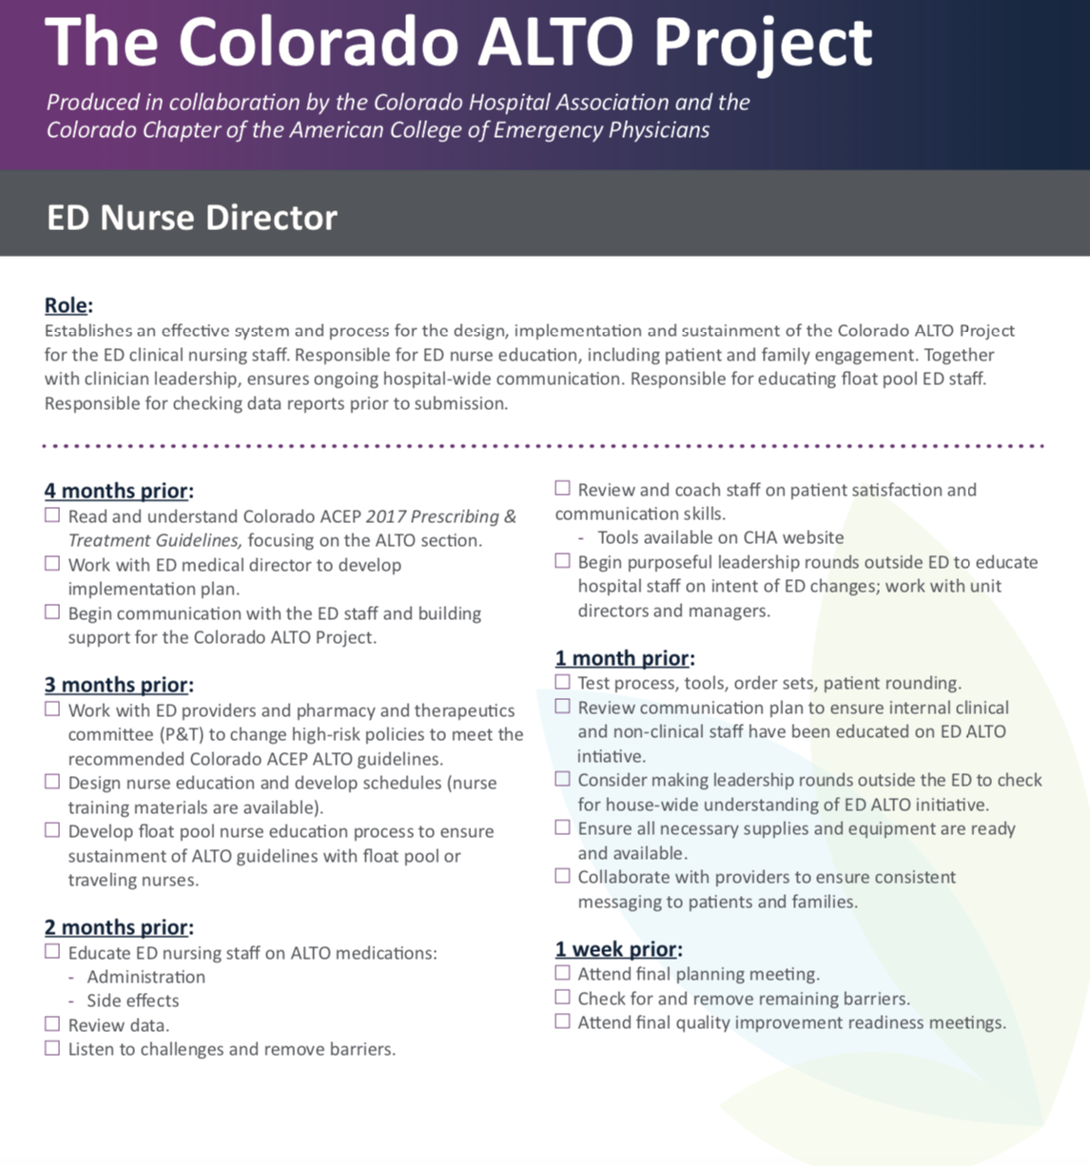

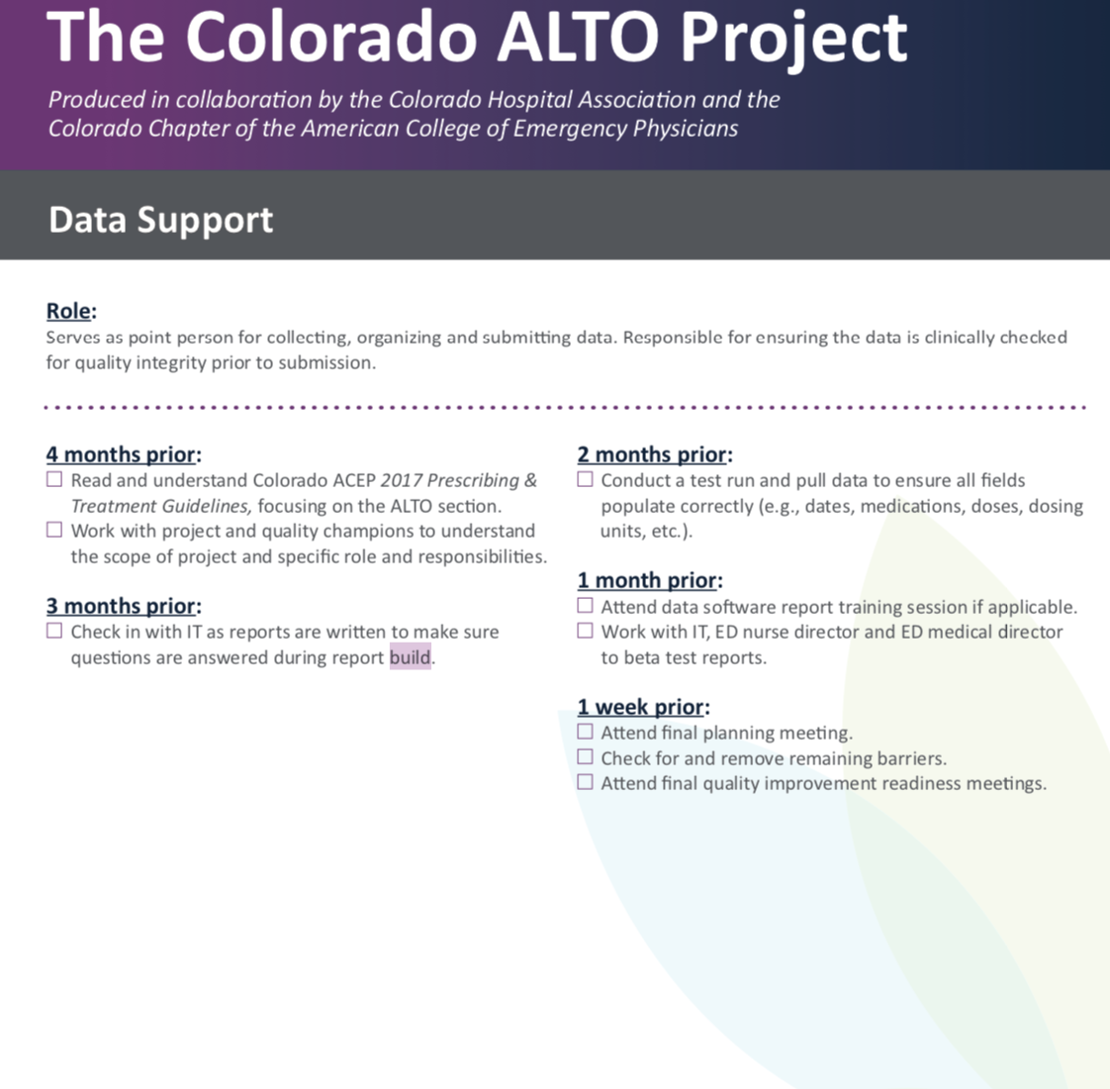

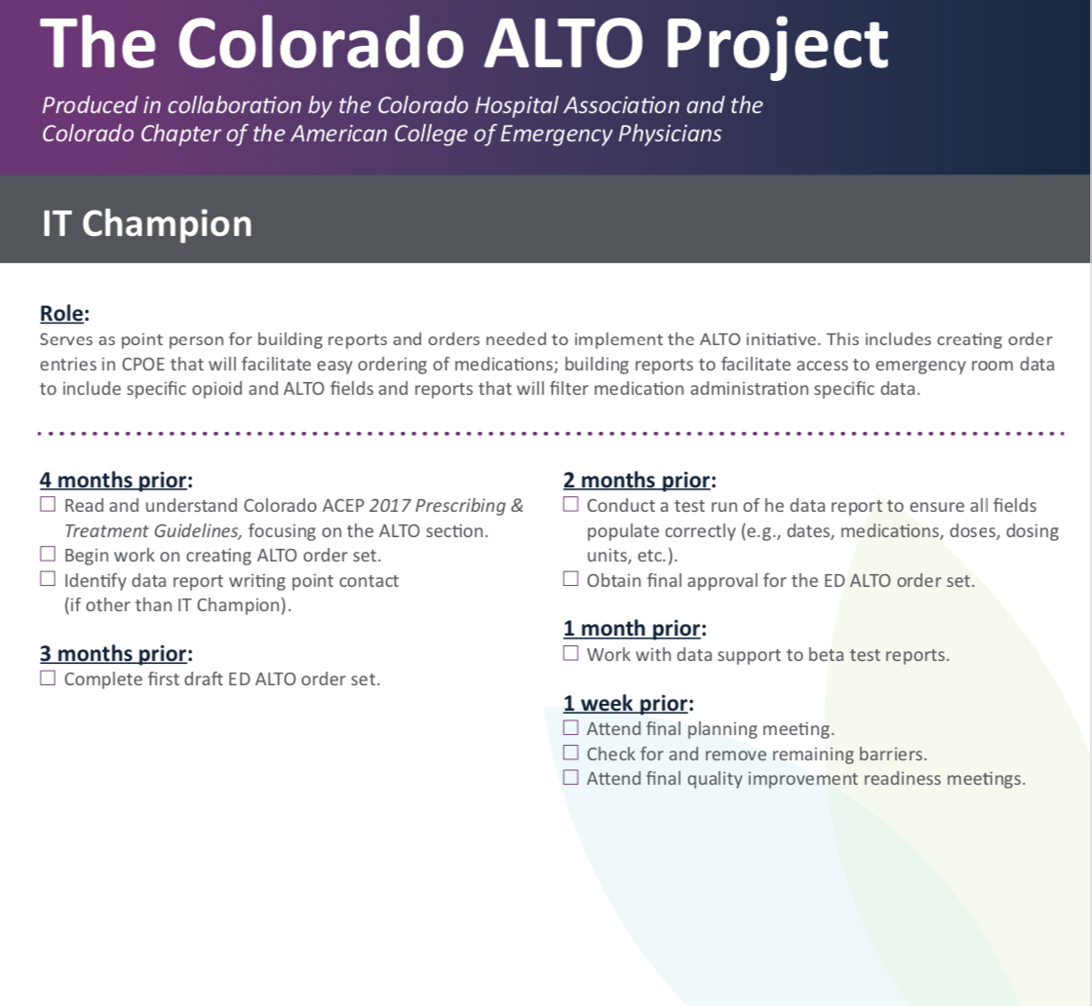

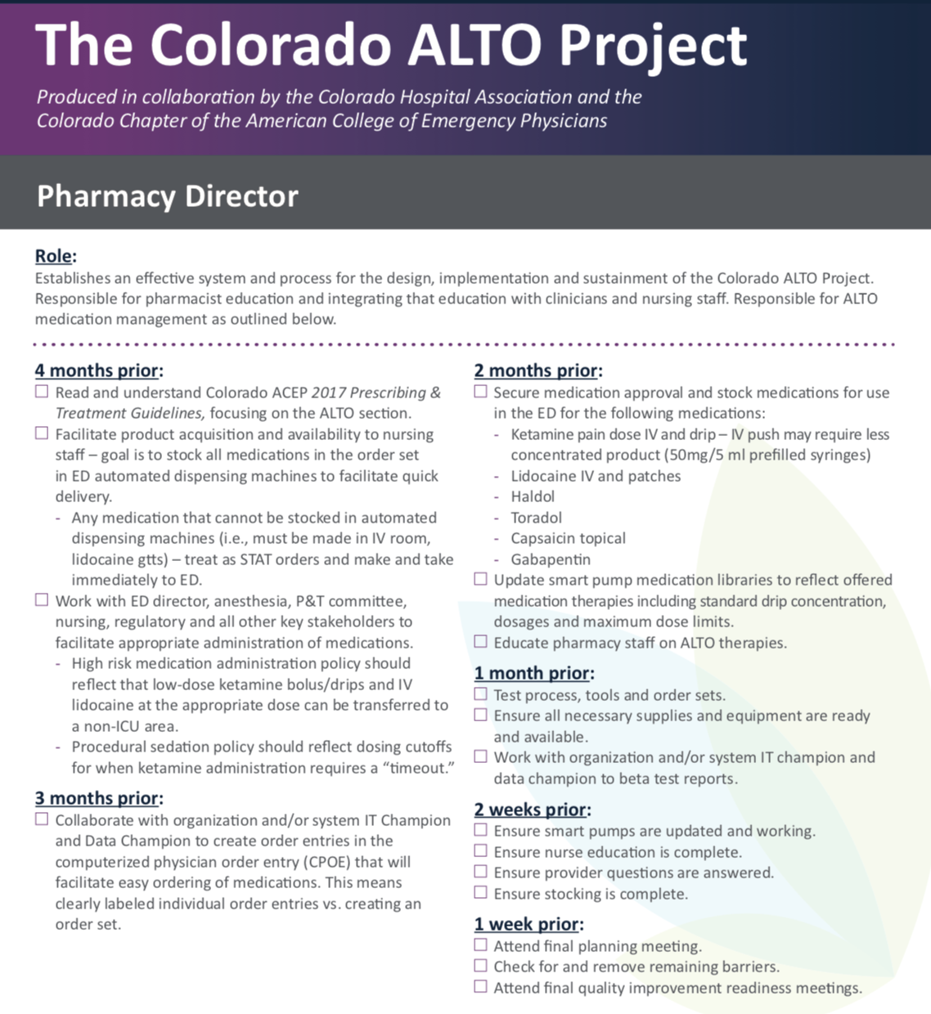

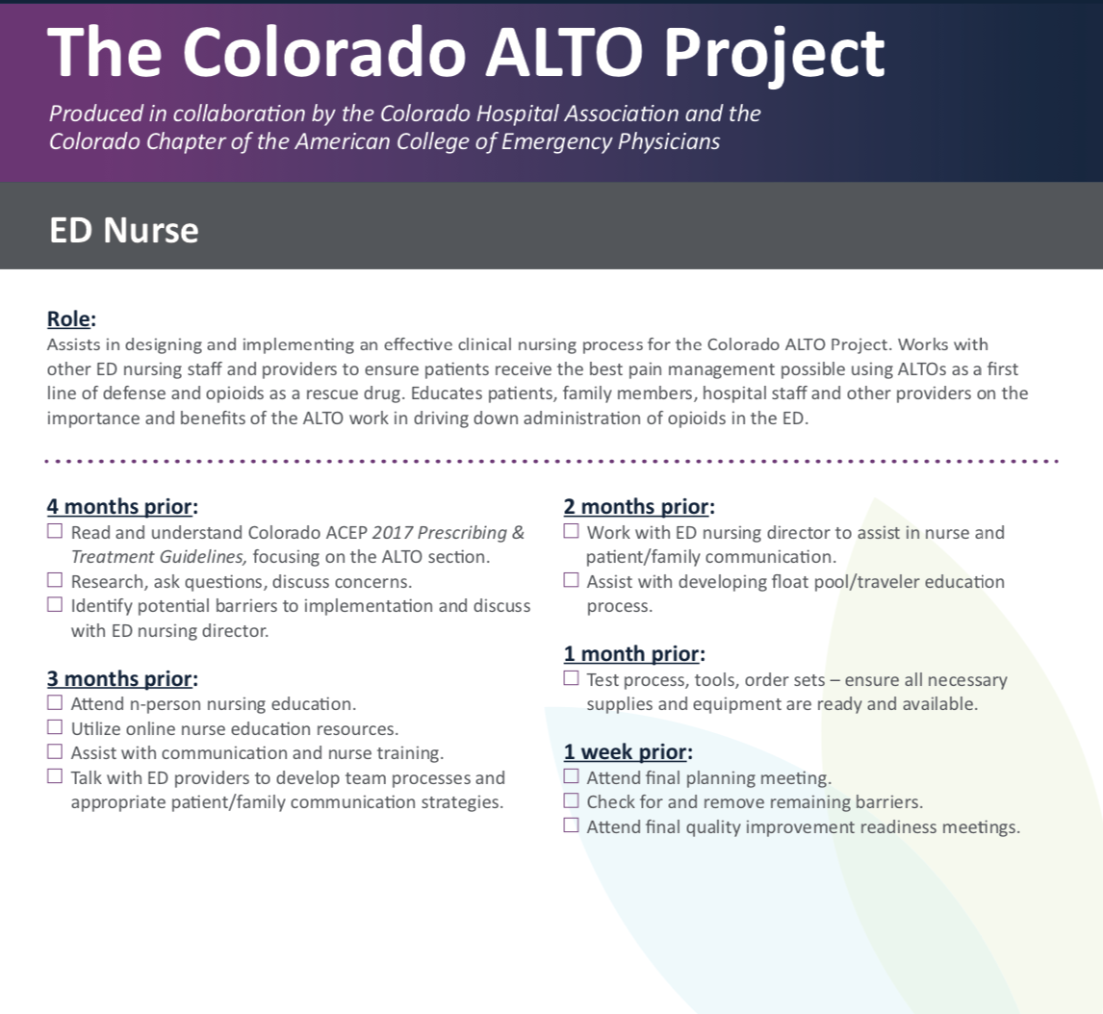

References
Brooks, D. (2016). Innovative program targets five common pain syndromes with non-opioid

alternatives. ED Management , 28(6), 61–72. Retrieved from

http://web.b.ebscohost.com.ezproxy.libraries.udmercy.edu/ehost/pdfviewer/pdfviewer?vi

d=1&sid=0766aa75-e107-41a9-baad-781027675211@pdc-v-sessmgr06

Center for Disease Control and Prevention. (2019): Opioid overdose: Retrieved from

https://www.cdc.gov/drugoverdose/data/index.html

Chang, A. K., Bijur, P. E., Esses, D., Barnaby, D. P., & Baer, J. (2017, November 7). Effect of a

single dose of oral opioid and nonopioid analgesics on acute extremity pain in the

emergency department: A Randomized Clinical Trial. Retrieved from

https://www.ncbi.nlm.nih.gov/pubmed/29114833.

Cleveland Clinic. (2017). Acute pain vs. chronic pain: What it is & differences. Retrieved from

https://my.clevelandclinic.org/health/articles/12051-acute-vs-chronic-pain

Colorado ALTO Project. (2019.). Retrieved from https://cha.com/opioid-safety/colorado-alto-

project/

Gratton, M. (2017). The ER doctor's role in combating the opioid epidemic. Retrieved from

https://www.ncbi.nlm.nih.gov/pmc/articles/PMC6140208/

Hoppe, J. A., Kim, H., & Heard, K. (2015, May). Association of emergency department opioid

initiation with recurrent opioid use. Retrieved from

https://www.ncbi.nlm.nih.gov/pubmed/25534654.

IHI (2021) :Science of improvement: How to improve: Retrieved March 01, 2021, from
http://www.ihi.org/resources/Pages/HowtoImprove/ScienceofImprovementHowtoImprove.
aspx

Karlow, N., Schlaepfer, C. H., Stoll, C. R., Doering, M., Carpenter, C. R., Colditz, G. A., . . .

Schwarz, E. S. (2018, October). A systematic review and meta-analysis of ketamine as

an alternative to opioids for acute pain in the emergency department. Retrieved from

https://www.ncbi.nlm.nih.gov/pubmed/30019434

Kumar, K, and P Elavarasi. “Definition of pain and classification of pain disorders.” Journal of

Advanced Clinical & Research Insights32016.): 87–90.

http://jcri.net/eJournals/_ejournals/112_Review Article.pdf.

LaPietra, A., Motov, & Rosenberg. (2016). Alternatives to opioids for acute pain management

in the emergency department: Part I. ProQuest, 37(19). Retrieved from https://search-

proquestcom.ezproxy.libraries.udmercy.edu/docview/1993224917/fulltext/BF8C7B84A7

DD4248PQ/1?accountid=28018

NIH. 2019. The drug overdose epidemic affects all U.S. communities. Retrieved from

https://nimhd.nih.gov/news-events/features/community-health/overdose-epidemic.html

Scalpel, S. (2016). The Joint Commission deserves some blame for the opioid crisis. Retrieved

from https://www.ncbi.nlm.nih.gov/pmc/articles/PMC6139759/

Todd, K. H. (2017, December). A review of current and emerging approaches to pain

management in the emergency department. Retrieved from

https://www.ncbi.nlm.nih.gov/pmc/articles/PMC5693816/.

