OPIOID FREE ANESTHESIA WITH INTRAOPERATIVE INTRAVENOUS LIDOCAINE
AS PART OF A MULTIMODAL ANESTHETIC APPROACH

An Evidence-Based Scholarly Project
Submitted to the University of Detroit Mercy
McAuley School of Nursing
in Partial Fulfillment of the
Requirements for the Degree
Doctor of Nursing Practice

Sheila Williamson, CRNA
University of Detroit Mercy
May 17, 2021

Abstract
Background-In the United States 99% of patients receive opioids as a primary method of pain control both perioperative and postoperatively (Hah, Bateman, Ratliff, Curtin & Sun, 2017). The need for alternative methods to treat patients in pain places increased pressure on CRNAs to explore alternative methods. In 2016, the CDC released guidelines for prescribing opioids for chronic pain; however, the focus on perioperative prescribing has gone without being addressed. Intravenous Lidocaine infusion (IVLI) as part of a multimodal analgesic (MMA) approach has shown favorable results in the reduction of opioid consumption in the postoperative phase of care (Mujukian et al., 2019). IVLI with MMA shows promise because this technique offers an alternative to the current practice that relies heavily on opioids as the primary method for treating patient’s pain intraoperatively.
Design-The DNP project was a quasi-experimental study involving pre and post surveys. This type of design allows for the examination of the relationships between the variables. For this project, the relationship between the independent (educational intervention) and dependent variables (CRNA knowledge and utilization of IVLI) was examined to determine the effectiveness of the educational intervention.
This study was conducted at a large level I trauma hospital located in an urban area. The study participants included CRNAs that provided direct patient care in the hospital’s main operating room.
Purpose-The purpose of the project was to identify barriers to the implementation of IVLI, provide an educational intervention on IVLI infusion to CRNAs, develop and introduce a best practice protocol for the use of IVLI as part of MMA to CRNAs at Henry Ford Hospital Detroit Campus. The aim of the project was to bring evidence into practice with the overall goal of decreasing a patient’s exposure to opioids during the intraoperative phase of care.
Methodology-A mixed methods design where quantitative data analyzed the age range, years of practice and the number of times the IVLI technique was used pre and post intervention. Data was collected from August through October 2020 (pre-intervention survey) and November 2020 through January 2021 (post-intervention survey). Additional qualitative data was analyzed to identify CRNAs attitude, belief, experience, knowledge of the opioid epidemic and willingness to use IVLI as part of a practice change. A meta-analysis synthesized evidence on the use of intraoperative IVLI in patients undergoing abdominal surgery, an additional meta-analysis reviewed barriers to the translation of evidence into practice. An educational intervention was provided via PowerPoint with a handout on IVLI protocol. Assessment of survey responses were compiled, and data was analyzed using Excel version 16.45, and Social Science Calculator, 2021.
Intervention-Educational intervention via PowerPoint on the use of intraoperative intravenous lidocaine infusion accompanied by a practice protocol handout. This lesson was provided online, and a copy of the presentation was sent via email.
Results-Chi square statistic was used for data analysis. More participants expressed a willingness to use IVLI as part of MMA after the educational intervention, five (22.7%) did not use this technique in their practice prior to the educational intervention, and 19 (76%) responded yes to using the technique after participating in the educational intervention (p-value of .000267). The result for age group and years in practice were not significant at p < .05 pre and post intervention.
Implication for practice-The results will benefit and inform the academic community on the need to limit a patients’ exposure to opioids and opioids negative side effects. In addition to facilitating the translation of evidence into clinical practice.
Acknowledgements
I want to thank my creator; nothing is possible without Him.
I want to thank Aveshah, my amazing husband for his untiring love and support while I completed my DNP project. His encouraging words and presence made the task of countless hours dedicated to school worthwhile. It is of great comfort to know that you were always there for me and had my back. You are truly my rock.
I want to thank my children, David, Matthew (Myele), Jordan and Olivia. You all are truly my biggest supporters. I especially want to thank my grandchildren, Marley, Jordan Jr., Mila, Mina and Maya, for being such great kids in my absence while I pursued my terminal degree.
Dr. Michael P. Dosch PhD, CRNA (Committee Chair). The journey of the DNP program is rigorous. I could not imagine doing it without Dr Dosch. Dr. Dosch has been a mentor and inspiration to me since my graduate anesthesia program. His dedication to the practice of anesthesia has served as a template for excellence. Thank you for taking a chance on me over 10 years ago when my journey at The University of Detroit Mercy began.
To my mentor and friend, Dr. Stephanie White-Evans DNP, CRNA (Committee Member) thank you for your friendship, supportive guidance and encouragement throughout this process. I felt like you were on this journey with me.
Dr. Gary Loyd M.D., (Site Mentor) for your wisdom and guidance in navigating the hurdles of promoting evidence-based practice in an academic setting. Thank you to Claude Johnson CRNA, anesthesia department manager and my anesthesia colleagues who took a chance at practice change and participated in my evidence-based project. Your support and encouragement are greatly appreciated.
Last but certainly not least, the Detroit Mercy University’s staff, especially Dr. Rosanne Burson (Program Advisor), Dr. Lori Glenn, and Dr. Karen Mihelich, Dr. Patricia Rouen, your guidance and support helped me to this final destination. By far, The University of Detroit Mercy has been the best academic institution I’ve attended. They make me want to be better and work harder. Thank you.

Table of Contents

Part Page
1
Introduction 6
Background 7
Significance of the Problem 9
Practice Problem Statement 11
Clinical Question 12

Review of Literature 12
Search Strategies 13
Synthesis of Research 13
Quality of Research 14
Available Knowledge
Themes Identified 15
Evidence to support project 15
Major Variables Identified 16
Barriers to implementation of EBP 17
Themes Identified 17
2
Purpose Statement 19
Project Objectives 19
Purpose Aim 19
Theoretical Framework

Organizational Assessment 20
SWOT Analysis 21
Cost Factors 21

Design/Methods 24

Evidenced Based Practice 25
Quasi Experimental 25

Review of Literature 28
Pre/Post Intervention Surveys
Sample Size, Population, and Size 28
Educational Intervention with Practice Protocol 29

Implementation Plan 29
Step 1 30
Step 2 30
Step 3 30

Ethical Considerations 31
Protecting human subjects 31

Results 31

Data Analysis 31
Pie Charts 32
Chi Square Analysis 32

Discussion 34
Interpretations 34
Implications for Clinical Practice 37
Sustainability Measures 38
Dissemination 39
Strengths and Limitations
Conclusion 40

Application of DNP Essentials 41
Scientific Underpinnings of Practice 41
Organizational and Systems Leadership 41
Clinical Scholarship 41
Information Systems and Technology 41
Health Care Policy and Advocacy 41
Interprofessional Collaboration 42
Clinical Prevention and Population Health 42
Advanced Practice Nursing 42

References 43

Appendix A 54
Appendix B 56
Appendix C 57
Appendix D 58
Appendix E 59
Appendix F 62
Appendix G 64
Appendix H 68
Appendix I 69
Appendix J 72
Appendix K 73
Appendix L 74

List of Abbreviations
ABBREVIATIONS
ASA- American Society of Anesthesiology
CDC- Centers for Disease and Control
COVID-19- Corona Virus Disease
CRNA- Certified Registered Nurse Anesthetist
DNP – Doctor of Nursing Practice
EBP- Evidence Based Practice
HFHS- Henry Ford Health System
IRB- Institutional Review Board
ITK- Integrated Knowledge Translation
IVLI- Intravenous Lidocaine Infusion
JCAHO-Joint Commission for Accreditation of Healthcare Organizations
MMA- Multimodal Analgesic
NMDA- N-methyl-D-aspartate
NSAID- Nonsteroidal Anti-Inflammatory
OFA-Opioid Free Anesthesia
PCP- Primary Care Provider
PICO – Population, Intervention, Comparison, and Outcome
PONV- Postoperative Nausea and Vomiting
RCT- Randomized Controlled Trial
SWOT- Strengths, Weakness, Opportunity, and Threat

Introduction
Since 1999 the use of opioids and deaths associated with opioid use have risen. According to Koepke et al. (2018) overdose related to opioid use has surpassed motor vehicle accidents. Patient’s first exposure to opioids may be during the perioperative period (Koepke et al., 2018). In response to the opioid epidemic in this country, Certified Registered Nurse Anesthetists (CRNA) along with healthcare organizations will need to be leaders in limiting patient’s exposure to opioids during the preoperative, perioperative, and postoperative phases of care. Opioid use and the risks associated with it, spark major concerns for patients in the postoperative phase of care because of increased incidence of pain, postoperative nausea, and vomiting (PONV) as well as the increased risk for ileus (Ahn et al., 2015). These opioid adverse effects have created an increased interest in the use of non-opioid alternatives to treating a patient’s pain during the perioperative period.
According to Thota et al. (2019) a call to action has been voiced recently by the several governing agencies, i.e. The American Association of Nurse Anesthetist, The American Society of Anesthesiologists, The Surgeon General, and The Substance Abuse and Mental Health Services Administration to end the opioid epidemic, by reducing a patient's exposure to opioids in the surgical setting. It will require a massive effort to move away from the current practice that relies heavily on opioids to treat patients in acute pain. One strategy suggested is to adopt loco-regional techniques and non-opioid based multimodal pain management, where opioid use is completely eliminated (Thota et al., 2019). This new and emerging technique called opioid free anesthesia (OFA) was introduced in 2012, it included a combination of drugs, multimodal anesthesia (MMA) with different mechanisms of action to achieve general anesthesia without the use of opioids. Each medication is used in conjunction with one another to attenuate the pain associated with surgical stimuli on a specific portion of the pain pathway. The use of these medications reduced opioid requirements by 20-50% in the postoperative phase of care (Thota et al., 2019).
Background
Grundy et al. (2021) stated that through the 1990s and 2000s, opioid manufacturers aggressively promoted and heavily marketed opioid medications, particularly for chronic, non-cancer pain, despite the scarcity of evidence on their safety and efficacy for long-term use. Van-Zee (2009) reported that in 1996 Purdue Pharma introduced a sustained-release oxycodone preparation (OxyContin) in the United States. The sale of oxycontin reached nearly $3 billion (over 14 million prescriptions) by 2002. The high availability of OxyContin correlated with increased abuse, diversion, and addiction, and by 2004 OxyContin had become a leading drug of abuse in the United States. Van-Zee (2009) continued to explain that the focus of Purdue's marketing plan was to target the least discriminant prescribers (Grundy et al., 2021). OxyContin's manufacturers aggressively marketed towards these high-prescribing physicians and released information that the medication was best suited for the treatment for non-cancer-related pain due to its low-risk for iatrogenic addiction (Van Zee, 2009). As a result of the Patient Protection and Affordable Care Act in 2010, the Department of Health and Human Services (HHS) enlisted the Institute of Medicine (IOM) to declare pain as a public health problem. Acting through the National Institutes of Health (NIH), HHS asked the IOM to assess the state of the science regarding pain research, care, and education and to make recommendations to advance the field ("Relieving Pain in America: A Blueprint for Transforming Prevention, Care, Education, and Research", 2016).
In 2010, the CDC declared the opioid crisis an epidemic and released guidelines for prescribing opioids for chronic pain; however, the focus on perioperative prescribing has gone without being addressed. Koepke et al. (2018) stated that opioids are used more frequently than needed due to the increasing use of quality metrics that use pain control as a measure of quality and patient satisfaction. A study by Chia et al. (1999) stated that although side effects of opioids are significant, patients that received opioids as a primary mode of pain control required an increased number of opioids postoperatively. The requirement for increased postoperative opioids is a result of acute tolerance to the effects of opioids. The loss of efficacy may be a result of opioid hyperalgesia. Opioid hyperalgesia is defined as a state of nociceptive sensitization caused by exposure to opioids (Chu et al., 2008).
Acute tolerance and hyperalgesia have been identified as two phenomena related to increased dosing of opioids over time. In other words, the more opioids given intraoperatively the more are required postoperatively (Koepke et al., 2018). Hyperalgesia results in more patients being discharged on prescription pain medications such as opioids. Hyperalgesia was not believed to be problematic because the school of thought was that the development of addiction was rare in medical patients with no prior history of addiction (Koepke et al., 2018). However, recent studies suggest there is a direct link between naïve opioid patients ultimately becoming chronic opioid users (Brummett et al., 2017). Multifaceted factors contributing to the issue include the prescribing patterns of primary care providers (PCPs), requirements from the Joint Commission for Accreditation of Healthcare Organizations (JCAHO) to treat pain. The American Pain Society’s declaration that pain should be assessed vigorously and treated as the fifth vital sign, the encouragement from other federal agencies and pharmaceutical companies that encouraged the use of narcotics to treat chronic pain are also listed as contributing factors that lead to opioid addiction (Alam & Juurlink 2016).
Significance
In the United States 99% of patients receive opioids as a primary method of pain control both perioperative and postoperatively (Hah, Bateman, Ratliff, Curtin & Sun, 2017). Unfortunately, for over half of postsurgical patients their pain is only adequately relieved, and of these patients, 88% of them report their pain to be moderate to severe (Mackey, 2014). The management of acute postoperative pain remains a significant challenge for CRNAs, physicians, and all those involved with patient care (Gan et al., 2018). In the study by Gan et al. (2018), 95.8 % of physicians reported prescribing opioids as the main drug of choice for treating patients in pain after having surgery without regard to the risk for addiction. Han et al. (2017) stated that 60% of people receiving 90 days of continuous opioid therapy remain on opioids years later. Approximately 80 percent of people who use heroin first misused prescription opioids (CDC WONDER, 2021).
In 2019, nearly 50,000 people in the United States died from opioid-involved overdoses (CDC WONDER, 2021). The approximate total of 63,632 deaths reflected a rate of 19.8 per 100,000 persons. Although deaths might have involved more than one drug, prescription and/or illicit opioids were involved in 66.4% (42,249) of these drug overdose fatalities (Florence et al., 2016).
According to CDC WONDER (2021) in 2018 Michigan’s drug overdose rate averaged 78%, a total of 2011 deaths (a rate of 20.8). At least one opioid was involved. Among opioid-involved deaths, 633 (a rate of 6.5) involved heroin and 556 (a rate of 5.6) involved prescription opioids. Fatalities involving synthetic opioids other than methadone (mainly fentanyl and fentanyl analogs) continued to rise to 1,531 (a rate of 16.0).
Opioid overdose is a serious public health problem with a tremendous burden on healthcare, addiction treatment, and the criminal justice system. The Centers for Disease Control and Prevention estimates the total “economic burden” of prescription opioid misuse alone in the United States is $78.5 billion a year (Florence et al., 2016).
Lidocaine in the form of a bolus and infusion offers an alternative to the use of opioids for pain control when included as part of a multimodal approach to anesthesia (Ahn et al., 2015; Bakan et al., 2015; Boysen et al., 2018; Tikuisis et al., 2014; Tauzin-Fin et al., 2014; Yon et al., 2014; Zhou et al., 2017). Lidocaine is a sodium channel blocking amide type of local anesthetic that was first discovered in 1943, and introduced in 1949. Lidocaine had documented benefits of analgesia, anti-hyperalgesia, anti-inflammatory properties, fast recovery, reduction of hospital stay, and reduction in time for bowel recovery (Mujukian et al., 2019). Lidocaine analgesic effects can extend for months following surgery, possibly due to sustained concentrations of lidocaine in the cerebrospinal fluid (Tsai et al. 1998). Studies suggest a reduction in central sensitivity and hyperalgesic pathways, inhibition of N-methyl-D-aspartate (NMDA) receptors, and a decrease in inflammatory biomarkers as contributing mechanisms (Hollmann & Durieux 2000). The mechanism of action, like other local anesthetics, binds to the intracellular portion of the sodium channels and blocks sodium influx into nerve cells, which prevents depolarization. Lidocaine binds to alpha 1 acid glycoprotein and is metabolized by the liver. Onset and the duration of lidocaine is 1 minute with elimination half-life being 1.5-2 hours.
MMA consists of hypnotics (midazolam), N-Methyl-D-Aspartate (NMDA) antagonists (ketamine), local anesthetics (xylocaine), anti-inflammatory drugs (dexamethasone), nonsteroidal anti-inflammatory (NSAID) (ketorolac), and intravenous acetaminophen and alpha 2 agonists (dexmedetomidine). Each medication is used in conjunction with one another to attenuate the pain associated with surgical stimuli on a specific portion of the pain pathway.
The importance in using IVLI as part of an MMA is with the control of nociception response and pain. Two types of nociceptive pain exist; somatic (localized, present in the skin, tissue, muscles, or bones) and visceral (diffuse, originating from deep inside the body). Nociception is the propagation through the sensory system of potentially noxious and harmful stimuli, whereas pain is the conscious perception of nociceptive information (Brown et al., 2018). The greatest benefit of perioperative lidocaine infusion was seen in patients undergoing laparoscopic and open abdominal surgery (Weibel et al., 2018). Additional benefits of intravenous lidocaine are that it is inexpensive, easy to inject, and relatively safe to use (Ahn et al., 2015). All of these benefits resulted in fewer harmful outcomes and improved the post-surgical experience for patients.
Problem
Patients undergoing major intra-abdominal surgeries, such as colon resection, face the
challenge of postoperative pain control, return of bowel function, postoperative ileus, and PONV (Weibel et al.,2018). As an adjunct to MMA, IVLI in colectomy patients has been shown to decrease postoperative pain, opioid consumption, postoperative ileus, decreased incidence of PONV, and length of hospital stay (Dunn and Durieux, 2017). Brown, Pavone, & Naranjo (2018) stated that while opioids are the most effective antinociceptive agents, they have undesirable side effects, including respiratory depression, nausea, vomiting, urinary retention, constipation, ileus, and pruritus and are highly addictive. Over reliance on opioids has certainly contributed to the opioid epidemic in the United States (Brown et al., 2018). This over reliance on opioids has created a need for practicing CRNAs’ to research and utilize alternative anesthesia techniques to minimize a patient's exposure to opioids preoperatively, perioperatively, and postoperatively.
There is decreased awareness among CRNA’s regarding the use of OFA with intraoperative IVLI as part of MMA. The evidence points toward the benefits of IVLI as part of MMA, yet there is a slow uptake of IVLI as part of MMA into practice by CRNAs’ (Mohsen et al., 2016). According to Mohsen et al., (2016) a concerted effort is necessary to reeducate nurse anesthetists and the entire perioperative staff to move away from opioids as a first line treatment of acute and chronic pain in surgical patients.
Clinical Question
The project addressed the following clinical question: For CRNAs that deliver anesthesia in the operating room specifically in patients having major intraabdominal surgery, will an educational presentation based on EBP increase anesthesia provider knowledge,
and use of OFA with IVLI as part of MMA?
Literature Review and Synthesis
A literature review presented as a matrix (Appendix A) was conducted to show the relevance and benefits of OFA with IVLI as part of an MMA to treat patients in pain during preoperative, perioperative, and postoperative phases of care.
The OFA with IVLI as part of MMA technique was aimed at decreasing a patient’s exposure to opioids. Adverse effects are associated with opioids (Weibel et al., 2018). An assumption can be made that if exposure to opioids is decreased then a patient’s postoperative experience will be more favorable. The literature search was completed utilizing Google Scholar, Science Direct, PubMed, and Cochrane electronic databases through the University of Detroit Mercy Library. Search dates were from 2013-2019, articles written in English from any country, and other filters included full-text and free journal articles of any design. The search terms used were anesthesia, Certified Registered Nurse Anesthetist, perioperative lidocaine infusion, opioid, opioid free anesthesia, opioid epidemic, multimodal anesthesia, postoperative pain, the return of bowel function, surgery, adult patients, barriers, strategies to overcome barriers, implementation, evidenced based practice, clinical guidelines, change, behavior, translation of science, and practice. According to Ljungqvist, Scott, & Fearon (2016) the several undesirable side effects of opioids and recent opioid epidemic have catalyzed efforts to develop new balanced anesthesia paradigms, which reduce or eliminate opioid use. The American Association of Nurse Anesthetists share in the concern of increased drug use and deaths associated with this epidemic (A Holistic Approach to Pain Management: Integrated American Association of Nurse Anesthetists 2016). The future requires change. CRNAs play a key role in the shift toward helping to prevent the reliance on opioids by utilizing a patient-centered multimodal approach for the treatment of pain during the preoperative, perioperative, and postoperative phases of care (Schoneboom et al., 2016).
The review of the literature indicates that the use of opioids results in several adverse effects including nausea vomiting, constipation, and overall unsatisfactory postoperative recovery (Weibel et al., 2018). According to Weibel et al. (2018) in clinical practice the management of postoperative pain continues to be less than acceptable in a number of cases. There are several concepts noted as a review of relevant evidence. In all studies, pain was the primary outcome measured. Secondary outcomes measured were bowel function, and PONV.
The search resulted in 12 articles that met the criteria. One was excluded because its date fell outside of criteria, and two were excluded that did not contribute to the support of evidence into practice. Five articles were randomized controlled double-blind placebo studies; one was an observational controlled study, one was a case study consisting of two patients, one was a historical prospective quality improvement study, one was a randomized parallel group single center study, and one meta-analysis. In six of the studies patients underwent abdominal surgery, and in one study the patients were having a nephrectomy. All studies used patients with similar demographics, age, weight, health history, and anesthesia risks. The population in all studies were adults of 18 years of age or older, male and female who had an American Society of Anesthesiology (ASA) physical status classification of two which signified a patient with mild systemic disease. Exclusion criteria were similar, including no previous history of opioid use. Because of the design of the studies, the sample sizes were smaller. The sample sizes ranged from 2 to 80 patients. Patients in all studies were divided into two groups. Group one (the control group) received an opioid-based anesthetic to treat intraoperative pain while group two (the experimental group) received OFA with IVLI as part of an MMA.
Quality of Research
A primary investigator reviewed and appraised research for its quality using the Nursing Melnyk Level of Evidence (LOE) Pyramid ( see Figure 1). Melnyk created this scale for nursing research, incorporating a variety of research designs. Research studies are ranked according to the strength of its design (Melnyk 2021). The levels are from I through VII (highest to lowest LOE). The articles were appraised and leveled, with the results listed in the column underneath the type of the study design (see Appendix A). The primary consideration for study inclusion was based on the value of information the study provided for this project. Additionally, methodological rigor and limitations of each individual study was considered.

Figure 1.
Melnyk Levels of Evidence
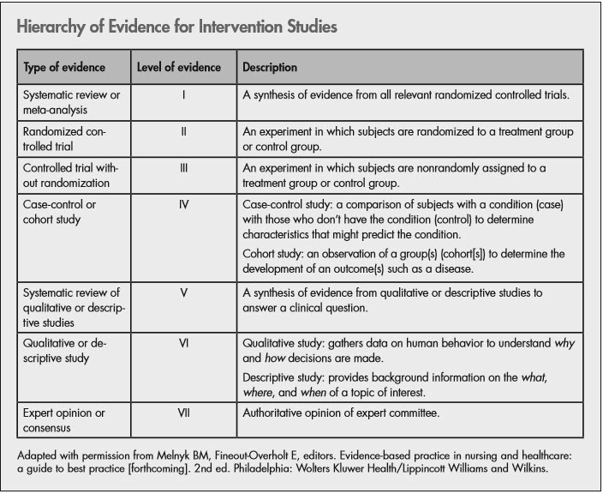
Pain
Ahn et al. (2015) stated that IVLI is an inexpensive, easy to inject, and relatively safe drug. Lidocaine is shown to have analgesic, anti-inflammatory properties as well as fast recovery, reducing hospital stay and the time for bowel function recovery (Grigoras et al., 2012). Many of the studies showed favorable results with IVLI as part of an MMA in the amount of 1.5-2mg/kg/hr. with a bolus amount at induction of anesthesia of 100mg (Ahn et al., 2015; Bakan et al., 2015; Boysen et al., 2018; Tikuisis et al., 2014; Tauzin-Fin et al., 2014; Yon et al., 2014; Zhou et al., 2017). Because of the pharmacokinetics of lidocaine, it should be used with caution in the elderly, as well as in patients with impaired hepatic, renal, and heart failure. A major safety concern was combining IVLI with other liposomal local anesthetics, like bupivacaine used in abdominal surgery and transverse abdominis plane blocks for pain control (Butterworth, 1990). The use of both drugs simultaneously can lead to cardiac toxicity; therefore, lipids should always be on hand to ensure patient safety at all times.
Bowel Function
Opioid consumption, visceral inflammation secondary to surgery, and postoperative sympathetic stimulation are factors associated with the development of postoperative ileus (Kurz, & Sessler 2003). Return of bowel function was measured in three of the nine studies reviewed. IVLI infusion affected the return of bowel function in a favorable way in all three studies considered (Brandal, et al., 2017, Taizin-Fin et al., 2014; Tikuisis et al., 2014). Tikuisis et al. (2014) postulated that this positive effect on return of bowel function was due to the anti-inflammatory effects of lidocaine. The infusion dosage listed in the study for avoiding toxicity was 1.5mg-2mg/kg/hr.
Postoperative Nausea and Vomiting
In five of the studies, a review of IVLI and its impact on PONV was concluded. Ziemann-Gimmel et al. (2014) compared postoperative nausea and vomiting among bariatric surgery patients. Patients were randomized into two groups. The first group received OFA. The second group of patients received volatile –opioid anesthesia. Although IVLI infusion was not used, the decrease in incidence of PONV was significant in the non-opioid technique. This supported the use of an opioid free anesthetic. According to Ahn et al. (2015) PONV contributed to the dissatisfaction of patients undergoing an elective surgery. PONV can contribute to delays in the hospital discharge time and prolong the return to daily life. Several of the studies supported the use of OFA with IVLI as part of an MMA. (Ahn et al., 2015; Bakan et al., 2015; Tauzin-Fin et al., 2014; Tikuisis et al., 2014).
Grol and Wensing (2004) stated that significant gaps exist between current evidence and current clinical practice. Furthermore, the researchers indicated, the time it takes to implement a research finding into clinical practice is more than 17 years. Although research may exist that should be translated into practice, the time it takes to deliver these research-based interventions to patients takes too long. The second part of this review will focus on identifying barriers to clinical use of evidenced based practice (EBP).
Barriers to Implementation of EBP
The second literature review (Appendix B) resulted in 10 articles based on search criteria that utilized Google Scholar, Science Direct, PubMed, and Cochrane electronic databases through the University of Detroit Mercy Library. Search dates were from 2013-2019, and included articles from any country. Search terms included barriers, facilitators, EBP, EBCP, overcoming barriers to clinical practice, knowledge, translation of evidence, nursing, practice protocol, and patient outcome. The number of articles eliminated was five because they were either out of the date range or were irrelevant. Three articles were literature reviews, one was a context analysis; and one was a clinical practice discussion paper. All articles discussed the barriers to change and the need to understand behaviors associated with change. The barriers were associated with individual and organizational beliefs and practices. In order to bridge the gap and overcome barriers an understanding of change theory is necessary.
Lack of Knowledge
New clinical knowledge is being published at a rate at which clinicians are not able to keep up and therefore their knowledge of new development lag. In the era of technology when information is easily available, the dissemination of new information is inconsistent. After the surveys were sent to clinicians, it was concluded that practitioners were less likely to adopt a guideline if they were not comfortable enough with knowledge necessary for implementation (Curtis et al., 2017; Li, Cao & Zhu 2019; Lizarondo et al., 2019). The consensus in three out of five articles resulted in the need for initiatives to be made in the area of education, retraining, and organizational support to overcome this barrier.
Lack of Time
Studies reported that barriers to EBP among those that work in large busy environments with heavy workloads, are less likely to implement research into clinical practice (Curtis et al., 2017; Li, Cao & Zhu 2019). Two articles identified a lack of time as an environmental barrier that contributed to practitioners applying EBP.
Tailored Interventions to Overcome Barriers
In the literature review by Baker et al. (2015) barriers to EBP and clinical practice were identified by observation, focus groups, discussion, surveys, and analysis of organizations. After investigation into factors that explained current professional practice, tailoring interventions to identify barriers can change professional practice. Therefore, policy support from stakeholders, administrators, and leadership regarding staff to patient ratios, supplemental resources, and additional support staff were ways to overcome these barriers. Tailoring interventions will likely improve professional practice more so than no intervention or dissemination of guidelines.
Decision-making is not something that should be based on random acts or thoughts. The transfer of knowledge by way of guidelines should direct decisions by healthcare providers at every turn in clinical practice (Muche-Borowski et al., 2015). These guidelines should be rooted in the process of theory, analysis, experience, and joint responsibility with the aim of quality improvement, as well as improved patient outcomes, and should guide behavior (Muche-Borowski et al., 2015).
Project Purpose
An opportunity exists to improve patient outcomes by decreasing exposure to opioids for pain control in patients having abdominal surgery. The purpose of the project was to identify barriers to the implementation of IVLI, provide an educational intervention on IVLI infusion to CRNAs in order to increase anesthesia provider knowledge, develop and introduce a best practice protocol for the use of IVLI as part of MMA for CRNAs at Henry Ford Hospital Detroit Campus. The overall goal of the project was to bring the best research evidence into practice.
Theoretical Framework
Lewin’s Change Theory (see Figure 2) addresses from a practitioner’s perspective how to change the way CRNAs view the translation of evidence into practice. OFA is an initiative in response to the increased costs of opioid addiction in the healthcare system. Lewin’s Change Theory as a framework for behavioral change is relevant because a gap exists between what is best and what is actually done regarding patient care. Lewin’s Change Theory addresses how to change the way CRNAs view a new way of practicing anesthesia and what can be done to minimize the resistance to change. There were driving forces which were reasons driving the need to change, an unfreezing of current practice which was opioid based anesthesia i.e., status quo. The change or moving phase is when communication, tailored interventions to overcoming barriers, reinforcing education on the topic, and leadership support serve as a catalyst for getting CRNAs’ involved, engaged, and empowered so that they feel a part of the change process. These processes served as a way to overcome the resisting forces. So, if the driving forces and benefits of change are stronger than the resisting forces, the outcome will be positive and change occurs. The opposite will also be true, because if there are no systems in place to overcome the resistance to change then the status quo will remain. The success of this project evidenced by CRNAs adopting the use of OFA with IVLI as part of MMA served as the refreezing stage to change.
Figure 2.
Lewis’s Change Theory
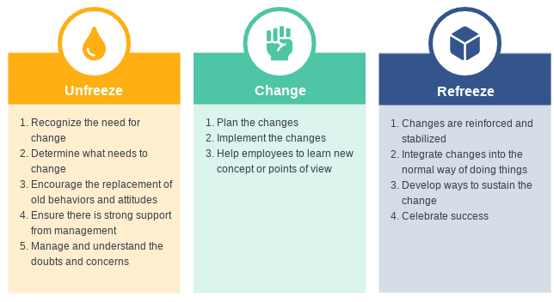

Organizational Assessment
A strength, weakness, opportunity and threat (SWOT) analysis (see Figure 3) was conducted at the Henry Ford Health System, Detroit campus. The hospital’s anesthesia department was the site for this DNP project. The results of the SWOT analysis identified the need for an educational intervention regarding the use of intraoperative IVLI by CRNAs. Henry Ford Health System (HFHS) is an academic level one-trauma hospital consisting of 847 beds. The hospital was chosen because of the variety of surgical cases and patient population. At the time of this project the anesthesia practice model for the majority of CRNAs relied heavily on opioids as the first line drug for treating pain. The University of Iowa Tool 7.1 (see Appendix C) was used to determine the need for a practice procedure change. The tool outlines if an evidenced based practice procedure is needed.
As stated in the Henry Ford Department of Anesthesiology, Pain Management and Perioperative Medicine Strategic Plan, “leadership and collaboration will be the basis for continual quality improvement in the clinical and scholarly activities of the department; thus, ensuring dedication to the vision of our health system”. Because the department lacks a protocol and anesthesia providers are deficient in knowledge regarding IVLI, this project is supported by the CRNA manager (Appendix K) and division head (Appendix L) and is in line with the mission and vision of the department. Both leaders served as members of the team that also included the primary investigator, and committee chair.
Figure 3.
SWOT Analysis Henry Ford Health System, Detroit Main Campus
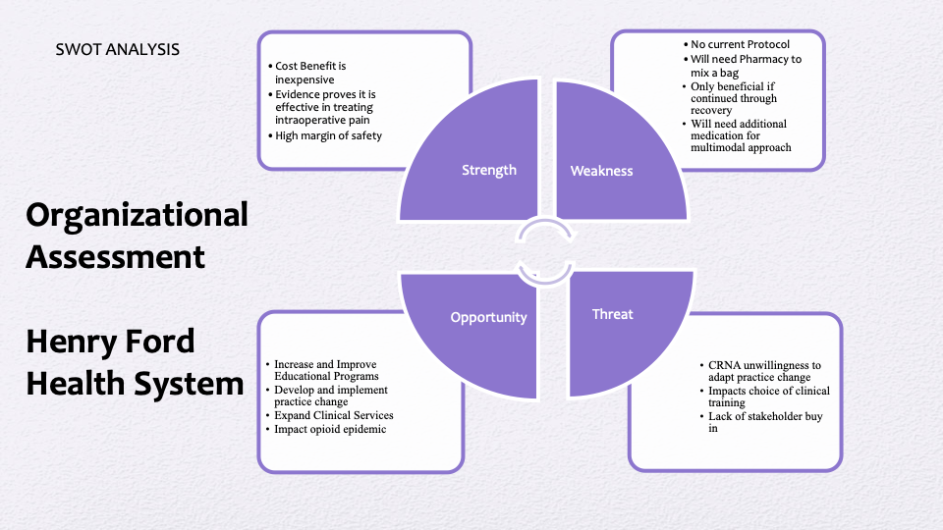
Cost Effectiveness of OFA with IVLI as part of MMA
Implementation of IVLI when compared to the cost of fentanyl, initially seems cost prohibitive. After consulting with a clinical pharmacist within the facility, the cost of 2 grams in 250 ml premixed lidocaine bag is $204.30, and 2% lidocaine in 5 mls ranges from $29.64 to $66.30. The average wholesale cost of lidocaine is illustrated in table 1 with the average cost of Fentanyl is illustrated in table 2. However, when considering the financial burden on healthcare being billions of dollars per year, this disparity in costs seems insignificant.
Table 1.
Price for 2% Lidocaine HCl injectable solution from $53.35 for 500 milliliters
Quantity | Per unit | Price
250 (25 x 10 milliliters) | $0.35 | $87.80
500 (25 x 20 milliliters) | $0.11 – $0.19 | $53.35 – $96.68
1250 (25 x 50 milliliters) | $0.14 | $171.33
Note.
Adopted from
ttps://www.drugs.com/price-guide/fentanyl
Table 2.
Price for fentanyl injectable solution from $21.76 for 20 milliliters

Quantity | Per Unit | Price
10 (10 x 1 milliliters) | $2.81 | $28.06
20 (10 x 2 milliliters) | $1.09 – $1.35 | $21.76 – $26.99
25 (25 x 1 milliliters) | $0.89 | $22.20
50 (10 x 5 milliliters) | $0.52 – $0.82 | $25.88 – $40.95
Note.
Adopted from https://www.drugs.com/price-guide/fentanyl
Dzwończyk, Weaver, Puente, & Bergese (2012) conducted an economic study to determine the financial implications of providing surgical patients with PONV prophylaxis. The goal was to increase patient satisfaction, and minimize postoperative complications, primarily PONV. The researchers investigated the cost of treating patients that returned to the hospital because of PONV. It was concluded that PONV is consistent in contributing to a patient’s undesirable experience in addition to adding a financial burden on hospitals by way of treatment of those patients that return to the hospital. The researchers reviewed 28 patient charts and concluded that the total billable charges for PONV for these returning patients was $83,674; the total reimbursements were $25,816 yielding a 31% reimbursement rate. The total hospital expenses were $24,123 yielding a net hospital profit of $1693. The average hospital cost and charge per antiemetic drug dose was $0.304 and $3.66 (Dzwończyk, Weaver, Puente, and Bergese 2012).
Shafi et al. (2018) determined that opioid related adverse drug events (ORADE) were associated with a 2.9% increase in absolute mortality, an $8225 increase in cost for the index hospitalization, and a 1.6-day increase in length of stay for the index hospitalization. The study concluded that of the 135,379 patient charts reviewed 14,389 (10%) experienced adverse opioid drug events. Opioid-related adverse drug events and their association increased inpatient mortality, discharge to another care facility, length of stay, cost of hospitalization, and 30-day readmission.
(Elvir-Lazo et al. (2020) concluded that PONV and postoperative pain continues to be a challenge for patients, and can delay discharge from the hospital following surgery. What they suggested is that there are multifactorial causes of PONV and postoperative pain that all resulted in increased financial burden of hospitals and patients. The routine opioid use during perioperative phase of care was identified as a primary cause (Elvir-Lazo et al., 2020).
Illustrated in table 3 is a comparison of the daily costs associated with inpatient hospital stay. The table compares the cost between nonprofit and for-profit hospitals in the United States and Michigan. Evidence points to the financial advantages associated with reducing a patient’s exposure to opioids as it is a contributing factor that leads to PONV, delayed discharge, postoperative pain, cost of hospitalization, and 30-day readmission. The cost burden when treating patients that have adverse effects regarding opioids versus the cost burden of OFA is incomparable as it relates to hospital stay and treatment of PONV in the United States and Michigan.
Table 3.
Average Daily Cost of Hospital Stay
Average Daily Cost of Hospital Stay | Non-Profit Hospital | For-Profit Hospital | State/Local Government Hospital
United States | $2,488 | $1,889 | $2,052
Michigan | $2,298 | $2,200 | $1,366
Note.
Adapted from https://www.kff.org/health-costs/state-indicator/expenses-per-inpatient-day/?currentTimeframe=0&sortModel=%7B%22colId%22:%22Location%22,%22sort%22:%22asc%22%7D (Kaiser family foundation, 2019)
Sources
1999 - 2018 AHA Annual Survey, Copyright 2019 by Health Forum, LLC, an affiliate of the
American Hospital Association. Special data request, 2019. Available at http://www.ahaonlinestore.com.
Project Design
This DNP project used a quasi-experimental study involving pre and post surveys. This type of design allows for the examination of the relationships between the variables.
For this project, the relationship between the independent (educational intervention) and
dependent variables (CRNA knowledge and utilization of IVLI) were examined to determine the effectiveness of the educational intervention.
According to Knighton et al. (2019) the Iowa EBP Model (see Figure 4), allows for adherence to evidence-based clinical practice and is linked to better care quality and improved health care outcomes. Knighton (2019) stated that evidence-based clinical practice (EBCP) as illustrated in figure 5, is based on best research evidence (found in health sciences literature) used to guide decision making, clinical expertise (what the health care provider knows), and patient values (what the patient wants and believes) to create a plan of action regarding patient care. Evidence-based practice is an umbrella term that covers evidence-based medicine, evidence-based dentistry, evidence-based public health, evidence-based nursing and is appropriate for this project (Knighton et al. 2019).
Translation and dissemination of evidence is a critical step for implementing practice change (Schaffer et al., 2013). There are five steps to EBP, and are displayed in figure 4 (Lobiondo-Wood & Haber, 2019, pp. 14). There are several issues that can trigger a project. Issues can be problem or knowledge focused concerning patient outcomes, clinical, organizational, national or state level focused; data or new evidence care issues (Buckwalter et al., 2017). These triggers create a process of questioning current practice that creates a culture of inquiry and is the foundation for developing a learning environment in healthcare systems (Cullen et al., 2017). There were several triggers that prompted this project including: The opioid crisis, it is a significant problem facing the nation today; the call to action by healthcare governing bodies and anesthesia providers; research demonstrating a lack knowledge regarding alternative methods for treating patients in pain; OFA with IVLI as part of MMA as an emerging technique new to anesthesia providers; the absence of a practice protocol for use of IVLI for intraoperative pain control, and research suggesting that CRNAs are not utilizing recommended strategies and interventions to reduce a patient’s exposure to opioids during perioperative period. The process begins with inquiry then formulating an answerable question. Because this project is problem focused, my answerable question is pertaining to the use of OFA with IVLI as part of MMA. The review of current literature provides adequate research in support of this technique. However, data from this project's pre intervention survey indicated that the majority of CRNAs are not using this technique. The critical appraisal of evidence is next. Critical appraisal appraises the validity and relevance of evidence. A literature review matrix was created to synthesize, structure, and systematically review current literature so best practice can be implemented based on evidence. Following appraisal was application, which may be defined as integrating the results with clinical expertise, patient values, and local conditions to change practice coupled with the best available evidence (Lobiondo-Wood & Haber, 2019, pp. 14). The application of current literature was the foundation of this project. The implementation of this EBP was centered on best practice research. The final step in the process was evaluation of the effectiveness of the process to determine if the use of the best available research evidence was applicable (Brown 2014). Post intervention surveys were used to evaluate if CRNAs knowledge and use of IVLI increased.

Figure 4.
Iowa Evidence Based Practice Model
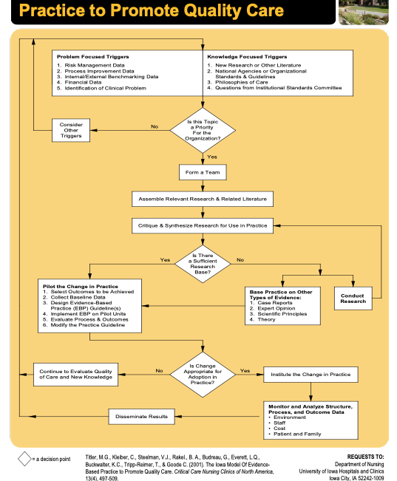
Figure 5
Evidence Based Clinical Model
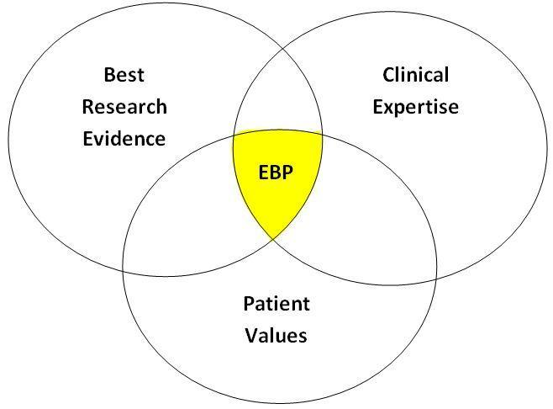
Methods
As a result of Corona Virus Disease (COVID-19) restrictions and social distancing, in person presentations were not allowed. The setting took place via an online PowerPoint presentation with media voice file inserted and a practice protocol handout. Included in the convenience sample population were CRNAs at the Detroit main campus, HFHS. The population included CRNAs that provided direct patient care in the main operating room.
Review of Literature
A literature review was performed on the use of intraoperative IVLI in patients undergoing abdominal surgery, an additional literature review was on barriers to the translation of evidence into practice. Data extraction included a synthesis of current evidence to categorize themes used to guide this DNP project.
Pre and Post Intervention Surveys
The total number of CRNAs in the department is 70 that provide anesthesia in the main operating room. On average, the main operating room requires 38-42 CRNA providers per day. The implementation of this project happened over six months in an attempt to include as many CRNAs as possible because of complexity of schedules and vacation. A total of 70 pre and post-intervention surveys were sent by a third party to CRNAs on the department’s roster. The employment status ranged from full time to contingent. Data collection that included a consent script (see Appendix D) was via Likert scaled pre intervention survey (see Appendix E), and post intervention survey (see Appendix F) that included questions to gauge attitudes, values, and opinions of CRNAs concerning the use of intraoperative IVLI and the number of times IVLI is used as part of their anesthesia practice.
Educational Intervention via PowerPoint/Practice Protocol
Once the pre-intervention surveys were returned to third-party and de-identified, an educational PowerPoint and practice protocol handout about the use of intravenous IVLI was forwarded to each individual CRNA via email. This process happened over a three months period from August 2020 to November 2020. A follow up email was sent to the CRNAs with a post intervention survey attached. Information was analyzed for statistical significance. A conclusion was made as to whether or not the educational intervention was successful in increasing the knowledge base, use of intraoperative IVLI, and willingness of participants to implement this technique as part of their practice.
Participant Incentive
Participation was incentivized by offering a $100 gift card to those that completed the pre and post survey. The participants were instructed to write their names on cards and place them in a sealed envelope that was held by a third party. The drawing will take place once all criteria for graduation is met.
Implementation
Implementation began after IRB approval from HFHS (see Appendix G), Detroit Campus and the University of Detroit Mercy (see Appendix H).

Step 1. A pre-intervention survey was sent to individual emails via an electronic link to CRNAs in the department to identify demographics, age, years of experience, opinions, behavior, perceptions, willingness, and any barriers regarding the use of intraoperative IVLI infusion. The survey was multiple-choice using the Likert scale to measure responses. The pre-intervention survey included quantitative data intended to quantify attributes, attitudes, behaviors, and other defined variables with the purpose of answering the clinical question, accepting or rejecting the hypothesis of a specific phenomenon by contextualizing the data obtained via surveying the study sample.
Step 2. The educational intervention was based on the evidence from literature review concerning the clinical use of an intraoperative IVLI infusion guideline/protocol (see appendix I). Guideline/protocol included the definition of pharmacology, application, and dosing requirements for intraoperative IVLI. The educational intervention presented to the CRNA group was delivered via PowerPoint presentation with a voice file presented with a handout.
Step 3. A post intervention survey was issued to CRNAs in the anesthesia department via email to evaluate their knowledge and use regarding IVLI as a result of the educational in-service. The survey returned zero responses. Due to lack of response to post-intervention surveys via email, surveys were converted to paper surveys and placed in a manila folder in the CRNA break room to be filled out by CRNA. This room is only accessed by CRNAs with the code for entry. CRNAs were instructed to fill out the surveys anonymously and place it in a sealed envelope which was then placed in the manila folder to be collected at a later date. The survey included open-ended questions to gather qualitative data on the overall experience.

Ethical Considerations
The pre/post surveys were sent to individual CRNAs via Microsoft Teams to their emails by way of a third party who protected the anonymity of participants. This third party was not a
The pre/post surveys were sent to individual CRNAs via Microsoft Teams to their emails by way of a third party who protected the anonymity of participants. This third party was not a part of the study. The primary investigator did not have access to any identifiable information.
The results were stored in a folder on DNP students’ computer with two-step authentication required. This fulfilled IRB requirements for safeguarding any participant information. No patient information was a part of this DNP project. All information will be destroyed after graduation criteria is met from the University of Detroit Mercy. No harm to participants, physical or emotional was a result of this project.
Results
Data Analysis
A total of n=22 participants responded to the pre intervention survey and n=25 responded to the post intervention survey. The pie charts show in proportions the pre intervention survey responses from CRNAs regarding the opioid epidemic, their knowledge of IVLI technique, their willingness to try IVLI, how interested they are in learning about this technique, and if they feel barriers exist to the adoption of OFA with IVLI as part of an MMA (see Figure 6). The years in practice, age of CRNAs and use of intraoperative IVLI infusion were compared in both pre- and post-intervention. Qualitative data analysis software tools used were Excel (Version 16.45), and Chi-Square Test Calculator (Social Science Statistics, 2021) for categorical variables.

Figure 6.
Pie Charts CRNA Pre Intervention Survey Responses
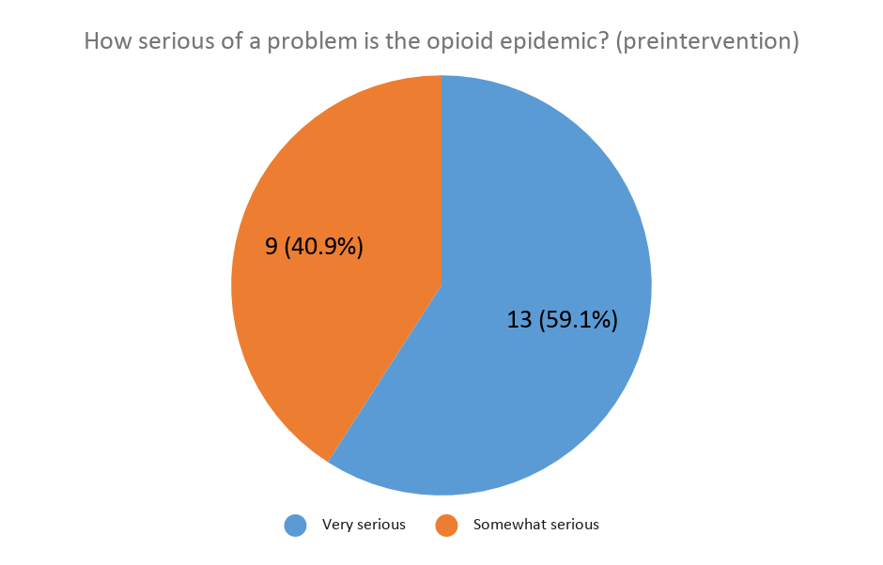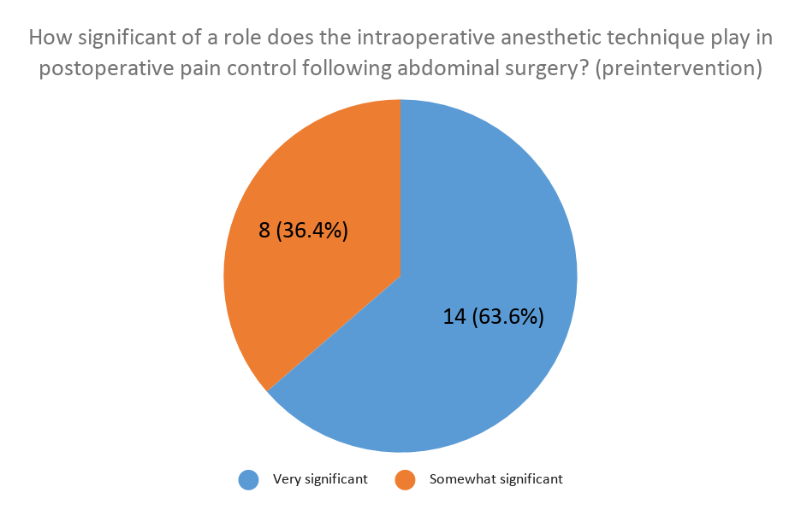

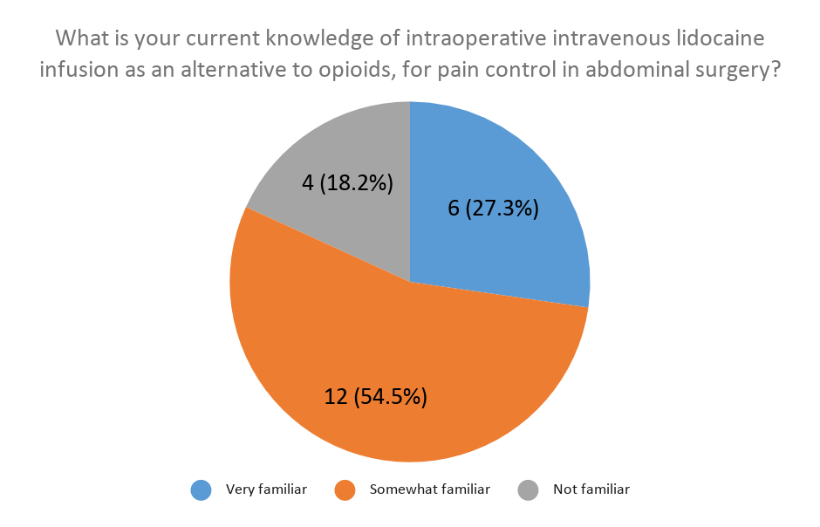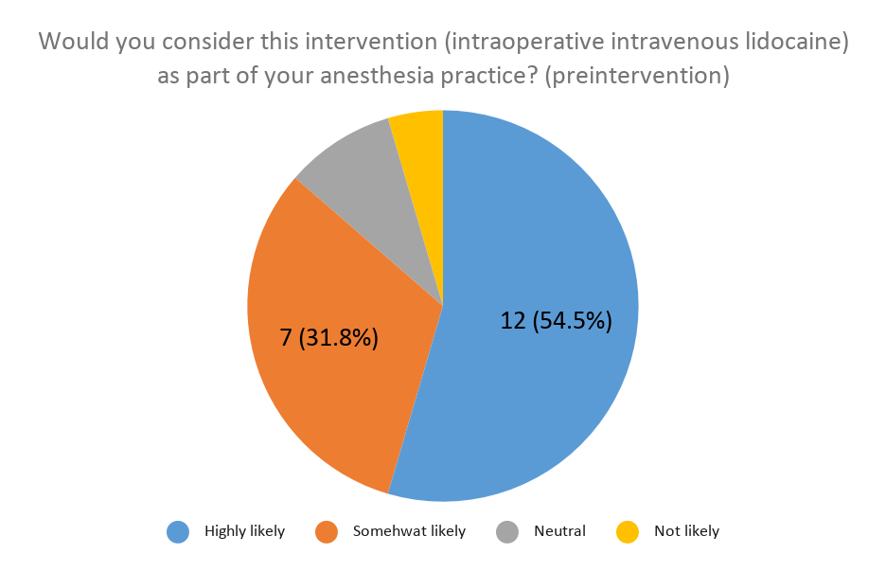
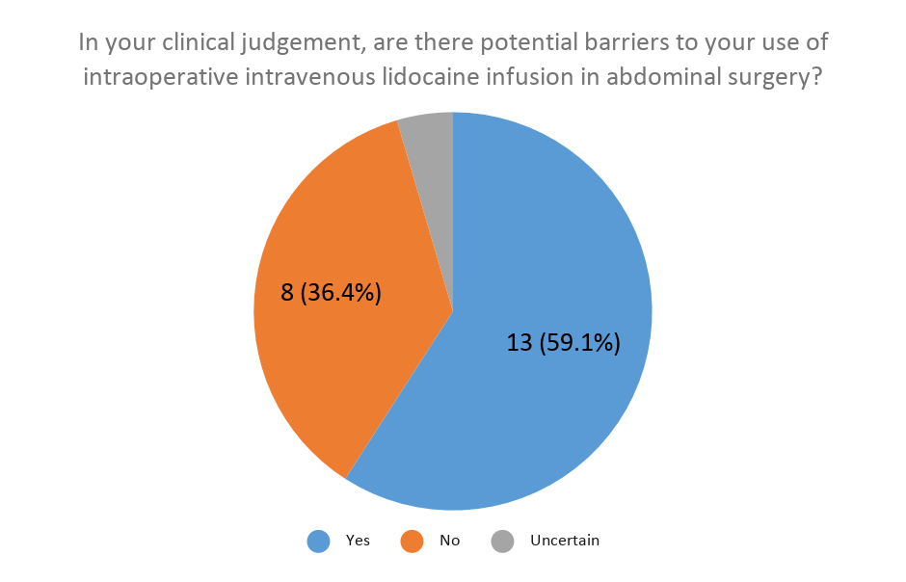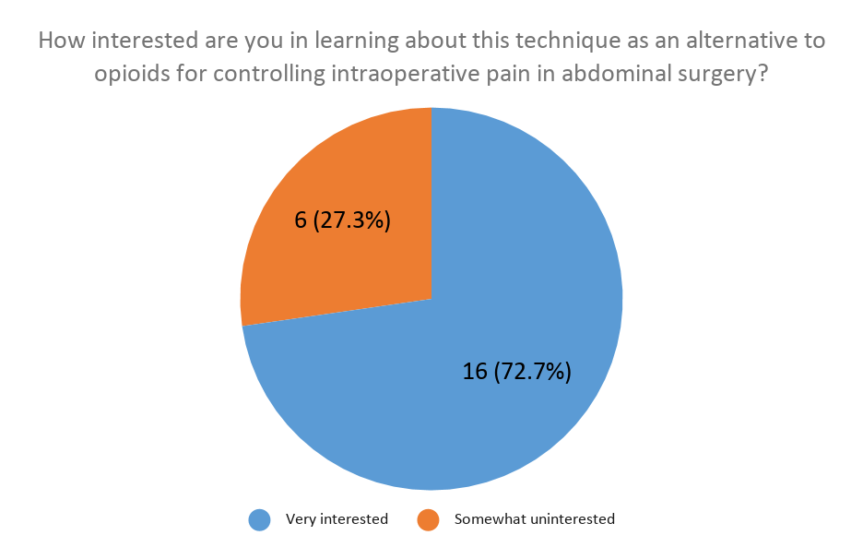
Chi Square Test
A chi-square test of independence was performed to compare the group which filled out pre- and post-intervention on age group, years in practice (see Figure 7), and the frequency of IVLI usage. There was no significant difference in years of practice between pre and post intervention respondents X² (4, N = 47) = 5.6994, p = .224429).
Figure 7.
CRNA Years in Practice Pre- and Post-Intervention
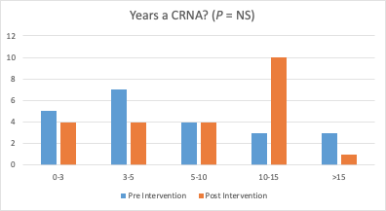
A chi-square test of independence showed that there was no significant association between age groups (see Figure 8) and pre- and post-intervention, X² (2, N = 47) = 5.1294, p < .076942.
Figure 8.
Age Groups of CRNAs
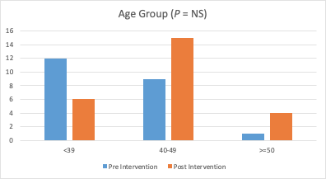
A chi-square test of independence showed that there was a significant association between the use of intraoperative IVLI infusion (see Figure 9) pre intervention and post intervention as a result of the CRNA educational presentation, X² (1, N = 47) = 13.2902, p < .000267.
Figure 9.
CRNAs use of IVLI Pre-and Post-Intervention
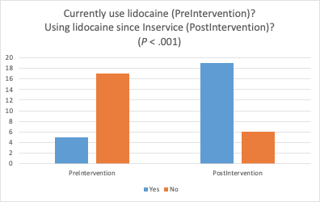
A simple bar chart (See figure 10) displays the percentage of CRNAs that felt the educational intervention directly affected their knowledge level and use of the IVLI as part of an MMA.
Figure 10.
CRNA knowledge and use of IVLI as a result of Educational Intervention
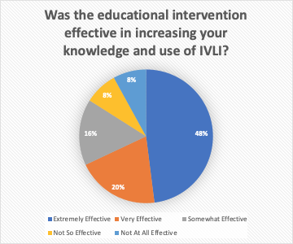
Discussion
Although the topic of OFA is emerging, before this EBP there was not a practice protocol available to facilitate the use of this technique for the CRNAs in the anesthesia department. The expected outcomes were to increase provider knowledge, create a practice protocol as an educational resource that was user friendly based on EBP, and identify any barriers to the use of IVLI. The adherence to implementing EBCP is a very important element to advancing the quality and safety of the care that is offered to patients by the caregivers and the health care system (Knighton et al., 2019). Given the statistical significance of the educational intervention presented in this EBP project, one way to increase the translation of evidence into practice is supported. Anesthesia providers are very informed in the area of pain and pain control. As a result of the rising tide of chronic opioid users, opioid addiction and opioid deaths in the United States, a call for change is underway. In the past, anesthesia relied on opioids as the primary method for controlling pain, but now with several randomized controlled trials (RCT) available (see Appendix A), anesthesia providers can continue to research alternative methods to treating patients in pain, while continuing to provide a safe and quality anesthetic. The majority of studies included in the literature review of OFA with IVLI as a part of MMA support the use of this technique with patients. The most profoundly favorable outcomes were postoperative pain, incidence of postoperative nausea and vomiting, return of bowel function, and length of stay in the hospital after surgery.
Pre-Intervention Survey
It is difficult to determine the beliefs, and practice habits of every CRNA in the HFHS main campus anesthesia department. The results of the pre intervention surveys show the proportion of CRNAs beliefs regarding the importance of the opioid epidemic 13(59.1%). The majority of CRNAs reported feeling the opioid epidemic is a significant problem. This served as a basis for which trajectory this project would take. The study results showed that CRNAs were at least open to changing the way they practice currently. Current knowledge of IVLI as reported by CRNAs was 6 (27.3%), with 16 (72.7%) willing to learn about the technique. Over half of those that filled out the pre intervention survey, 12 (54.3%) were willing to consider incorporating this technique into their practice.
Barriers To IVLI
Another finding from the pre-intervention survey revealed that 13 (59.1%) felt there were barriers to using OFA with IVLI as part of MMA. The responses from CRNAs are listed in the following section. According to Mohsen et al. (2016) there are many factors influencing the adoption of EBP in nursing practice. The majority of articles reviewed suggest that an understanding of individual beliefs toward change is essential in changing the behavior of practitioners and overcoming barriers to change (Mohsen et al., 2016; Lizarondo et al., 2019; Curtis et al., 2017) Certain themes have been identified as primary barriers to practice change. Tailoring interventions in response to the identified themes will strengthen the benefits associated with the use of a IVLI clinical practice protocol (Mohsen et al., 2016; Lizarondo et al., 2019; Curtis et al., 2017).
CRNA Responses. There must be a protocol in place to prevent toxicity; Unfamiliarity of MDA with procedure; The MDA being an agreement; There might be barriers depending on the patient's medical history; Not widely accepted pre-existing neuromuscular disease; Yes-please explain below; pressure to proceed. Pharmacy is slow to produce a lidocaine infusion bag.; Administrative support, ease to obtain and successfully train all Providers who would care for patients on infusion: anesthesia, PACU, floor, etc. Availability- medication, pumps, lines. Resistance by other members of the ACT. Unsure of the effectiveness. Pt history/comorbidities Potential for delayed emergence; staff buy in, pharmacy hurdles.

Post Intervention Survey
Chi square analysis determined that there was not an association with age or years in practice with the pre versus post educational intervention. However, given the statistical significance, X² (1, N = 47) = 13.2902, p < .000267 in the results regarding the use of IVLI pre and post intervention, it can be concluded that the educational intervention was a successful way to improve anesthesia provider knowledge and implementation of OFA with IVLI as part of MMA with the use of a practice protocol. Forty eight percent of those that responded to the post intervention survey felt the educational in-service was extremely effective in increasing their knowledge and use of IVLI as part of an MMA approach.
Implications for Clinical Practice
The results of this project will benefit and inform the academic community on the need to limit a patients’ exposure to opioids and opioids negative side effects. In addition to facilitating the translation of evidence into clinical practice
By increasing anesthesia providers' knowledge and comfort with OFA with IVLI as part of MMA administration, there is the potential to decrease the undesired side effects associated with opioid administration (Ahn et al., 2015; Bakan et al., 2015; Boysen et al., 2018; Tikuisis et al., 2014; Tauzin-Fin et al., 2014; Yon et al., 2014; Zhou et al., 2017).
According to Tikuisis et al. (2013) although IVLI has some beneficial effects in providing pain relief, further studies are needed to compare the cost effectiveness and the superiority of pain relief compared to epidural anesthesia. This is relevant only to patients having abdominal surgery because of the way an epidural is designed to work. Further studies are necessary to compare the effects of systemic lidocaine versus a regional block that target specific nerves.
Graham et al. (2018) postulated that health research is conducted with the expectation that it advances knowledge and eventually translates into improved health systems and population health. According to Graham et al. (2018) integrating knowledge users identified as clinicians, managers, policy makers, patients/families and others to work with researchers throughout the research process is an important step needed to decrease the know-do-gap. The researchers continue to suggest that the future will require all those involved with impacting patient outcomes positively, to join together in changing the way knowledge is created and implemented.
According to Kandil & Melikman & Adinoff (2017) several unanswered questions regarding dosing, infusion duration and appropriate patient selection will need to be researched and answered before IVLI is proven effective and an important tool for treatment of chronic pain. Additionally, a more specific recommendation is to conduct an increased number of large double-blinded placebo-controlled trials to determine the precise efficacy of IVLI in the surgical setting.
Sustainability Measures
An important sustainability measure begins with policy reform on the organizational level. Stakeholders and administrators will be required to support projects that promote positive healthcare outcomes. A systematic curriculum as part of continuing education beyond the anesthesia department to include pharmacists, recovery room nurses, inpatient floor nurses, and all other members of the healthcare team on EBP knowledge and implementation can serve as the starting point for bridging the gap between barriers and the uptake of evidence into practice (Li, Cao & Zhu 2019). When there are measures in place that overcome the barriers to translating evidence into practice, all healthcare providers will have a profound impact on patient outcomes with practice based in theory, and best available evidence (Muche-Borowski et al., 2015). Because gaps in research remain regarding the efficacy of OFA with IVLI as part of MMA as an emerging technique, continued quality improvement with ongoing updates to the practice protocol will be required. The final sustainability measure should include an electronic copy of the protocol stored in a resource folder attached to the Epic electronic record.
Dissemination
Dissemination of project findings will include a poster presentation to be presented to the anesthesia department including CRNAs, anesthesia residents, anesthesiologists and pharmacists assigned to the operating room pharmacy. A broader scale dissemination of project findings will include submission of results to the nursing education department to be published in the hospital’s newsletter.
Strengths and Limitations
The primary strength of this project was that it is evidenced based research. EBP as defined by Lobiondo-Wood and Haber (2018) is the collection, evaluation, and integration of valid research evidence, combined with clinical expertise and an understanding of patient and family values and preference to inform clinical decision making (pp. 6). The educational intervention used easy instruction, visual aids and made no assumptions about the data. CDCs Social distancing guidelines and COVID-19 restrictions placed limitations on how information was disseminated to the CRNA staff. Several follow-up emails were sent to encourage participation without success. Therefore, the need to convert from online to paper surveys was done. A potential limitation to implementation of the use of lidocaine infusion is the cost when compared to the cost of fentanyl. Because lidocaine infusions are not formulary and therefore have to be mixed on demand, this subsequently leads to an increased cost to the hospital and patients. The pharmacist continued to explain that a strategy to offset the cost would be to order in bulk if the use and demand for lidocaine infusion increased. An additional limitation is that the primary investigator will need to develop new skills in seeking appraising evidence. Without these skills, confirmation bias is a possibility.
Conclusion
Gaps in research remain in the standardization of OFA with intraoperative IVLI protocols. Further indication for research in the area of development of such protocol is needed. In order to have the greatest impact on patient outcomes a practice change is imperative in order to increase evidenced based patient care. Change will have to include adoption of a new way and abandoning habits that have contributed to the current state, for instance the opioid epidemic. Change in the prescribing habits of PCP’s, change in JCAHO using pain as a measure of quality and patient satisfaction, and change in anesthetists that rely heavily on an opioid based anesthetic approach are imperative to decreasing a patient’s exposure to opioids. All of those involved with patient care require continued education to improve provider knowledge and practice in OFA. A systematic approach to behavior change is needed to provide evidenced based guidelines for this change.

Application of AACN DNP Essentials

DNP Essential 1 | Scientific Underpinnings for practice | Iowa Evidence Based Practice provided the framework for this project.
DNP Essential II | Organizational & Systems  Leadership for Quality  Improvement & System  Thinking | Determined that practice change that positively impacts patient outcomes has the potential to be adopted systemwide.
DNP Essential III | Clinical Scholarship & Analytical Methods for Evidence Based Practice | Performed critical appraisal of current literature to inform, and build nursing knowledge in addition, encourage research base practice change.
DNP Essential IV | Information Systems/Technology and Patient Care Technology for the Improvement and Transformation of Health Care | Information systems used to capture and maintain raw data. Google Scholar, Science Direct, PubMed, and Cochrane electronic databases through the University of Detroit Mercy Library databases used to search for current and relevant evidence to inform healthcare practitioners.
DNP Essential V | Health Care Policy for Advocacy in Health Care | Critically analyzed organizations policy and procedures with the goal of advocating for social justice and educating the nursing profession.
DNP Essential VI | Interpersonal Collaboration  for Improving Patient and  Population Health Outcomes | Led inter-professional team consisting of MD, CRNAs, and pharmacists in leadership roles in the development and implementation of practice change models, standards of care, and education.
DNP Essential VII | Clinical Prevention and Population Health for Improving the Nation’s Health | Applied Lewin’s Change Theory to change perceptions and use of IVLI as a way to address the opioid epidemic by limiting patients' exposure to opioids.
DNP Essential VIII | Advance Nursing Practice | Created, implemented, and evaluated evidence-based interventions that will improve the health of the general population by preventing further contribution to the opioid epidemic. Developed an educational intervention that will have a powerful positive impact on patient outcomes.

References

Ahn, E., Kang, H., Choi, G. J., Park, Y. H., Yang, S. Y., Kim, B. G., & Choi, S. W. (2015). Intravenous lidocaine for effective pain relief after a laparoscopic colectomy: A prospective, randomized, double blind, placebo-controlled study. International Surgery, 100(3), 394–401. https://doi.org/10.9738/INTSURG-D-14-00225.1
Alam A, Juurlink D.N. (2016). The prescription opioid epidemic: An overview for anesthesiologists. Canadian Journal of Anesthesia, 63(1):61-8 https://doi.org/10.1007/s12630-015-0520-y.
Aana.com. (2016). Retrieved 4 May 2021, from https://www.aana.com/docs/default-source/practice-aana-com-web-documents-(all)/professional-practice-manual/a-holistic-approach-to-pain-management-integrated-multimodal-and-interdisciplinary-treatment.pdf?sfvrsn=f40049b1_4.
Bakan, M., Umutoglu, T., Topuz, U., Uysal, H., Bayram, M., Kadioglu, H., & Salihoglu, Z. (2015). Opioid-free total intravenous anesthesia with propofol, dexmedetomidine and lidocaine infusions for laparoscopic cholecystectomy: A prospective, randomized, double-blinded study. Brazilian Journal of Anesthesiology (English Edition), 65(3), 191-199. https://doi.org/10.1016/j.bjane.2014.05.001
Baker, R., Camosso-Stefinovic, J., Gillies, C., Shaw, E. J., Cheater, F., Flottorp, S., & Robertson, N. (2015). Tailored interventions to overcome identified barriers to change: Effects on professional practice and health care outcomes. The Cochrane Database of Systematic Reviews, (3), CD005470. https://doi.org/10.1002/14651858.CD005470.pub2
Boysen, P., Pappas, M., & Evans, B. (2018). An evidence-based opioid-free anesthetic technique to manage perioperative and periprocedural pain. Ochsner Journal, 18(2), 121-125. https://doi.org/10.31486/toj.17.0072
Brandal, D., Keller, M. S., Lee, C., Grogan, T., Fujimoto, Y., Gricourt, Y., Yamada, T., Rahman, S., Hofer, I., Kazanjian, K., Sack, J., Mahajan, A., Lin, A., & Cannesson, M. (2017). Impact of enhanced recovery after surgery and opioid free anesthesia on opioid prescriptions at discharge from the hospital. Anesthesia & Analgesia, 125(5), 1784–1792. https://doi.org/10.1213/ane.0000000000002510
Brown, C.G. (2014). The Iowa Model of evidence-based practice to promote quality care: An illustrated example in oncology nursing. Clinical Journal of Oncology Nursing, 18 2, 157-9.
Brown, E. N., Pavone, K. J., & Naranjo, M. (2018). Multimodal general anesthesia: Theory and practice. Anesthesia and Analgesia, 127(5), 1246–1258. https://doi.org/10.1213/ANE.0000000000003668
Brummett, C. M., Waljee, J. F., Goesling, J., Moser, S., Lin, P., Englesbe, M. J., & Nallamothu, B. K. (2017). New persistent opioid use after minor and major surgical procedures in US adults. JAMA Surgery, 152(6). https://doi.org/10.1001/jamasurg.2017.0504
Buckwalter, K. C., Cullen, L., Hanrahan, K., Kleiber, C., McCarthy, A. M., Rakel, B., Steelman, V., Tripp-Reimer, T., Tucker, S., (2017). Iowa Model of Evidence-Based Practice: Revisions and validation. Worldviews On Evidence-Based Nursing, 14(3), 175-182. https://doi.org/10.1111/wvn.12223
Butterworth, J., Walker, F., & Neal, J. (1990). Cooling potentiates Lidocaine inhibition of median nerve sensory fibers. Anesthesia & Analgesia, 70(5), 507. https://doi.org/10.1213/00000539-199005000-00007
Centers for Disease Control and Prevention guideline for prescribing opioids for chronic pain | drug overdose | CDC Injury Center. (2020). Retrieved 6 March 2020, from https://www.cdc.gov/drugoverdose/prescribing/guideline.html
Centers for Disease Control and Prevention Publications. (2020, January 22). Retrieved February 13, 2021 from https://www.cdc.gov/drugoverdose/pubs/index.html
Centers for Disease Control and Prevention, National Center for Health Statistics. Multiple Cause of Death 1999-2018 on CDC WONDER Online Database released in 2020. Data are from the Multiple Cause of Death Files, 1999-2018, as compiled from data provided by the 57 vital statistics jurisdictions through the Vital Statistics Cooperative Program. (2020 February 14) Retrieved 2 May 2021 from http://wonder.cdc.gov/mcd-icd10.html
Chia, Y., Liu, K., Wang, J., Kuo, M., & Ho, S. (1999, 09). Intraoperative high dose fentanyl induces postoperative fentanyl tolerance. Canadian Journal of Anesthesia, 46(9), 872-877. https://doi.org/10.1007/bf03012978
Chu, L. F., Angst, M. S., & Clark, D. (2008, 07). Opioid-induced hyperalgesia in humans. The Clinical Journal of Pain, 24(6), 479-496. https://doi.org/:10.1097/ajp.0b013e31816b2f43
Chi-Square Test Calculator. (2018, November 13). Retrieved from https://www.socscistatistics.com/tests/chisquare2/default2.aspx.
Cullen, L., Deberg, J., Farrington, M., Hanrahan, K., Klieber, C., & Tucker, S. (2017). Evidence-Based Practice in Action: Comprehensive strategies, tools, and tips from the University of Iowa Hospitals and Clinics (pp. 4-10). Sigma Theta Tau.
Curtis, K., Fry, M., Shaban, R. Z., & Considine, J. (2017). Translating research findings to clinical nursing practice. Journal of Clinical Nursing, 26(5-6), 862–872. https://doi.org/10.1111/jocn.13586
Dunn, L., & Durieux, M. (2017). Perioperative use of intravenous lidocaine. Anesthesiology, 126(4), 729-737. https://doi.org/10.1097/aln.0000000000001527
Dzwończyk, R., Weaver, T., Puente, E., & Bergese, S. (2012). Postoperative nausea and vomiting prophylaxis from an economic point of view. American Journal of Therapeutics, 19(1), 11-15. https://doi.org/10.1097/mjt.0b013e3181e7a512
Elvir-Lazo, O., White, P., Yumul, R., & Cruz Eng, H. (2020). Management strategies for the treatment and prevention of postoperative/post discharge nausea and vomiting: an updated review. F1000research, 9, 983. https://doi.org/10.12688/f1000research.21832.1
Florence, C. S., Zhou, C., Luo, F., & Xu, L. (2016). The economic burden of prescription opioid overdose, abuse, and dependence in the United States, 2013. Medical Care, 54(10), 901–906. https://doi.org/10.1097/mlr.0000000000000625
Gan, T., Epstein, R., Leone-Perkins, M., Salimi, T., Iqbal, S., & Whang, P. (2018). Practice patterns and treatment challenges in acute postoperative pain management: A survey of practicing physicians. Pain And Therapy, 7(2), 205-216. https://doi.org/10.1007/s40122-018-0106-9
Graham, I., Kothari, A., & McCutcheon, C. (2018). Moving knowledge into action for more effective practice, programmes and policy: protocol for a research programme on integrated knowledge translation. Implementation Science, 13(1). https://doi.org/10.1186/s13012-017-0700-y
Grigoras, A., Lee, P., Sattar, F., & Shorten, G. (2012). Perioperative intravenous Lidocaine decreases the incidence of persistent pain after breast surgery. The Clinical Journal of Pain, 28(7), 567–572. https://doi.org/10.1097/ajp.0b013e31823b9cc8
Grol, R., & Wensing, M. (2004). What drives change? Barriers to and incentives for achieving evidence-based practice. Medical Journal of Australia, 180(6), 57-60. https://doi.org/10.1097/AJP.0b013e31823b9cc8
Grundy, Q., Mazzarello, S., Brennenstuhl, S., & Karanges, E. (2021). A comparison of educational events for physicians and nurses in Australia sponsored by opioid manufacturers. PLOS ONE, 16(3), e0248238. https://doi.org/10.1371/journal.pone.0248238
Hah, J., Bateman, B., Ratliff, J., Curtin, C., & Sun, E. (2017). Chronic opioid use after surgery. Anesthesia & Analgesia, 125(5), 1733-1740. doi: 10.1213/ane.0000000000002458
Hollmann, M. W., & Durieux, M. E. (2000). Local anesthetics and the inflammatory response. Anesthesiology, 93(3), 858–875. https://doi.org/10.1097/00000542-200009000-00038
Kaiser Family Foundation. (2019). Retrieved March 21, 2021, from https://www.kff.org/health-costs/state-indicator/expenses-per-inpatient-day/?currentTimeframe=0&sortModel=%7B%22colId%22:%22Location%22,%22sort%22:%22asc%22%7D
Kandil, E., Melikman, E., Adinoff, B. (2017) Lidocaine infusion: A promising therapeutic approach to chronic pain. Journal of Anesthesia and Clinical Research, 8(1). 697. https://doi.org/10.4172/2155-6148.1000697
Kessler, E. R., Shah, M., Gruschkus, S. K., & Raju, A. (2013, 04). Cost and quality implications of opioid-based postsurgical pain control using administrative claims data from a large health system: Opioid-related adverse events and their impact on clinical and economic outcomes. Pharmacotherapy: The Journal of Human Pharmacology and Drug Therapy, 33(4), 383-391. https://doi.org/10.1002/phar.1223
Knighton, A., McLaughlin, M., Blackburn, R., Wolfe, D., Andrews, S., & Hellewell, J., Moore, R., Edwards, D. P., Allen, T.L., Srivastava, R. (2019). Increasing Adherence to Evidence-based clinical practice. Quality Management In Health Care, 28(1), 65-67. https://doi.org/10.1097/qmh.0000000000000195
Koepke, E. J., Manning, E. L., Miller, T. E., Ganesh, A., Williams, D., & Manning, M. W. (2018). The rising tide of opioid use and abuse: the role of the anesthesiologist. Perioperative medicine (London, England), 7, 16. https://doi.org/10.1186/s13741-018-0097-4
Kurz, A., & Sessler, D. I. (2003). Opioid-induced bowel dysfunction. Drugs, 63(7), 649–671. https://doi.org/10.2165/00003495-200363070-00003
Leliefeld P.H., Wessels CM, Leenen LP, Koenderman L, & Pillay, J. (2016): The role of neutrophils in immune dysfunction during severe inflammation. Critical Care; 2073
Li, S., Cao, M., & Zhu, X. (2019). Evidence-based practice: Knowledge, attitudes, implementation, facilitators, and barriers among community nurses-systematic review. Medicine, 98(39), e17209. https://doi.org/10.1097/MD.0000000000017209
Liang, L. (2007). The Gap Between Evidence and Practice: We still have much to learn about practice and patient factors that affect clinical outcomes. Health Affairs, 26(Suppl1), w119-w121.
Lizarondo, L., Lockwood, C. & McArthur, A. (2019), Barriers and facilitators to implementing evidence in African health care: A content analysis with implications for action. Worldviews on Evidence‐Based Nursing, 16,131-141. https://doi.org/0.1111/wvn.123
Ljungqvist, O., Scott, M., & Fearon, K. C. (2017). Enhanced recovery after surgery. JAMA Surgery, 152(3), 292. https://doi.org/10.1001/jamasurg.2016.4952
Lobiondo-Wood, G. & Haber J. (2018). Nursing research: Methods and critical appraisal for evidence-based practice (9th ed.)(201). Mosby/Elsevier.
Mackey, S. (2014). The IOM pain report revisited: Setting the stage for what's next in transforming pain care, education and research. Pain Medicine, 15(6), 885-886. https://doi.org/10.1111/pme.12471
Melnyk, B. (2021). Level of evidence plus critical appraisal of its quality yields confidence to implement evidence-based practice changes. Retrieved 28 April 2021. https://sigmapubs-onlinelibrary-wiley-com.ezproxy.libraries.udmercy.edu/doi/full/10.1111/wvn.12181.
Mohsen, M. M., Safaan, N. A., & Okby, O. M. (2016). Nurses’ perceptions and barriers for adoption of evidence-based practice in primary care: Bridging the gap. American Journal of Nursing Research, 4(2), 25-33.
Muche-Borowski, C., Nothacker, M. & Kopp, I. Implementation of clinical practice guidelines
How can we close the evidence-practice gap? Bundesgesundheitsbl. (2015) 58,32-37.
https://doi.org/10.1007/s00103-014-2078-1 Retrieved December 7, 2019
Mulier, J. P., Wouters, R., Dillemans, B., & De Kock, M., (2018). A randomized controlled, double-blind trial evaluating the effect of opioid-free versus opioid general anesthesia on postoperative pain and discomfort measured by the QoR-40. Journal of Clinical Anesthesia and Pain Medicine, 2(1),1-6. https://www.researchgate.net/publication/323425051
Mujukian, A., Truong, A., Tran, H., Shane, R., Fleshner, P., & Zaghiyan, K. (2019). A standardized multimodal analgesia protocol reduces perioperative opioid use in minimally invasive colorectal surgery. Journal of Gastrointestinal Surgery, 24(10), 2286-2294. https://doi.org/10.1007/s11605-019-04385-9
Relieving pain in America: A blueprint for transforming prevention, care, education, and research. (2016), 181(5), 397-399. https://doi.org/10.7205/milmed-d-16-00012
Schaffer, M.A., Sandau, K.E., & Diedrick, L. (2013) Evidence‐based practice models for organizational change: Overview and practical applications. Journal of Advanced Nursing 69(5), 1197– 1209. https://doi.org/10.1111/j.1365‐2648.2012.06122.x
Schoneboom, B. A., Perry, S. M., Barnhill, W. K., Giordano, N. A., Nicely, K. L. W., & Polomano, R. C. (2016). Answering the call to address chronic pain in military service members and veterans: Progress in improving pain care and restoring health. Nursing Outlook 64(5), 459-484. https://doi.org/10.1016/j.outlook.2016.05.010
Shafi, S., Collinsworth, A. W., Copeland, L. A., Ogola, G. O., Qiu, T., Kouznetsova, M., Liao, I. C., Mears, N., Pham, A. T., Wan, G. J., & Masica, A. L. (2018). Association of opioid-related adverse drug events with clinical and cost outcomes among surgical patients in a large integrated health care delivery system. JAMA surgery, 153(8), 757–763. https://doi.org/10.1001/jamasurg.2018.1039
Tauzin-Fin, P., Bernard, O., Sesay, M., Biais, M., Richebe, P., Quinart, A., Revel, P., & Sztark, F., (2014). Benefits of intravenous lidocaine on post-operative pain and acute rehabilitation after laparoscopic nephrectomy. Journal Of Anaesthesiology Clinical Pharmacology, 30(3), 366. https://doi.org/10.4103/0970-9185.137269
Thota, R. S., Ramkikiran, S., Garg, R., Goswami, J., Baxi, V., & Thomas, M. (2019). Opioid free onco-anesthesia: Is it time to convict opioids? A systematic review of literature. Journal of Anaesthesiology, Clinical Pharmacology, 35(4), 441-452. https://doi.org/10.4103/joacp.JOACP_128_19
Tikuišis, R., Miliauskas, P., Samalavičius, N. E., Žurauskas, A., Samalavičius, R., & Zabulis, V. (2013, 09). Intravenous lidocaine for post-operative pain relief after hand-assisted laparoscopic colon surgery: A randomized, placebo-controlled clinical trial. Techniques in Coloproctology, 18(4), 373-380. https://doi.org/10.1007/s10151-013-1065-0
Tsai, P. S., Buerkle, H., Huang, L. T., Lee, T. C., Yang, L. C., & Lee, J. H. (1998). Lidocaine concentrations in plasma and cerebrospinal fluid after systemic bolus administration in humans. Anesthesia & Analgesia, 87(3), 601–604. https://doi.org/10.1213/00000539-199809000-00020
Van Zee, A. (2009). The promotion and marketing of OxyContin: Commercial triumph, public health tragedy. American Journal of Public Health, 99(2), 221-227. https://doi.org/10.2105/ajph.2007.131714
Weibel, S., Jelting, Y., Pace, N. L., Helf, A., Eberhart, L. H., Hahnenkamp, K., Hollmann, M. W., Poepping, D. M., Schnabel, A., & Kranke, P. (2018). Continuous intravenous perioperative lidocaine infusion for postoperative pain and recovery in adults. The Cochrane Database of Systematic Reviews, 6(6), CD009642. https://doi.org/10.1002/14651858.CD009642.pub3
Wojciechowski E., Oearsall, T., Murphy, P., & French, E. (2020). A Case Review: Integrating Lewin’s theory with lean’s system approach for change – PubMed – NCBI. Retrieved 6 March 2020, from https://www.ncbi.nlm.nih.gov/pubmed/27854425
Yon, J. H., Choi, G. J., Kang, H., Park, J. M., & Yang, H. S. (2014). Intraoperative systemic lidocaine for pre-emptive analgesics in subtotal gastrectomy: a prospective, randomized, double-blind, placebo-controlled study. Canadian Journal of Surgery, 57(3), 175–182. https://doi.org/10.1503/cjs.009613
Zhou, J., Fan, Y., Zhong, J., Wen, X., & Chen, H. (2017). Efficacy and safety of multimodal analgesic techniques for preventing chronic post-surgery pain under different surgical categories: a meta-analysis. Scientific Reports, 7(1). https://doi.org/10.1038/s41598-017-00813-5
Ziemann-Gimmel, P., Goldfarb, A., Koppman, J., & Marema, R. (2014). Opioid-free total intravenous anesthesia reduces postoperative nausea and vomiting in bariatric surgery beyond triple prophylaxis. British Journal of Anaesthesia, 112(5), 906–911. https://doi.org/10.1093/bja/aet55

Appendix A
Literature Review Matrix

Author | Sample  Size | Participants  Age, Gender,  Ethnicity | Study Design/Level of Evidence | Intervention  Product/Plan | Intervention  Length | Outcome  Measure 1 | Outcome  Measure 2 | Outcome  Measure 3
Ahn et al., (2015)  South Korea | 50 patients, Group L (25) Lido Group C (25) =NS | Age -20-65, Weight- 45-100kg, 8 Male and 17 Female in Group C, 11 Male and 14 Female in Group L | Randomized Double Blind, Placebo-  Controlled Study  Level II | Group L-IV bolus of lidocaine, the infusion  Group C received the same but Normal Saline, Measured 48 hrs. postop | After induction and was cont. infused during the operation | Pain, measured at intervals 2, 4, 8, 12, 24 and 48 hrs.  Tool – VAS  PCA | Nausea less in group L  Vomiting no difference  Tool patient self- reported
Bakan et al., (2015)  Brazil | 80 patients Group DL (40) opioid‐free anesthesia  Group RF (40) opioid‐based anesthesia | ASA I-II, elective laparoscopic cholecystectomy | Randomized Controlled Trial (RCT)  Level II | Group DL (40) opioid‐free anesthesia with dexmedetomidine, lidocaine, and propofol infusions.  Group RF (40) opioid‐based anesthesia with remifentanil, and propofol infusions | A patient-controlled analgesia device was set to deliver IV fentanyl for 6 h after surgery. | Fentanyl consumption  Measured at 2nd and 6th hour interval was in Group DL, compared with Group RF, which were 75 ± 59 μg and 120 ± 94 μg respectively,  Tool  PCA pump
Brandal et al., (2017)  United States |  | Patients undergoing colorectal surgery  Pre Eras (N=194)  ERAS (N=189),  Male  ASA I-IV | Historical-  prospective quality improvement study  Level VI | ERAS protocol implemented for patients undergoing colorectal surgery with a focus on the opioid-free and multimodal analgesia components of the pathway. | Compared patients undergoing colorectal surgery 1 year before implementation (June 15, 2015, to June 14, 2016) and 1 year after implementation (June 15, 2016, to June 14, 2017). | Opioid Consumption  ERAS intervention for colorectal surgery led to an increase in opioid free anesthesia and multimodal analgesia
Boysen et al., (2018)  United States | 2 | 1 male and 1 female | Case study  Level IV | Opioid free anesthesia, lidocaine infusion from induction of anesthesia then for 24hrs post op | Lidocaine infusion from induction of anesthesia then for 24hrs post op | Pain neither patient required opioids post op  Tools  Patient’s self-reported  Nurse assessment of bowel sounds | Bowel Function  Female- returned first day post  Male-No mention  Tools-Nurse assessment of bowel sounds
Tauzin-Fin et al., (2014)  France | 47 patients | Age (year) 58 (17) 61 (14), Sex (M/F) 10/12 11/11, Weight (kg) 68 (10) 75 (20), ASA I-III | A 2 phase  Observational study  Level III | Phase 1 Reference group- Sept., to Dec.,  2009=NS  Phase 2 Jan., to Apr., 2010 Lidocaine Group IV lidocaine (1.5 mg/kg/h) | During surgery and for 24 h post-operative | Pain lower in lido group-measured day 1 q 3 hrs., day 2 q 12 hrs., and day 4,  Tools VAS and PCA pump | Return of bowel function first flatus day 1  Tool  Nurse assessment
Tikuisis et al., (2013)  Lituania | 64 patients | 61.7% male, 38.2 % female, ages 18-75, ASA 1-3. March 2010 to March 2012 | Randomized, placebo-  double blind controlled clinical trial  Level II | Lidocaine infusion [lidocaine group (LG)] or normal 0.9 % saline infusion [placebo group (PG)] | LG -bolus at induction then infusion during surgery for a period of 24 hr., postop  PG- received NS | Pain measured at 2, 4, 8, 12 and 24 hrs. post op. LG<PG first post op day  Tool -VAS | Return of bowel function  LG<PG flatus and first bowel movement  Tool  Patient self-report | Length of stay  LG<PG by 1.2 days  Tool  D time
Yon et al., (2014)  Canada | 36 Patients | Age 18–80 yrs.  Excluded  patients who weighed less than 45 kg or more than 100 kg; | Double-blind, randomized placebo-  controlled trial.  Random assignment was  based on a random table generated using PASS software  version 11 (NCSS).  Level II | Group 1 Intervention received Patients assigned  to the lidocaine group received an intravenous bolus infusion of 1.5 mg/kg of lidocaine followed by a continuous  infusion of 2 mg/kg/h.  throughout surgery  Control group (placebo) received Normal Saline | Patients who  underwent subtotal gastrectomy between May 2012 and  March  Outcomes measured at 12 and 24 hrs., postop | Pain  Lower in intervention group 1  Tool  VAS | Opioid consumption  Lower in intervention group 1  Tool  PCA
Ziemann-Gimmel et al., (2014) | 119 Patients | Similar clinical characteristics, surgical procedure, and PONV risk scores | Prospective Randomized Controlled trial  Level II | Classic group (n=59), general anesthesia with volatile anesthetics and opioids. In the Total i.v. anesthesia (TIVA) group (n=60), opioid-free TIVA with propofol, ketamine, and dexmedetomidine. | November 2011 to October 2012. | PONV  The severity of PONV was significantly worse in the Classic group.  Tool  Likert scale (none, mild, moderate, and severe).
Zhoa et al., (2018) | 274 patients | Average age ranged from 44 to 54.  Female | Meta -Analysis of 5 RCTs  Level II | The intervention group=intravenous infusion of lidocaine Comparisons: The control group received normal saline | 5 RCTs published between 2008 and 2017 | Pain  Measured at 12, 24 and 48 hrs., post op was significantly lower  Tool  VAS | Opioid Consumption  Measured at 12, 24 and 48 hrs., post op was significantly lower

Appendix B
Literature Review Matrix
 | Purpose | Methods | Results
Baker et al., (2015)  United States | To assess the effectiveness of interventions tailored to address identified barriers to change on professional practice or patient outcomes. | Randomized controlled trials (RCTs) of interventions tailored to address prospectively identified barriers to change that reported objectively measured professional practice or healthcare outcomes in which at least one group received an intervention designed to address prospectively identified barriers to change.  Level II | Interventions tailored to prospectively identified barriers are more likely to improve professional practice than no intervention or dissemination of guidelines.
Curtis et al., (2017)  United States | To describe the importance of, and methods for, successfully conducting and translating research into clinical practice. | Clinical practice discussion paper that.  is informed by the scientific literature around knowledge translation, implementation science and clinician behavior change, and presented from the nurse clinician perspective. We provide practical, evidence‐informed suggestions to overcome the barriers and facilitate enablers of knowledge translation.  Level VII | Translation should be considered in research design, including the end users and an evaluation of the research implementation.
Muche-Borowski et al., (2015)  Germany | Guidelines are intended as instruments of knowledge transfer to support decision-making by physicians, other health professionals and patients in clinical practice and thereby contribute to quality improvements in healthcare. | Discussion Paper to review force field analysis to identify barriers against and facilitators for the implementation of specific guideline recommendations.  Level II | Therefore, a process using theory, analysis, experience and shared responsibility of stakeholders in healthcare is recommended, with the aim to achieve sustainable behavioral change and improve the quality of care by guideline-oriented behavior.
Li, Cao & Zhu (2019)  China | This study is to summarize the status of knowledge, attitudes, implementation, facilitators, and barriers of evidence-based practice (EBP) in community nurses (CNs). | A literature search was conducted. The information of the knowledge, attitudes, implementation, and the perceived facilitators and barriers of EBP in CNs was extracted and summarized.  Level V | Findings demonstrate a compelling need for improvement in knowledge and implementation of EBP in CNs, compared with the better attitudes. Except education, knowledge translating into implementation needs more coordination with authorities to magnify the facilitators and overcome the barriers.
Lizarondo et al., (2019)  Africa | The aim of this study was to determine barriers and facilitators to evidence implementation in African healthcare settings, based on implementation projects undertaken as part of the Joanna Briggs Institute (JBI) Clinical Fellowship program. | A purpose-built data extraction form was used to collect data from individual reports. Data were analyzed using content analysis.  Level V | The study identified a core set of barriers and facilitators in African healthcare settings, which are common to other low- and middle-income countries. These can be used to develop a method by which implementation programs can systematically undertake barrier or facilitator analysis.

Appendix C
University of Iowa Determining a Need for Policy or Procedure Tool 7.1
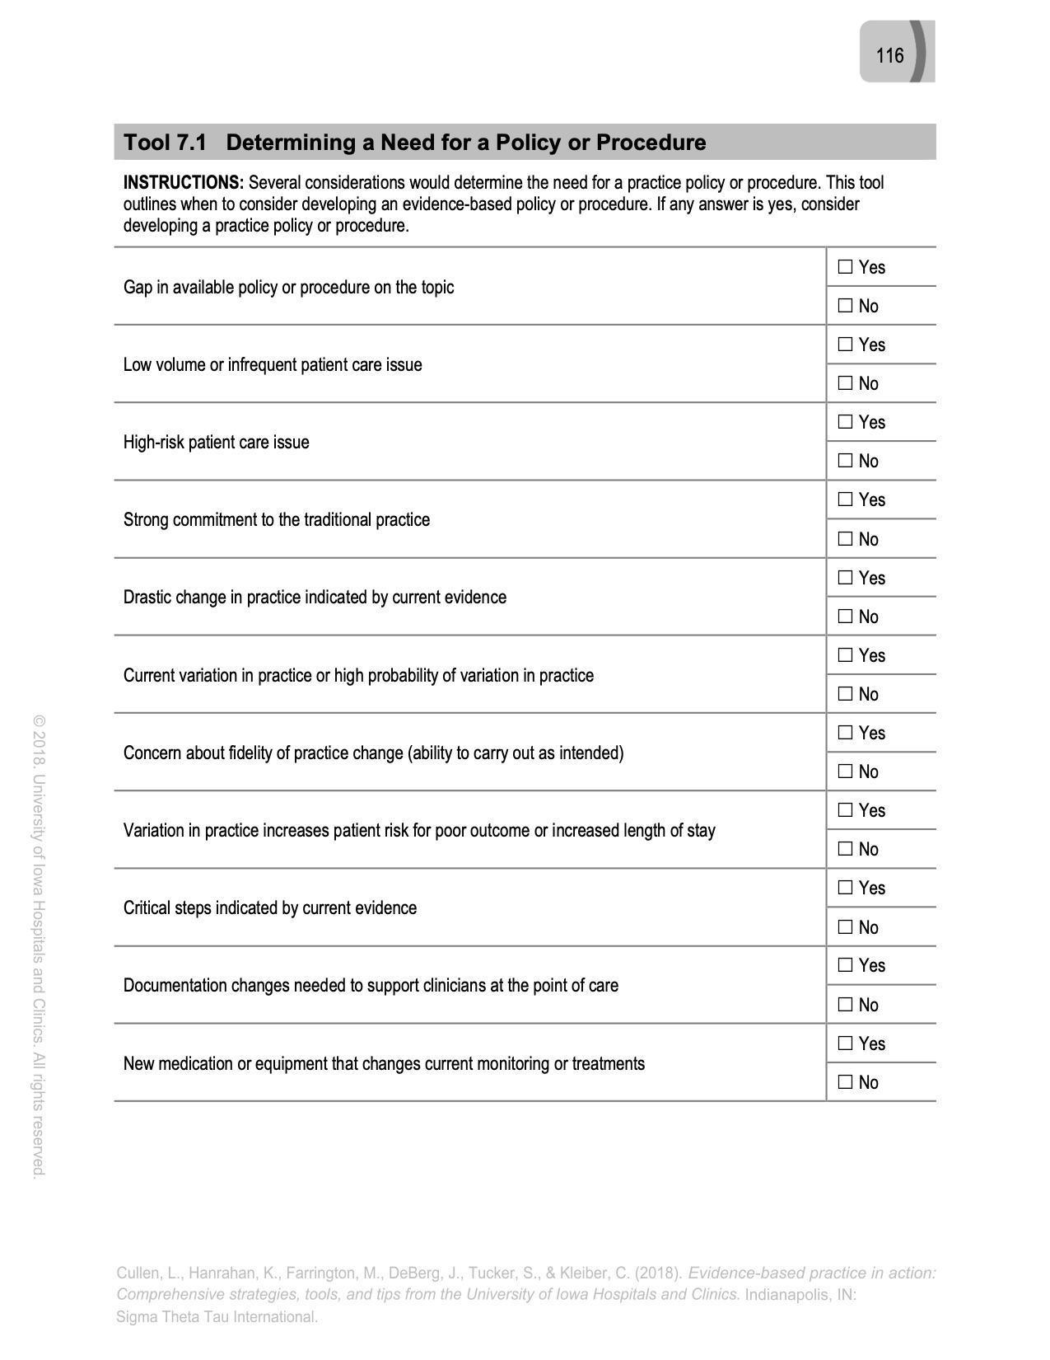
Copyright is retained by University of Iowa Hospitals and Clinics. Permission is not granted for placing on the internet. Permission is granted for use within your organization on a password protected internal website.

Please contact UIHCNursingResearchandEBP@uiowa.edu or 319-384-9098 with questions.

Citation: Cullen, L., Hanrahan, K., Farrington, M., DeBerg, J., Tucker, S., & Kleiber, C. (2018). Evidence-based practice in action: Comprehensive strategies, tools, and tips from the University of Iowa Hospitals and Clinics. Indianapolis, IN: Sigma Theta Tau International.

Appendix D
CRNA Survey Consent Script
My name is Sheila Williamson, and I am a Certified Registered Nurse Anesthetist (CRNA) and Doctorate of Nursing Practice (DNP) student at the University of Detroit Mercy interested in your experience as a CRNA. I am conducting an evidence-based practice project regarding the barriers to the use of Opioid Free Anesthesia that utilizes Intravenous Lidocaine Infusion (IVLI) as part of a Multimodal Approach and I am interested in your experiences as a Certified Registered Nurse Anesthetist. The purpose of this project is to investigate why this technique is not used.
I will provide an educational intervention on IVLI in order to promote the translation of evidence into practice. Your participation will involve a pre/post intervention survey on the use of IVLI that will last between thirty minutes and an hour. This evidence-based practice project has no known risks. The results will benefit the academic community because it helps to inform the academic community on the need to limit a patients’ exposure to opioids and their negative side effects. The information provided will remain strictly confidential and you will not be identified by your answers. You and/or your company’s name will not be disclosed in any way. Data will be compiled as a whole with no individual responses tied to your name or any identifying information about you. All information disclosed during the surveys and posttest will be kept in a secure location. Please know that I will do everything I can to protect your privacy. Please keep in mind that your participation is voluntary. I can supply you with contact information regarding this study upon request. Filling out this survey will serve as informed consent.

Appendix E
Anesthesia Provider Survey
Pre-Intervention
Participation in this questionnaire is strictly voluntary. The results of this survey will be used for educational purposes only and serves as informed consent.
1) What is your age?
- 20 and 29
- 30 and 39
- 40 and 49
- 50 and 59
- > 59
2) How long have you been a Certified Registered Nurse Anesthetist (CRNA)?
- 0-3 years
- 3-5 years
- 5-10 years
- 10-15 years
- >15 years
3) In your clinical judgment, how serious of a problem is the opioid epidemic?
- Very serious
- Somewhat serious
- Not serious
- No experience
- No opinion

4) How significant of a role does the intraoperative anesthetic technique play in
postoperative pain control following abdominal surgery?
- Very significant
- Somewhat significant
- Not Significant
- I have no experience
- No opinion
5) What is your current knowledge of intraoperative intravenous lidocaine infusion as an alternative to opioids, for pain control in abdominal surgery?
- Extremely familiar
- Very familiar
- Somewhat familiar
- Not so familiar
- Not at all familiar
6) Do you currently use intraoperative intravenous lidocaine as part of your anesthesia practice?
- Yes, please explain________________________________________________
- No, please explain_________________________________________________
7) Would you consider this intervention (intraoperative intravenous lidocaine) as part of your anesthesia practice?
- Highly likely to consider
- Somewhat likely to consider
- Neutral
- Somewhat unlikely to consider
- Not likely to consider
8) In your clinical judgment, are there potential barriers to your use of intraoperative intravenous lidocaine infusion in abdominal surgery?
- No
- Yes, please explain_______________________________________________________
__________________________________________________________________________
9) How interested are you in learning about this technique as an alternative to opioids for controlling intraoperative pain in abdominal surgery?
- Extremely interested
- Very interested
- Somewhat interested
- Not so interested
- Not at all interested

Appendix F
Anesthesia Provider Survey
Post-Intervention
1) What is your age?
- 20 and 29
- 30 and 39
- 40 and 49
- 50 and 59
- > 59
2) How long have you been a CRNA?
- 0-3 years
- 3-5 years
- 5-10 years
- 10-15 years
- >15 years
3) Was intraoperative intravenous lidocaine implemented into your practice since the presentation?
- Yes
- No, please explain____________________________________________________________
_____________________________________________________________________________

4) How many times have you used IV lidocaine since you did the pre-survey?
- 1 to 3
- 4 to 6
- 7 to 10
- Not at all
5) Was the educational intervention effective in increasing your knowledge and use of this technique?
- Extremely effective
- Very effective
- Somewhat effective
- Not so effective
- Not effective at all
6) Please add any comments that will assist in the improvement of this intervention that will increase your use of intraoperative intravenous lidocaine.

Appendix G
Henry Ford Health System Internal Review Board Approval
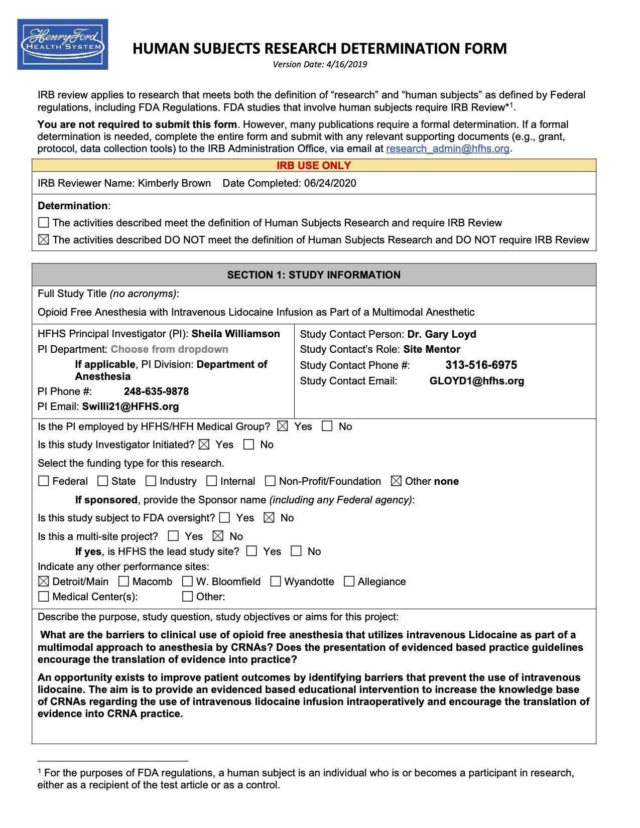
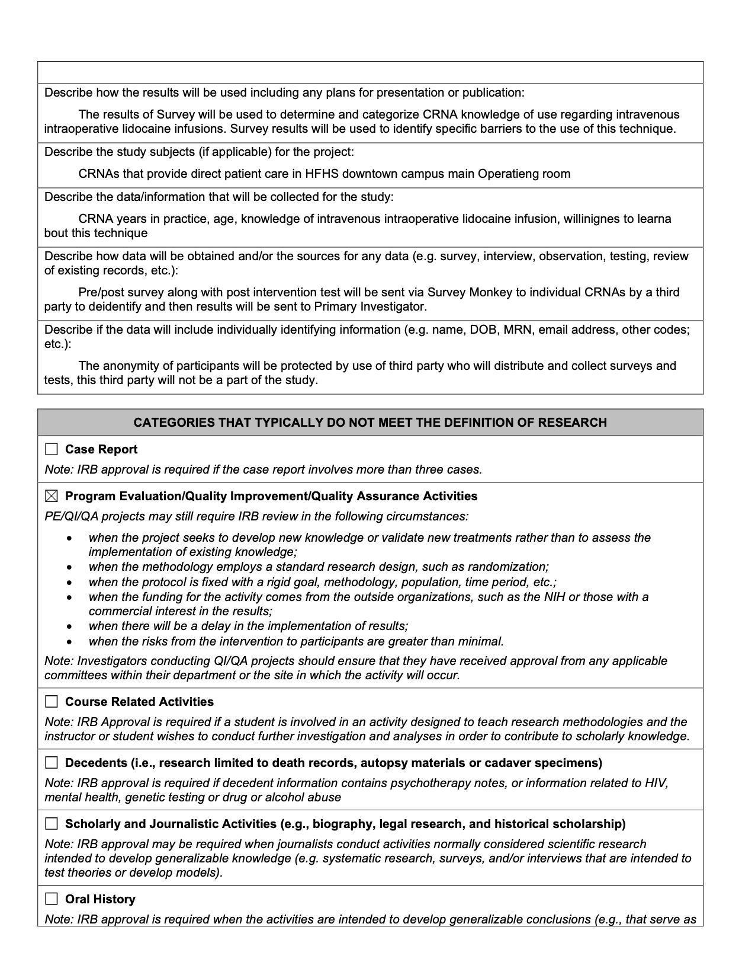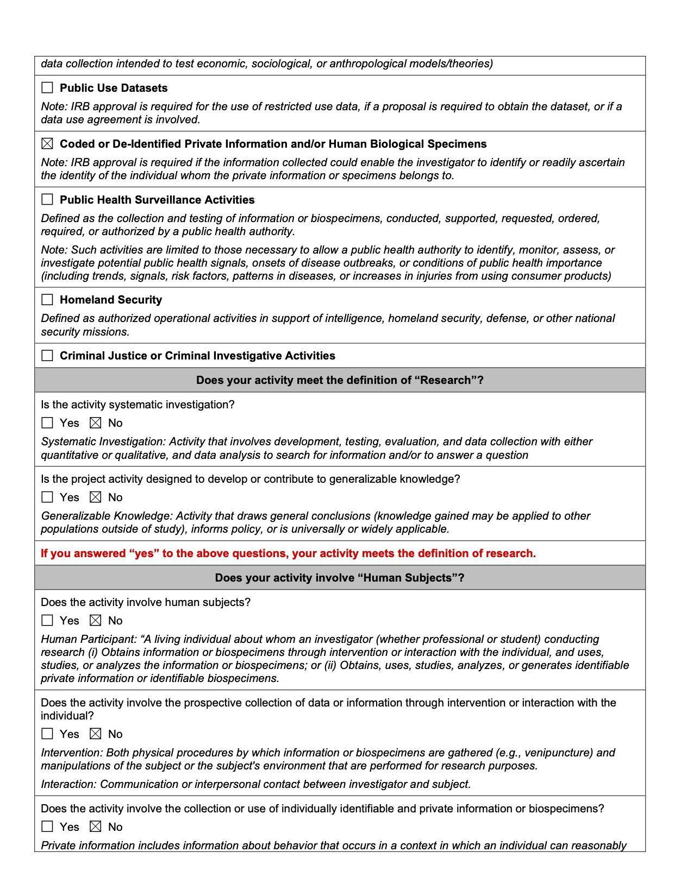

Appendix H
University of Detroit Mercy IRB Approval Letter

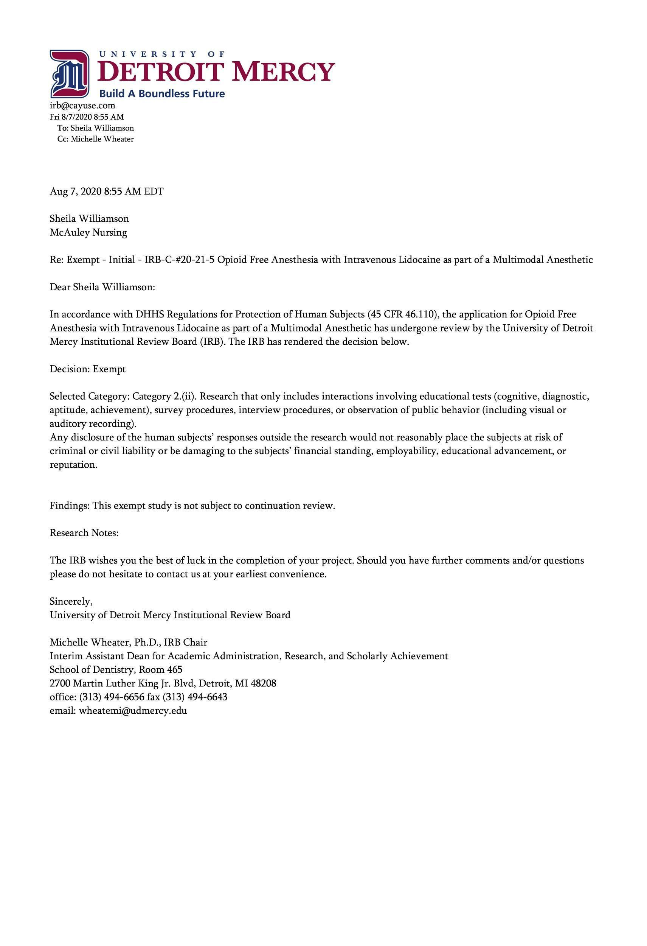

Appendix I
Intraoperative IVLI Protocol

Background
Intravenous Lidocaine infusion (IVLI) as part of a multimodal analgesic (MMA) approach has shown favorable results in the reduction of opioid consumption in the postoperative phase of care (Mujukian et al., 2019). IVLI with MMA shows promise because this technique offers an alternative to the current practice that relies heavily on opioids as the primary method for treating patient’s pain intraoperatively.
Purpose
To limit a patient's exposure to opioids, decreasing PONV, decreases post op pain and decreases ileus in patients undergoing abdominal surgery.
Definitions
- Ileus: Postoperative ileus (POI) may be defined as the impairment of gastrointestinal (GI) motility after intra-abdominal or non-abdominal surgery. It is characterized by bowel distention, lack of bowel sounds, accumulation of GI gas and fluid, and delayed passage of flatus and stool.
- MMA: Multimodal analgesic approach is a pharmacologic method of pain management which combines various groups of medications for pain relief. The most commonly combined medication groups include local anesthetics, opioids, NSAIDs, acetaminophen and alpha-2 agonists.
- Opioids: medications including but not limited to hydrocodone, oxycodone, fentanyl, morphine, oxymorphone, methadone, codeine, and meperidine which provide analgesia through agonizing the mu receptor in the central nervous system.
- PONV: Postoperative nausea and vomiting is typically used to describe nausea and/or vomiting or retching in the post-anesthesia care unit (PACU) or in the immediate 24 postoperative hours.
Pharmacology
Onset
-45-90 seconds IV
-Peripheral Nerve Block 5 minutes/1-3 hrs.
-Epidural 5 Minutes/1-2 hrs.
-Spinal < 5 Minutes 30-60 Mins
-Half Life 90-120 minutes
-Hepatic impairment 343 minutes
-CHF 136 minutes
-Time to steady state 8-10 hrs.
-Distribution- Lipophilic
-Protein binding 60-80%
Contraindications
- Unstable coronary disease

- Cardiac ejection fraction <20%
- Heart block 2nd and 3rd without pacemaker
- Electrolyte disturbances
- Severe SA nodal block without pacemaker
- Amide anesthetic allergy
- Prior use of Amiodarone hydrochloride
- Severe liver disease (bilirubin >1.46 ml/dL)
- Acute porphyria
- Severe renal impairment
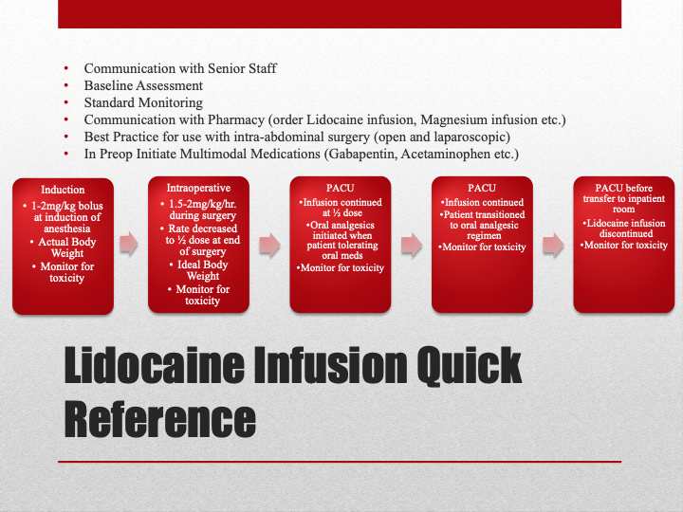
- Patients taking MOA inhibitors possible fatal interactions
Dosing
- Induction
1-2mg/kg bolus
- Intraoperative
1.5-2mg/kg/hr.
½ dose at end of surgery
Ideal body weight
- PACU
Infusion continued at ½
Transition to oral analgesic
D/C before transfer to
inpatient room
Monitor for Toxicity
Drowsiness, blurred vision, altered taste, tinnitus, confusion, and tremors
- Obtain BP/HR
- Do not increase rate
- Consider stopping infusion for 30 minutes or until resolution of adverse effects
- Raise Seizure Threshold
Seizure, arrhythmia, respiratory failure, hypotension, and bradycardia
- Stop Infusion
- Call for Help
- Obtain BP/HR
Rescue of Local Anesthetic Overdose with Lipid Emulsion
Immediately
- Give an initial intravenous bolus injection of 20% lipid emulsion 1.5mL/kg over 1 minute and start intravenous infusion of 20% lipid emulsion at 15 mL/ kg/hr.
After 5 minutes

•Give a minimum of two repeat boluses (same doses) if
• Cardiovascular stability has not been restored or
• An adequate circulation deteriorates
Leave 5 minutes between boluses
A maximum of three boluses can be given (including initial bolus)
Continue at same rate but double the rate to 30mL/kg/hr. at any time after 5 minutes if
Cardiovascular stability has not been restored or an adequate circulation deteriora

Appendix J
Permission to use Iowa EBP Model
Permission to Use the Iowa Model Revised: Evidence-Based Practice to Promote Excellence in Health Care
Inbox

Kimberly Jordan- University of Iowa Hospitals and Clinics <survey-bounce@survey.uiowa.edu> Sun, Mar 28, 3:10 PM
(20 hours ago) to Aveshah.will

Dear Sheila:

Thank you for your interest in the Nursing Evidence-Based Practice Survey© developed by the Department of Nursing Services and Patient Care at the University of Iowa Hospitals and Clinics. Following is a link to the 2005 updated survey, instructions to use the survey, and a description of the psychometrics from the 1998 version. The survey may be used as a 5-factor model, depending on your needs and interest.
You have permission, as requested today, to review and/or reproduce The Iowa Model Revised: Evidence-Based Practice to Promote Excellence in Health Care. Click the link below to open.

The Iowa Model Revised (2015)

Copyright is retained by University of Iowa Hospitals and Clinics. Permission is not granted for placing on the internet.

Citation: Iowa Model Collaborative. (2017). Iowa model of evidence-based practice: Revisions and validation. Worldviews on Evidence-Based Nursing, 14(3), 175-182. doi:10.1111/wvn.12223
In written material, please add the following statement:
Used/reprinted with permission from the University of Iowa Hospitals and Clinics, copyright 2015. For permission to use or reproduce, please contact the University of Iowa Hospitals and Clinics at 319-384-9098.
Please contact UIHCNursingResearchandEBP@uiowa.edu or 319-384-9098 with questions.

Appendix K
CRNA Manager Letter of Support
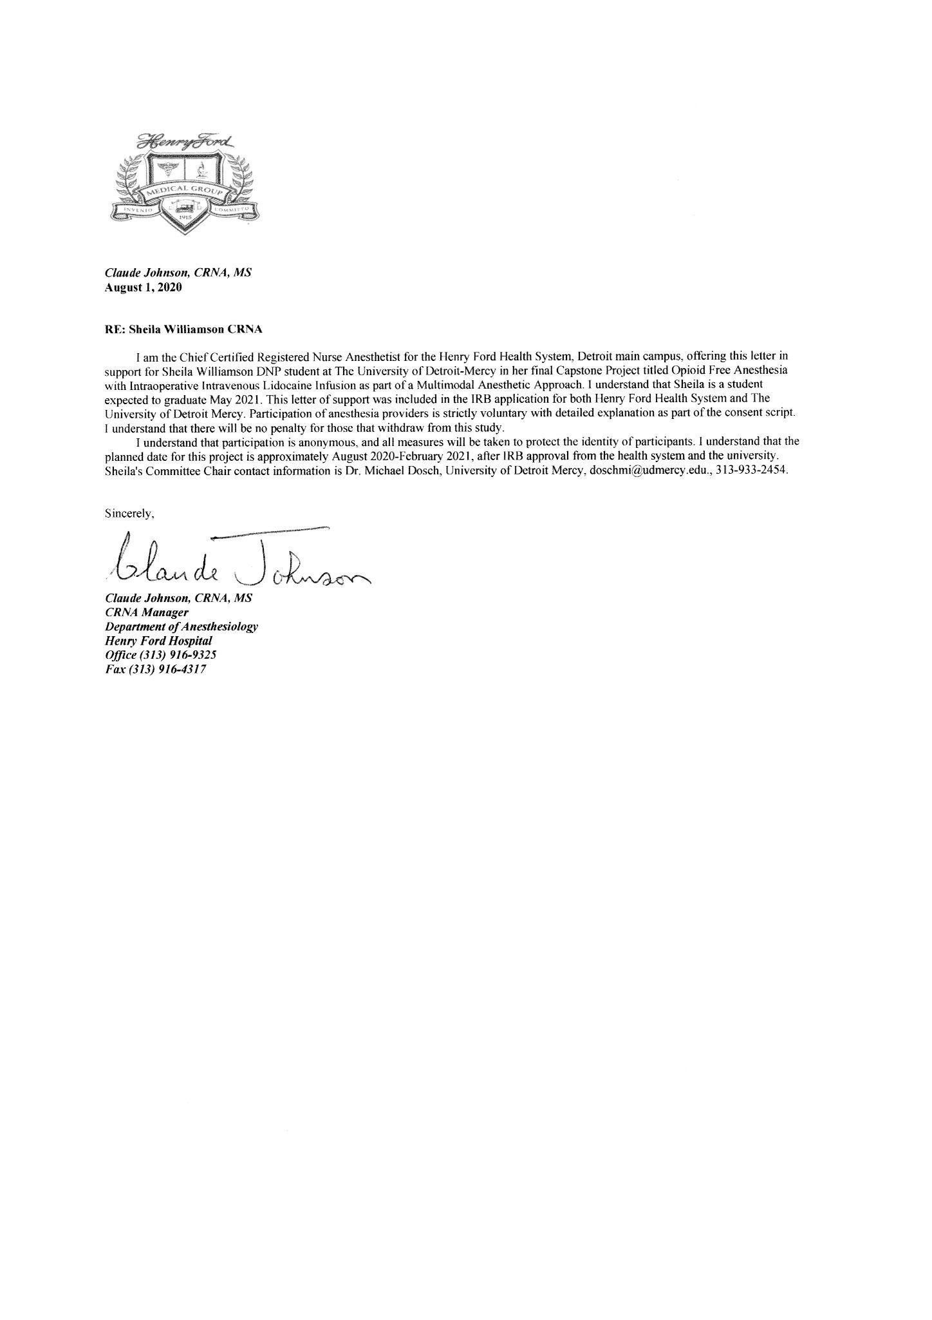
Appendix L
Division Head of Anesthesia Letter of Support
