Utilization of a Sepsis Documentation Tool in an Emergency Department
Sarah LeFevre, MSN, RN
University of Detroit Mercy
4/11/2022

Introduction
Sepsis is a global healthcare concern that can lead to life threatening complications, organ failure, and death in a patient. (World Health Organization, 2020) Per the Centers for Disease Control and Prevention (CDC), 1.7 million individuals in America will develop sepsis each year, leading to 270,000 deaths. The CDC has also reported that 1 out of 3 patients that die in the hospital setting die from sepsis. (CDC, 2020) These numbers demonstrate the importance of early sepsis recognition and timely treatment within a hospital. Early recognition and timely treatment are also known as early goal-directed therapy (EGDT), an idea studied and presented by Rivers et al in 2001. EGDT is a comprehensive strategy for treating septic patients that includes identification, interventions based on developed protocol, and evaluation of compliance and outcomes. (Armen et al, 2016) “EGDT has demonstrated significant outcome benefits in patients with severe sepsis and septic shock, with the original study demonstrating decreased in-hospital mortality from 46.5% in the standard therapy group to 30.5% in the EGDT group.” (Armen et al, 2016) Per the World Health Organization (WHO), “When sepsis is not recognized early and managed promptly, it can lead to septic shock, multiple organ failure and death.” (2020) Early detection, timely and appropriate treatment, and performance improvement programs have been associated with a reduction in mortality. (Kim and Park, 2019)
The emergency department is the initial contact or point of entry for most patients that present to a hospital. The role of the emergency team is to utilize assessment and diagnostic skills to determine a patient’s level of care requirement and initiation of treatment or management. This initial phase of the emergency department can be challenging as patients may present with multiple complaints and symptoms that are not always obvious, however, given the severity of the situation, necessitates assessment and action. In the past, recognition of sepsis was dependent on the provider and nursing knowledge and assessment. The focus hospital for this project was Ascension St. John Hospital (ASJH) located in Detroit Michigan. This hospital recently implemented a sepsis alert system to help with early recognition of potential sepsis signs. The alert analyzes data including vital signs and laboratory values as they are inputted in the computer system. The alert process runs in the background collecting this data from the electronic medical record and alerts when criteria are met. If a patient meets pre-established criteria an alert will be sent to the provider and nurse caring for that patient. The focus of this project was the implementation of a sepsis quality improvement project within the emergency department to assist with recognition, treatment, and documentation of care provided. The sepsis alert assisted with early recognition of potential sepsis; however, it is dependent on multiple factors including computer availability, alert parameters, and system accuracy. This alert notified a staff member assigned to the patient that the patient had met Systemic Inflammatory Response Syndrome (SIRS) criteria or sepsis criteria. If the staff member is not at a computer or does not have access to one this alert can be delayed, which in turn could delay action. Alert parameters and system accuracy also impacted the effectiveness of this notification. The alert parameters were determined by the hospital. If parameters are too broad the alert will fire too frequently which can lead to alarm fatigue. If the parameters are too strict it may not alarm early or frequent enough. Due to the concern for alarm fatigue, the hospital focused on more strict parameters. System accuracy was one of the main concerns related to this alert. After implementation staff found that the alert was not recognizing the current care takers. For instance, the alert would notify the emergency room nurse or physician after the patient had already been admitted to inpatient care. Due to this failure to recognize the current caregivers, staff were receiving many unnecessary alerts leading to alarm fatigue. This alert is a tool that can assist with early recognition; however, it does not negate the important role staff play in recognition and treatment of sepsis. The scope of this quality improvement project was to raise awareness and confidence in nursing staff identification and treatment of sepsis, as well as to provide an all-encompassing documentation tool to improve documentation compliance.
Background
Sepsis is defined as “life-threatening organ dysfunction caused by a dysregulated host response to infection.” (Kerrigan et al, 2019) Although anyone has the potential to develop Sepsis, certain groups are considered higher risk populations. These individuals include infants, the elderly, immunocompromised individuals, and those with chronic or severe disease processes. (Sepsis Alliance, 2020) Sepsis is largely identified with the use of screening tools available such as the modified early warning score (MEWS), national early warning score (NEWS), sequential organ failure assessment (SOFA), the quick sequential organ failure assessment (qSOFA), and systemic inflammatory response syndrome criteria (SIRS). (Nunnally et al, 2021) ASJH utilizes an electronic alert that reviews SIRS criteria and signs of organ dysfunction to assess for sepsis. SIRS criteria include a temperature >101 or <96.8, heart rate >90, respiratory rate >20, WBC >12,000 or <4,000, and bandemia >10%. (American College of Emergency Physicians, 2020) Certain SIRS clinical triggers such as heart rate >90 and respiratory rate >20 are challenging as these are common findings that present with multiple diagnoses. To improve patient care related to sepsis, the emergency department worked closely with the hospital sepsis coordinator and committee reviewing cases and assessing opportunities for improvement of care. This project provided staff education related to early recognition and treatment of sepsis and the development of a sepsis documentation tool to improve care of the septic patient. The sepsis documentation tool included all components of the centers for Medicare and Medicaid services (CMS) guidelines for care. “The evidence cited for all components of this measure is directly related to decreases in organ failure, overall reductions in hospital mortality, length of stay, and costs of care…when all bundle elements are completed and compared to patients who do not have bundle completion, the mortality difference is 14%”. (CMS, 2020)
Sepsis can lead to decreased ability to complete activities of daily living, longer length of stay in the hospital setting, organ failure, and death. Per the CDC, “those who survive severe sepsis are more likely to have permanent organ damage, cognitive impairment, and physical disability.” (2011) Length of stay for patients diagnosed with sepsis was 75% longer than for other conditions. (CDC, 2011) Per consumers health rating, “admission to a hospital in 2009 for a principal diagnosis of septicemia cost an average of $18,500 ($25,800 in 2021 dollars). Average cost per day of $2,300 was estimated ‘true’ cost” (2022) Depending on the severity, a patient may need increased observation and longer treatment to recover. This can lead to an increased length of stay in the hospital or need to attend a rehabilitation facility. Reducing length of stay with EGDT would account for a $2,300 daily savings based on this average cost per day. As an example, consider an elderly patient that presents for urinary frequency with a history of recurrent urinary tract infections. When the patient arrives at the emergency department, his triage demonstrates potential signs of an infection. After blood work is obtained, the team decides to complete a sepsis work up on the patient. The final disposition of the patient is admittance to the intensive care unit (ICU) on intravenous antibiotics for sepsis. Prior to coming to the hospital, the patient was able to complete daily activities, walk, enjoyed activities such as riding a bike, and live independently. Progression￼￼ may experience after surviving sepsis. (CDC, 2020) Due to post sepsis complications the patient was placed in a rehabilitation facility. This true account demonstrates the detrimental effects that sepsis can have on a patient or individual. Increased awareness, staff confidence, and the implementation of a sepsis documentation tool has the potential to benefit this patient by assisting with timely recognition of sepsis and implementation of EGDT. “This protocolized treatment, when administered to patients with severe sepsis or septic shock before admission to the ICU, reduced the incidence of multi-organ dysfunction and significantly decreased the in-hospital mortality rate compared with standard care.” (Kim & Park, 2019) This patient went from being independent and active, to requiring assistance within a short period of time. Now in a more weakened state, this patient has the potential to experience further complications such as falls or bedsores and possible readmission to the hospital. Possible complications of readmission include increased mortality and healthcare associated costs. Per Goodwin and Ford (2018), “thirty-day readmissions lead to significant mortality among sepsis survivors and contribute substantial cost to the healthcare system. Mortality rates during 30-day readmissions after sepsis survival range from 6.5–14.4%.”
Another important factor to consider related to sepsis readmission is the cost of readmissions for those that survive sepsis. According to a study published in the Journal of the American Medical Association, sepsis readmissions and cost were higher than other readmission rates evaluated. The study evaluated readmission rates for acute myocardial infection, heart failure, pneumonia, COPD, and sepsis. Sepsis was the leading cause for readmission and associated hospital cost. (Mayr et al, 2016) Per the sepsis alliance, “The mean (average) cost of each readmission after sepsis is $16,852, resulting in an annual cost of more than $3.5 million in the United States alone.” (Sepsis Alliance, 2020) Another study conducted by Norman et al (2018), looked at hospital readmission rates using a national sample. The study found that “nearly one-third of fee-for-service Medicare patients hospitalized with sepsis were readmitted within 30 days of discharge.” (Norman et al, 2017, p. 6) Readmission is a concern as it can demonstrate issues related to patient outcomes and cost concerns for hospitals and patients. The immediate goals of this project were to improve staff recognition in sepsis, improve staff confidence in completing the protocolized treatment, and improve documentation of care provided. Future goals would include evaluation for decreased length of stay and mortality in patients diagnosed with sepsis at ASJH.
This project focused on the Institute of Healthcare Improvement’s (IHI) model of triple aim. The three dimensions of triple aim include “improving the patient experience of care, improving health of populations, and reducing the per capita cost of health care” (Institute for Healthcare Improvement, 2020). Improvement of patient care experience is achieved by positively affecting patient outcomes. Early identification of sepsis and timely initiation of the sepsis bundles can lead to overall improved outcomes, decreased length of stay, and decreased mortality for the patient. (The Joint Commission, 2022) Two such bundle interventions include the administration of broad-spectrum antibiotics and intravenous fluids. Broad-spectrum antibiotics will cover a variety of common bacteria and are given intravenously to enter the system quickly until the source of infection can be determined. Intravenous fluids are provided to make sure the body has adequate fluids to help the organs function properly and reduce damage from sepsis. (Sepsis Alliance, 2020) This early identification and initiation improve quality and safe care that leads to improved patient and family satisfaction. Developing an aggressive and efficient sepsis protocol can prevent complications related to sepsis and improve the health of the community as it relates to infection. Sepsis is the body’s response to an infection. (Sepsis Alliance, 2020) Covid-19 is a healthcare concern worldwide that has led to many infections. As of February 25th, 2022, Michigan has had 2,357,955 cases or 23,610.6 per 100,000 individuals. (CDC, 2022) Patients who are critically ill with severe COVID-19 and other infectious diseases are at higher risk of developing and dying from sepsis.” (World Health Organization, 2020) Addressing sepsis improves the health of the population by reducing complications with early recognition and timely treatment. The final dimension of reducing per capita cost of health care is achieved by improving compliance with the sepsis core measures. EGDT has demonstrated improved patient outcomes which could lead to a reduction in the overall cost of care for both the facility and the patient. (Institute for Health Care Improvement, 2020) Recently in a blog post, the IHI CEO Kedar Mate proposed the addition of a fourth and fifth aim, making this a model of quintuple aim. The fourth aim would include workforce well-being and safety and the fifth aim would focus on improving health equity. (Kedar Mate, 2022) This new proposal is based on the theory that “the Triple Aim is not achievable without attention to healthcare burnout and inequity.” (Kedar Mate, 2022) “Nursing burnout is a widespread phenomenon characterized by a reduction in nurses’ energy that manifests in emotional exhaustion, lack of motivation, and feelings of frustration and may lead to reductions in work efficacy.” (Mundallal, Othman, & Al Hassan, 2017) The idea behind the sepsis documentation tool was to increase staff awareness and confidence, standardize documentation, and improve compliance with the sepsis bundle requirements. The tool was developed with input from the frontline nursing staff that would be utilizing it. It was important to obtain input and feedback from the individuals it was meant to assist. Staff involvement is meant to decrease frustration with process change and increase motivation for the tool to be successful; an idea congruent with the fourth aim. The fifth aim is to improve health equity. The documentation tool can be used for any patient that meets sepsis criteria within ASJH. As this is a standardized tool that is compliant with the 3- and 6-hour bundle requirements, it is designed to improve patient care for all patients that present to ASJH emergency department.
As stated above, one out of three patients that die in the hospital do so as a result of sepsis. (Centers for Disease Control and Prevention, 2020) The U.S. Department of Health and Human Services conducted a large-scale study on sepsis cases for Medicare beneficiaries from 2012-2018. This study found that “a sepsis admission carried an average adjusted 17.5% average predicted probability of mortality during hospitalization or 1 week following discharge versus the reference non-sepsis admission group in which 4.3% an average adjusted predicted probability of mortality was estimated.” (Buchman et al, 2019) These alarming numbers further demonstrate the importance of improving care of the septic patient in the hospital setting.
Cost and reimbursement are additional concerns that must be addressed in the care of the septic patient. Per the Joint Commission, “sepsis is also the most expensive disease to treat in the hospital, costing approximately $17 billion dollars each year”. (The Joint Commission, 2020) Although improved patient outcomes are the primary focus of this project, costs are also important to consider especially for hospital leadership’s buy in. The Healthcare Cost and Utilization Project (HCUP) evaluated national inpatient hospital costs by payer using 2017 national inpatient sample. The primary payers included Medicare, Medicaid, private insurance, self-pay, and other carriers. Per the data obtained, sepsis was identified as the most expensive condition treated in the United States. Below is a graph demonstrating the top four conditions based on aggregate hospital cost in millions. (Healthcare Cost and Utilization Project, 2020)

(Healthcare Cost and Utilization Project, 2020)
The Centers for Medicare and Medicaid Services (CMS) have developed core measures related to sepsis treatment and care provided. These core measures include “measurement of lactate, obtaining blood cultures, administering broad spectrum antibiotics, fluid resuscitation, vasopressor administration, reassessment of volume status and tissue perfusion, and repeat lactate measurement”. (Centers for Medicare and Medicaid Services, 2020) As stated previously, compliance with these core measures has been demonstrated to reduce mortality, length of stay, organ failure, and death. (Centers for Medicare and Medicaid Services, 2020) Failure to meet these core measures may soon directly impact hospital reimbursement for care provided. The idea behind the development of core measures was to move our healthcare system to a value-based system as opposed to volume-based system. (Centers for Medicare and Medicaid Services, 2020) This means that hospitals are reimbursed based on the quality of care provided to the patient, instead of the volume of patients they see. Currently, ASJH emergency department utilizes the three- and six-hour bundles of care to meet CMS treatment and documentation requirements. Within three hours, blood work (including lactate level and two sets of blood cultures) is obtained, antibiotics are administered, and fluids are provided for patients that are hypotensive or have a lactate level >4 mmol/L. Within six hours, the repeat lactate level must be obtained, vasopressors administered if hypotension persist despite the administration of a fluid bolus, and volume status and tissue perfusion must be assessed. These interventions are required based on the time sepsis is identified, also known as time zero. Time zero can be determined in multiple ways. The provider may document severe sepsis in their dictation, or it may be determined by chart documentation. Chart documentation would include documentation referencing infection, documentation of two SIRS criteria, and documentation of one sign of organ dysfunction. (Colorado Hospital Association, 2019) This identification time can be challenging as it involves documentation, vital signs, and laboratory values. There is a potential for delay in completing and reviewing these items dependent on the busyness and staffing of the department. Failure to recognize time zero delays providers from ordering and completing the core measures requirements in the designated timeframe provided.
The emergency department currently has representatives that sit on the hospital sepsis committee. This is a multidisciplinary committee that reviews sepsis cases monthly and discusses opportunities for improvement. The emergency department also developed their own quality improvement committee consisting of nursing and nursing leadership representation. Evaluation of the emergency department processes by the hospital sepsis committee and emergency department quality committee identified the greatest area for opportunity to be the resuscitation bay. This opportunity was identified through the review of current opportunities for improvement (OFI) found through hospital and department audits. These audits reviewed all aspects of the 3- and 6-hour bundles. The current paper documentation tool utilized in the department resuscitation bay did not include areas to document all core measure requirements. Furthermore, the document offered no clear direction of what the sepsis core measures include. One of the greatest opportunities was the documentation of the fluid bolus. Required documentation related to this metric included start time, stop time, type of fluids received, and total amount received. The chart utilized in the resuscitation bay did not reflect this required information. From this knowledge, the development of the sepsis documentation tool was proposed to assist with identifying and documenting all core measure requirements in one place.
Significance of the Problem
At a local level, the 2019 CDC data demonstrated that deaths from septicemia in Michigan is 9 per 100,000 with total death count of 1,178. Based on this data, Michigan is ranked the 25th for septicemia death rate in the United States. (Centers for Disease Control and Prevention, 2020) The Michigan Department of Health and Human Services (MDHHS) website provides septicemia death and death rates data from 1989-2018 in graph form. The trend demonstrated in this graph is upward in years progression from 1989. Based on the data provided on the MDHHS website, the number of deaths in 2018 from septicemia incurred the highest rate in the past 29 years. (Michigan Department of Health and Human Services, 2018) Another local concern related to sepsis is the Covid-19 pandemic. This project occurred in Detroit Michigan which is in Wayne County. Per CDC data, Wayne County is considered a high transmission rate; this means there are > 100 new cases per 100,000 individuals in the past seven days. The total cases in the past seven days equaled 2,279. This data was evaluated from February 19, 2022, through February 26, 2022. This high level of infection and possible transmission can demonstrate local concern for infections that have the potential to lead to sepsis.
At a national level, 1.7 million individuals in America develop sepsis each year and 270,000 will die from sepsis. (Centers for Disease Control and Prevention, 2020) It is also very expensive to treat septicemia in the United States. “It often involves a prolonged stay in the intensive care unit and complex therapies with high costs. The Agency for Healthcare Research and Quality lists sepsis as the most expensive condition treated in U.S. hospitals, costing nearly $24 billion in 2013. People with sepsis are two to three times more likely to be readmitted to the hospital than people with many other conditions, including heart failure, pneumonia, and chronic obstructive pulmonary disease. Readmissions due to sepsis are also more expensive than readmissions due to any of these other conditions.” (National Institute of General Medical Sciences, 2020)
According to the World Health Organization (WHO), “The global burden of sepsis is difficult to ascertain, although a recent scientific publication estimated that in 2017 there were 48.9 million cases and 11 million sepsis-related deaths worldwide, which accounted for almost 20% of all global deaths. Significant regional disparities in sepsis incidence and mortality exist; approximately 85.0% of sepsis cases and sepsis-related deaths worldwide occurred in low- and middle-income countries” (World Health Organization, 2020) Based on these numbers, 1 out 5 deaths worldwide are the result of sepsis. Sepsis is a condition that is important to address on a local, national, and global level given its impact on human lives and cost of care.
Problem Statement
Inconsistency with orders and documentation related to sepsis can lead to inadequate care and poor patient outcomes. To improve patient care, the CMS core measures guideline were developed to demonstrate the standards of care related to the septic patient. The concern identified by the hospital sepsis committee and emergency department quality committee within the emergency department was the lack of consistency on how orders were placed and where interventions are documented. The stakeholders identified for this project included the emergency department staff and leadership, the sepsis committee, hospital leadership, the hospital graphics center, patients, family members, and the community surrounding ASJH. Improved early recognition and timely treatment has the potential to improve patient outcomes and reduce mortality, decrease length of stay and hospital readmissions, and provide cost savings or increase reimbursement to the hospital. (Centers for Medicare and Medicaid Services, 2020) Development and implementation of a sepsis quality improvement initiative in the emergency department has the potential to assist with these concerns.
Clinical Question
The clinical question asked was, would the implementation of increased education and a paper sepsis documentation tool improve compliance with the CMS sepsis management bundles in the emergency department. The objectives that this project aimed to accomplish included improved staff confidence in recognition of sepsis, improved staff knowledge of CMS sepsis core measure requirements, and improved documentation for nursing staff in the resuscitation bay of the emergency department. The hope was that accomplishing these objectives would lead to long term improvement in patient outcomes, reduction in hospital mortality, and increased reimbursement for care over time.
Literature Review
A literature review was conducted using the CINHAL complete, PubMed Central, and ProQuest Central databases. The literature search strategy focused on keywords such as sepsis, emergency department, process improvement, identification, and bundle compliance. Search parameters included ability to view the full article, that the article be peer reviewed, and articles from 2015 to the present. The primary focus of this project was improvement of bundle compliance in the emergency department. This compliance is related to appropriate recognition, ordering of indicated testing, and timely treatment. The articles to be discussed identify the importance of implementation of a project within the emergency department, identify potential barriers to successful recognition and treatment, and offer process improvement suggestions and evaluations. The themes that were identified are demonstrated below:
Identification of Sepsis in the Emergency Department:
The first article reviewed is from the Patient Safety Monitor Journal in 2015. This journal article was titled Process Improvements in the ED Increase Sepsis Bundle Compliance, Reduce Mortality. This article reviewed the implementation of process improvement within the emergency department of Dartmouth-Hitchcock Medical Center. It highlighted the importance of early recognition and treatment of sepsis to reduce mortality rates. (Patient Safety Monitor Journal, 2015) “The reason sepsis is still so prevalent and dangerous is not a lack of best practice; the Surviving Sepsis Campaign was created in 2002 and guidelines have been in place for a decade. But sepsis continues to plague healthcare because of an inability to manage the process of applying those best practices consistently and in a timely manner.” (Patient Safety Monitor Journal, 2015) This article identified that one of the main reasons for low compliance with the recommended guidelines is that there are many moving parts and disciplines involved. Nurses, physicians, phlebotomy, pharmacy, laboratory personnel and others all play a role in the care of the septic patient. If there is a delay or lack of recognition in any of these areas, recognition and treatment can be delayed. Another factor that was considered was that the emergency department was where a process improvement can make the biggest impact in a hospital. Both concepts were consistent with the project implemented.
The article Factors Affecting Early Treatment Goals of Sepsis Patients Presenting to the Emergency Department by Kassyap et al (2018) also described identified barriers related to identification of sepsis in the emergency department. These barriers include lack of recognition of sepsis within the nursing triage and physician assessment. (Kassyap et at, 2018) If staff fail to recognize the early signs of sepsis in a patient, treatment will be delayed, and the outcome of the patient can be affected. Some recommendations within the literature to assist with staff recognition of sepsis include increased education and the development of sepsis alert system. (Grek et al, 2017)
The article Sepsis Awareness to Enhance Early Identification of Sepsis in Emergency Departments by Rajan and Rodzevik (2021) discussed the importance of early recognition of sepsis and initiation of order sets by nursing in the emergency department. This study analyzed the impact increased education with nursing staff had on early identification and initiation of a sepsis order set. In the study, half of the nursing staff received education on early recognition of sepsis, appropriate treatment, and use of an already available hospital order set. The data analyzed included the timeframe from when a patient registered in the emergency department to when sepsis was identified, and the order set initiated by nursing staff. This study found that those who received additional education had a decrease in identification and order set initiation of 33 minutes. (Rajan & Rodzevik, 2021)
Sepsis Bundle Compliance:
The article Factors Affecting Early Treatment Goals of Sepsis Patients Presenting to the Emergency Department by Kassyap et al (2018) also identified barriers related to compliance with the sepsis bundles. As sepsis is a global concern, this article is from the Indian Journal of Critical Care Medicine. The study was conducted as a prospective observational study in an emergency department in South India. This study reviewed sepsis cases from the hospital to review for compliance with the 3-hour and 6-hour sepsis bundles. The study found four factors that affected compliance with the bundles. These factors included under triaging, physician delay in diagnosis, logistical delays, and financial constraints. A triage assessment is completed in most emergency departments by the nursing stuff. If the nursing staff fail to recognize a potentially septic patient, they risk under triaging that patient and delaying care. This is also a concern related to physician assessment. If the physician is delayed in their assessment of the patient or fail to recognize a potentially septic patient, care can be delayed or missed. Logistical delays include a delay in procedures, testing, admission, etc. Financial constraints refer to the impact the cost of sepsis can have on the patient and family. (Kassyap et al, 2018)
Although this article was published outside of the United States, it demonstrates concerns that all hospitals will face regarding care of a septic patient. Within an emergency department there are many opportunities for aspects of care to be missed. This project included education for the nursing staff on recognizing potential sepsis. As stated previously, this can be challenging as patients present with multiple complaints and sepsis can present as other concerns. This speaks to the idea of incorrect triage or physician assessment errors. Logistic delays can also play a key role in delay of care. For example, in the proposed emergency department, phlebotomy is the preferred group to draw blood cultures for all patients as their contamination rates tend to be lower. Phlebotomy is not always available due to staffing, so blood culture draws may be delayed if staff choose to wait for them to be available. There can also be delays in transfers to the ICU for critical patients if the hospital is very busy or full. These are examples of ways in which care can be delayed logistically. The financial aspect does not affect the care a patient would receive in the emergency department in the United States as it may in other countries due to EMTALA rules. Financial delays could occur from a patient perspective. If they do not have insurance, they may be less inclined to come to the hospital immediately. This would mean patients may come after they have already progressed into severe sepsis or septic shock, making their care require more resources and cause potential complications. This article supported the project intervention of increased education for recognition and development of a documentation tool to assist with meeting all requirements in a timely manner.
The Patient Safety Monitor Journal (2015) also touched on the topic of sepsis bundle compliance. A barrier noted within this article was that sepsis involves many moving parts and disciplines. This can include nursing, physicians, lab technicians, phlebotomists, pharmacist, etc. If any of these disciplines fail to recognize or act in a timely manner, there is a potential for non-compliance with the sepsis bundle requirements. (Patient Safety Monitor Journal, 2015) Recommendations to assist with bundle compliance include increased staff education, development of a checklist to assist with bundle compliance, and the development of a quality improvement initiative within the organization. (Grek et al, 2017)
Process Improvement Initiatives:
The Patient Safety Monitor Journal article provided a recommendation that a process improvement project start in the emergency department as this is where the bulk of patients will present. This article suggested “there is an 80-20 split that identifies where sepsis patients are coming into the hospital.” (Patient Safety Monitor Journal, 2015) This idea is that 80% of septic patients present to the emergency department and 20% from other areas. If 80% present to the emergency department, it would make sense to develop a process improvement initiative that begins in the emergency department as this will have the greatest potential for impact. This article supported the project plan to initiate a process improvement within the emergency department, as well as the involvement of the sepsis multidisciplinary committee.
The article Pharmacist impact on sepsis bundle compliance through participation on an ED sepsis alert team by Yarbrough et al, 2019 discussed the use of a multidisciplinary sepsis alert team. This article focused on the impact a pharmacist would have on bundle compliance when added to this team. Cases were divided into two categories, those where a pharmacist responded and those where they did not. Cases that had pharmacy support demonstrated a higher success rate with the 3-hour sepsis bundle requirements. The study found that 79% of the cases where the pharmacist responded received antibiotic therapy within 1 hour, while only 33% of cases received antibiotic therapy within one hour when a pharmacist was not available. (Yarbrough et al, 2019) ASJH does not have a sepsis alert team, however, they do have 24/7 pharmacy available within the emergency department. A department pharmacist can assist with proper ordering and availability of antibiotics for septic patients, potentially improving sepsis bundle compliance. A sepsis alert team was not part of this project, however, it would make a good recommendation for future steps.
An additional article reviewed related to a process improvement initiative was Sepsis and Shock Response Team: Impact of a Multidisciplinary Approach to Implementing Surviving Sepsis Campaign Guidelines and Surviving the Process by Grek et al (2017). The purpose of this study was to create and evaluate a series of quality improvement initiatives started within a medical center. Patients were identified within the emergency department and followed throughout the course of their stay until discharge. This project started with the development of a multidisciplinary team that could evaluate and analyze current practice and opportunities for improvement. From this, the medical center implemented what they called an electronic sniffer. This sepsis sniffer was a computerized algorithm that would alert the lead nurse if a patient met designated criteria as a potential septic patient. This nurse could then contact the physician to have that patient evaluated. The facility created a sepsis and shock response team that was called to evaluate the patient within 15 minutes. This team would ensure that all aspects of the bundle were completed, and that the patient was transferred to the appropriate care area quickly. A checklist was developed and provided to assist the nursing staff with meeting all bundle requirements. This form also allowed staff to timestamp their interventions. Finally, education and feedback were provided to staff members, including the development of role specific badge cards that outlined each discipline's role in care of sepsis. Bundle compliance was evaluated pre and post implementation of the project. The pre implementation evaluation demonstrated that compliance with each aspect of the bundle was low. (Grek et al, 2017) “Post implementation compliance with each of the elements improved, including the all-or-none metric, which exceeded the original 30% improvement goal set by the institution.” (Grek et al, 2017, p. 503) This article contained certain aspects of the sepsis project discussed in this paper. The main proposal was the development of a sepsis documentation tool to assist with meeting all the requirements of the bundle sets; this project also proposed increased staff training. ASJH recently implemented the use of a sepsis alert system prior to the implementation of this project. Concerns regarding the alert system included an increase in false responses. In the study mentioned above, 146 patients met the requirements for severe sepsis/septic shock, yet the alert went off 386 times. (Grek et al, 2017) This means that the alert was only correct 37.8% of the time. The facility this study took place in was a 304-bed medical center. (Grek et al, 2017) A larger facility may see an even greater false alert, leading to potential for alarm fatigue. The development of the sepsis resuscitation tool utilized in this study is like the implemented documentation tool for this project. This article demonstrated that the tool/checklist is helpful for staff to make sure all aspects of the sepsis bundles are achieved in the designated time periods and supports the clinical question and this project.
The final article reviewed Sepsis Performance Improvement Programs: From Evidence Toward Clinical Implementation by Shinkel, Nanayakkara, and Wiersigna (2022) evaluated performance improvement programs initiated to improve compliance with sepsis requirements. Performance improvement programs evaluated included sepsis screening tools, sepsis response teams, standardized EHR order sets, nurse driven protocols, and sepsis education programs. The areas that demonstrated the greatest improvement in bundle compliance were the use of a sepsis response team, standardized EHR order sets, nurse driven protocols, and sepsis educational programs. Sepsis screening tools did not consistently demonstrate improvement in performance indicators. (Shinkel, Nanayakkara, & Wiersigna, 2022) “A limitation to all currently used tools is that they are susceptible to false positives because of the relatively low prevalence of sepsis, particularly in the general emergency department and ward populations.” (Shinkel, Nanayakkara, & Wiersigna, 2022)

Organizational Assessment
The organization this quality improvement project was completed at was Ascension St. John, a city hospital located in Detroit Michigan. Ascension St. John Hospital (ASJH) is a busy level one adult trauma center, level two pediatric center, and a comprehensive stroke center. ASJH is a teaching facility that hosts many different disciplines such as residents, nursing interns, and students in clinical rotations. The project was implemented within the emergency department. The emergency department is a 101-bed unit that includes behavioral health safe rooms, a locked down behavioral health holding unit, a pediatric emergency department, a trauma resuscitation bay, an ambulatory center, EMS bay, triage bay, and medical rooms. This project focused on data from October/November 2020 and October/November 2021. In the year 2020 ASJH emergency department had a daily average of 225 visits for a total of 82,198 visits yearly. In the year 2021 ASJH emergency department had a daily average of 234 visits for a total of 85,584 visits yearly. Daily staffing in the emergency department included physicians, resident physicians, nursing, emergency room technicians, paramedics, respiratory, pharmacy, health unit coordinators, and patient representatives.
Readiness for Change:
The area that this project occurred in was the emergency department. Currently within the facility, there is a sepsis committee that meets monthly to review cases and discuss opportunities. This committee is a multidisciplinary team that includes a sepsis coordinator, physicians, pharmacy, infectious disease, emergency department nursing leadership, and others who attend a monthly meeting. Data specifically for the facility, as well as the hospital system, are reviewed and discussed. This committee demonstrated the readiness for change of this organization. The emergency department leadership team also developed a monthly quality improvement meeting to discuss topics within the emergency department of significance. Such topics include stroke, STEMI, restraints, sepsis, and others. Related to sepsis, the department utilized information obtained from the sepsis committee and quality improvement meetings to identify areas of concern within the department related to sepsis. These concerns included failure to recognize sepsis in a timely manner, failure to implement all CMS required metrics, and difficulty with documentation of the sepsis metrics in the resuscitation bay. The development of a sepsis paper documentation tool was proposed to address the concerns identified. The department also audits all charts that include a physician note of sepsis for compliance. The data collected in these audits included identification of time zero, collection of initial lactic acid, collection of blood cultures, administration of antibiotics, fluid administration as needed, collection of repeat lactic acid, and administration of vasopressors. The audit also indicated if the opportunity for improvement (OFI) was nursing or physician based. Follow-up was provided to any staff members if any aspects of care were not completed within the sepsis guidelines. The commitment that the emergency department has placed by attending and developing these meetings demonstrated the readiness to change and improve the current process.
Facilitators:
Facilitators for this organization included the development of a sepsis coordinator role, development of the sepsis committee, and active multidisciplinary involvement in review of care and process improvement. The sepsis coordinator is a position that was added recently to focus on current data and ways to improve quality of care within the facility. This person is dedicated and instrumental to the sepsis program at ASJH. The sepsis committee is a facilitator as it has brought together many disciplines to work together towards positive change. This multidisciplinary approach offers a range of perspectives and expertise on the subject. The emergency department also has members of the staff that have volunteered to be sepsis champions who are considered facilitators. These facilitators are in place to help with continued department education and demonstration of the sepsis documentation tool. They also can act as department representatives for all staff to ensure all have a voice in the process.
Barriers:
A barrier for this organization was the use of paper documentation within the resuscitation area. Due to the high volume and critical acuity of the patients brought to the resuscitation area, computerized documentation has been unsuccessful in implementation. As such, all documentation in this area is completed via a paper chart. This documentation presents challenges as it relies on staff memory in a stressful environment to ensure all aspects of care are provided and documented as it relates to sepsis. With computerized charting, as used in the main emergency department areas, a physician can implement an order set which includes all requirements of the three- and six-hour bundles. As this is not an option in the resuscitation bay where the most severely septic patients are taken, there is a barrier of inconsistent ordering and documentation that was present in the emergency department.
Another barrier of the organization was staffing shortages. During the time of project implementation, the emergency department experienced a significant staff turnover. Agency registered nurses and system flex were hired to assist with the shortage. This is a barrier as many were not present during the rollout of sepsis education and were not as familiar with the sepsis documentation tool. Staff turnover would also affect the pre- and post-survey results as staff members that were present for the pre- survey may not have been present for the post survey. Another staffing concern involved the shortage of phlebotomists available to work in the emergency department. It is the recommendation of department and hospital leadership that a phlebotomist complete blood culture collection as their contamination rates tend to be lower. Without this additional resource there can be a delay in blood culture collection which could impact successful bundle completion.
Strengths of Organization:
The strengths of this organization/department included the buy-in and support from department leadership. Currently department leadership participates in the hospital sepsis committee monthly to discuss opportunities for improvement. In recognizing the need for improvement, department leadership also selected two associates to serve as department sepsis champions. The project involved the development of a sepsis paper documentation tool to be utilized within the resuscitation bay where critically sick patients are taken. Department leadership supported the development and implementation of this tool as a quality improvement project.
Staff support was also a strength of this organization. Staff were included in the development of the tool for ease of use. Staff also verbalized the need for further education and development of an initiative related to sepsis. Two staff members volunteered and were chosen to act as department sepsis champions. These individuals attended sepsis meetings to discuss process improvement with the leadership team. They also assisted with continued education throughout the department. This department's involvement was considered a great strength for this project for buy-in and successful implementation.
A final strength of this organization included the resources and support the department receives. This department has 24-hour pharmacy coverage that can assist with any medication related questions or concerns. Pharmacy can also assist in preparation of the antibiotics septic patients will receive and assist physicians with ordering the correct medications. Although currently short staffed, the department was previously provided a phlebotomist that could assist with blood draws. If a phlebotomist was available, they could assist with blood culture collection. If unavailable, the department trained all registered nurses, emergency room technicians, and paramedics in the proper technique to obtain blood cultures. Blood culture collection kits were also implemented to make all needed supplies readily accessible for staff. As a teaching hospital, there are both attending and resident physicians available within the department. This assists with improved and timely communication between nursing and physicians. Finally, supplies needed for care were readily accessible in the department as well as the stockroom. There is a supply coordinator that keeps all necessary equipment and supplies stocked and ready for staff.
Gaps and Limitations:
Gaps and limitations of this organization included inconsistency in ordering, challenges with proper documentation, and staffing concerns. As one area utilized paper documentation, it was challenging to ensure all aspects of required tests and treatment were ordered and documented correctly. There is an order set available within the computer that can be ordered for any patient located within the main section of the emergency department. It was discovered that not all physicians were utilizing this order set, but instead were ordering each item individually. This can pose a challenge as it relies on staff to remember all aspects of the requirements from memory. A second limitation identified was the use of paper documentation in the resuscitation area of this facility. Due to the large volume of critical patients that present in this fast-paced area, paper documentation is currently used. Patients who are suffering from severe sepsis or septic shock tend to be cared for in this area as they can receive more individualized care. With paper documentation, the use of the electronic order set is not an option. As such, physicians again were ordering interventions and treatments individually, or a la carte. This variability in ordering and documentation inspired the development of a paper order set and documentation tool to be utilized within the resuscitation area of the emergency department. The goal was to reduce the individualized ordering methods and improve compliance with treatment and documentation of the septic patient, improving patient outcomes. A third barrier was inconsistency in staffing. Like many healthcare facilities, staff turnover was a concern in the emergency department. To assist with staffing concerns, agency registered nurses were utilized within the department. New staff and agency nurses were not as familiar with department processes which again can lead to inconsistencies in treatment. A final barrier was failure to recognize sepsis within a timely manner. When sepsis is not recognized timely, care can be delayed, potentially impacting the patient outcome.
Cost Factors:
As discussed previously, sepsis reimbursement may soon be based on quality of care via CMS standards versus quantity of care. To meet this core measure, all aspects of the sepsis bundles must be met within the designated timeframes of three and six hours. Given these concerns, implementing a project to increase compliance with the core measure requirements can improve patient outcome and reduce hospital costs related to sepsis care. “The average direct cost borne by hospitals per case for a primary sepsis diagnosis is $18,700, yet the typical Medicare reimbursement for sepsis and sepsis with complications is only $7,100 to $12,000.” (Wolters Kluwer, 2018) Reducing length of stay, decreasing readmission, and improving bundle compliance can all lead to cost savings for the hospital system.
Rationale
It is well documented throughout the literature and across healthcare related sites that sepsis is a worldwide concern that needs to be addressed. The emergency department is the main avenue where most patients will have the potential to be identified as septic. It is here where the greatest opportunity to improve patient outcomes occur, have the potential to reduce length of stay, improve quality and safe care, and improve hospital reimbursement for care provided. Sepsis was an identified issue within the proposed organization. The emergency department demonstrated that they were ready and willing to support process improvement to increase compliance with CMS guidelines for the 3-hour and 6-hour bundles. The main identified issues for this department included lack of early recognition and challenges associated with documentation within their resuscitation area. Timely compliance with these bundles leads to improved patient outcomes and potential for increased reimbursement. The aim of this project was to achieve improved compliance with early recognition, with each individual aspect of the bundles, and with overall bundle compliance.
Theoretical Framework
The theoretical framework that helped guide this project was the Change Theory of Nursing by Kurt Lewin. This theory has a “three-stage model of change known as unfreezing-change-refreeze model that requires prior learning to be rejected and replaced”. (Petiprin, 2020) Practices in healthcare change as new best practices become available. This project is a quality improvement project within the emergency department. Quality improvement aims to “improve outcomes for patients, healthcare systems, and organizations.” (Centers for Medicare and Medicaid Services, 2021) This can be achieved through evaluation of current processes, implementation of proposed changes/interventions, and evaluation of effectiveness of this process. Lewin’s theory of change addresses the process of change.
Unfreezing refers to the process of identifying and letting go of old habits or behaviors that are counterproductive to the goal. (Petiprin, 2020) During the organizational assessment it was noted that barriers the department faced related to sepsis included failure to order or complete all sepsis bundle requirements and failure to document care appropriately. A common habit identified was the process of ordering testing and treatment individually as opposed to utilizing an order set. This was common in all areas of the emergency department. The hospital sepsis committee provided education to providers on the importance of breaking this habit and utilizing the sepsis order sets the hospital developed. From the standpoint of this project, nursing was also educated to encourage the use of order sets if they noted they were not being used. Regarding documentation, nursing struggled to document all required metrics in the resuscitation bay. The trauma documentation record did not include areas to document all requirements, hence why the sepsis documentation tool was developed. Staff were encouraged to utilize the sepsis documentation tool in conjunction with the trauma record to properly document and verify all steps were completed in the designated timeframes. This documentation tool aimed to break the old pattern of documenting at the associate's discretion to a standardized approach.
The change stage “involves a process of change in thoughts, feeling, behavior, or all three, that is in some way more liberating or more productive.” (Petiprin, 2020) Staff were provided education focused on sepsis recognition, treatment, and documentation to improve confidence and satisfaction with care of the septic patient in the emergency department. Improved confidence and satisfaction can change staff perceptions and feelings related to this diagnosis and their role in treatment. The sepsis documentation tool was also developed and implemented to change the behavior of documentation within the resuscitation bay of the emergency department. Staff were involved in the development of the tool to increase acceptance, commitment, and participation in utilization of the tool. “For overcoming the resistance in organizational change, the employee involvement is the most oldest and effective strategy in formulating the planning and implementing change. The participation will lead high quality change and prevail over the resistance in implementing stage” (Hussain et al, 2018)
The refreezing stage is the point where the new habit becomes “the standard operating procedure.” (Petiprin, 2020) The sepsis documentation tool that was developed for this project was presented to the emergency department advisory board and approved to be a permanent form within the organization for use. The form was barcoded and is considered a permanent part of the patient record. Staff received training on use of the form, and it was implemented within the emergency department. Since implementation within the ASJH emergency department the form has been introduced for use within another emergency department within the organization.
Conceptual Model
The conceptual model that helped guide this quality improvement project was the Model for Improvement. This model was developed by the Associates in Process Improvement. (IHI, 2020) This model involves two parts, three fundamental questions and the development of a plan-do-study-act (PDSA) cycle. Per IHI (2020), “The PDSA cycle guides the test of a change to determine if the change is an improvement.” The model for improvement works well with a quality improvement project as it is a simple, effective, and timely method to test and evaluate process changes within an organization. The three fundamental questions include:
- What are we trying to accomplish?
- How will we know that a change is an improvement?
- What change can we make that will result in improvement?
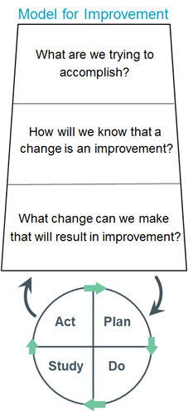
This Photo by Unknown Author is licensed under CC BY-SA-NC
After identifying the desired changes, the changes can then be tested utilizing the PDSA cycle. For this project, there were multiple goals/outcomes that the department wanted to accomplish. These fundamental questions and the development of a PDSA cycle were utilized for each individual goal/outcome. For example, the goal/outcome of developing a sepsis documentation tool:
- What are we trying to accomplish? Improving patient outcomes through the development and use of a
- How will we know that a change is an improvement? Comparison of patient medical records to measure compliance with the CMS sepsis bundles pre and post implementation.
- What change can we make that will result in improvement? The proposed change is the development of a paper sepsis documentation tool that can be utilized by nursing in the resuscitation bay of the emergency department.
PDSA cycle for sepsis identification tool:

As stated, this model can be used for all goals and objectives identified within the project. Within the organization there were several identified opportunities to improve the care of the septic patient. Utilizing the Model for Improvement helped identify aims, develop measures, identify changes, and test those changes. (IHI, 2020)
Project Purpose/Objectives
The purpose of the proposed project was to improve compliance with the sepsis bundles and overall care of the septic patient within the emergency department of ASJH. It also aimed to improve staff satisfaction and confidence with care of the septic patient. With improvement in care, the hospital has the potential to improve patient outcomes and increase hospital reimbursement for care provided. The project included the development of a sepsis documentation tool, increased staff awareness, and development of an education program within the emergency department. The paper documentation tool was developed to assist with bundle compliance for patients that present to the resuscitation area of the ASJ emergency department. A paper documentation tool can be a guide for nursing and providers to complete all required tests and interventions within the timeframes identified in the CMS core measures. It also can be a guide to assist with patient handoff for nursing during any transition of care. Increased awareness and education aimed to improve staff recognition and confidence in the care of the septic patient. Multiple methods for education were utilized including lecture, case studies, hands on training, and use of electronic resources such as email and google classrooms. Staff were also provided with a pre and post survey to evaluate their confidence level in recognizing sepsis and caring for the septic patient.
The goals of this project included timely and appropriate recognition of sepsis during RN assessment, timely completion of all sepsis bundle requirements, improvement in documentation of sepsis care, and increased awareness and confidence in staff related to sepsis.
The identified objectives for this project included:
- Implementation of a paper sepsis documentation tool for the resuscitation bay at ASJH
- Implementation of sepsis education program for staff in the emergency department at ASJH
- Evaluation of compliance with sepsis bundles
- Evaluation of staff confidence and satisfaction with sepsis identification and documentation tools utilizing a pre/post intervention survey
Methods/Design
The design for this project was a quality improvement project focused on adult patients within the emergency department. Methods included:
- Development and implementation of a paper sepsis documentation tool for the resuscitation bay at ASJH.
- Development and implementation of sepsis education materials for staff in the Emergency Department at ASJH.
- Pre-Implementation data collection: October 2020 and November 2020
- Post Implementation data collection: October 2021 and November 2021
- Pre-Implementation Survey: to evaluate staff confidence and satisfaction with sepsis identification and previous documentation tool
- Post Implementation Survey: to evaluate staff confidence and satisfaction with sepsis identification and new documentation tool
- Evaluation of pre and post data
- Evaluation of pre and post survey
Implementation
This project took place within the emergency department of ASJH. Data was collected for a 2-month period; October 2021-November 2021. The data collected included compliance with initial lactic acid collection, blood culture collection, antibiotics administration, fluid bolus administration, repeat lactic acid, administration of vasopressors, and tissue perfusion reassessment. Prior to implementation, a staff satisfaction/confidence survey was created and initiated to obtain pre-implementation input. (Appendix II) Upon completion of the 2-month period, audits were conducted to evaluate the 3- and 6-hour sepsis metrics and analyzed to assess for improvement with the three- and six-hour bundle requirements and documentation. The data was compared to the 2-month pre-implementation period; October 2020-Novmeber 2020 (Appendix IV). A post-implementation survey was also completed to assess staff satisfaction and confidence (Appendix III). Each section is detailed below.
Staff Education:
Education was provided at daily staff huddles and small in-person small groups to nursing. This education was provided by the emergency department educator, department quality coordinator, and the department sepsis champions. Due to Covid-19 restrictions the in-person small group sessions occurred by practicing social distancing, limiting numbers, and masking. The in-person sessions focused on sepsis awareness, recognition, treatment/management, and the proposed documentation tool. Staff huddles included brief five-to-ten-minute sessions discussing utilization of the proposed tools.
Staff education included background of the identification of sepsis, signs/symptoms the patient may present with (SIRS/Organ Dysfunction), required interventions and documentation, and information regarding the new documentation tool and processes being implemented (Appendix V). This information was provided at unit huddles and via rounding throughout the department. Tracking demonstrated that 75.5% of the emergency department nurses received education. Education was also provided to all new nurses and new to specialty nurses at an ED orientation class. This education included a sepsis presentation, blood culture education, and the completion of a sepsis case study (Appendix VI). Additionally, post implementation, staff were provided the sepsis key messages (Appendix V) and a sepsis case study (Appendix VII) via a google classroom.
Additionally, as September is sepsis awareness month, sepsis awareness bags were distributed to the staff throughout the month. The contents of these bags included a sepsis badge buddy card, candy with a sepsis fact on the bag, a sepsis pamphlet (Appendix VIII), and a “know” sepsis pen. A banner was also displayed near the breakroom.
Paper Documentation Tool:
The paper documentation tool was approved by the project committee and department leadership prior to implementation. The tool was barcoded and has an order number so it can be considered a permanent part of the patient’s chart. Barcoding the form also reduced the need for staff to document in multiple areas. All CMS requirements are on one form ensuring that staff members are compliant (Appendix I). Upon approval, the paper documentation tool was presented to staff for education regarding tool use and the implementation process. Once staff members were educated on the use of the documentation tool, the tool was placed in each station located within the resuscitation bay. Staff were encouraged to utilize this form when caring for a patient suspected of septicemia. As presentation of sepsis is not always obvious, staff may initially begin documentation on the current resuscitation paper chart. It was recommended to staff that they obtain the sepsis documentation tool upon recognition of sepsis to document the sepsis metrics. Staff members were not required to document these metrics on both forms, but rather use these forms in tandem. The form stayed with the patient’s chart throughout the course of their stay in the hospital. Upon discharge, the form was scanned electronically into the patient’s chart under assessment nursing for a later review as necessary.
Pre/Post Survey
Once education was complete, a pre-implementation survey was developed by the project lead and sent via a survey monkey link to evaluate staff confidence in recognition and treatment of sepsis, as well as satisfaction with the current documentation tool. An email with a link was sent to staff detailing the focus of the survey. A letter of consent was provided prior to administration of the survey. Privacy was also maintained with utilization of the hospital de-identification process. Results were converted to an excel document by a hospital data analyst and shared with the project lead for interpretation. After project implementation, a post implementation survey was developed by the project lead and sent via a survey monkey link to evaluate staff confidence in recognition and treatment of sepsis, as well as satisfaction with the new documentation tool. Both surveys utilized a Likert scale to answer questions related to staff confidence in identification and treatment of sepsis, as well as satisfaction with the designated documentation tool. Each survey also included open ended questions related to barriers with timely recognition, treatment, and documentation. (Please see appendix II and III) The data from both surveys was evaluated and compared.
Ethical Considerations
The implementation of a documentation tool related to sepsis will hopefully impact patient care in a positive manner. As this quality improvement project aimed to improve timely recognition, treatment, and documentation of septic patients, one must consider the ethical considerations as well. To evaluate if the implementation of this project has been effective within the designated department, patient data was collected and reviewed. This data included chart reviews of care provided. Criteria for patient selection included adult patients that had a diagnosis of sepsis based on physician documentation or sepsis alert criteria; only pediatric patients were excluded from the sample. The hospital sepsis committee reviews charts based on criteria the abstractors identify as including a sepsis diagnosis. In this committee the medical record number, sex, and age are included in patient data. In the evaluation phase, age, sex, and race were considered to evaluate data and look for trends. Information was collected in aggregate form to protect patient information; the medical record number and name of the patient were not utilized in any documentation or graphs that were presented during the final presentation. Instead, the data evaluated included sepsis metrics and staff surveys. Audit data will be stored in a private google drive within the hospital computer system that is password protected to protect patient privacy. Only the auditor and emergency department leadership will have access to this drive.
To ensure that patient privacy and rights were respected and protected, the Institutional Review Board (IRB) process was followed for both Ascension St. John and the University of Detroit Mercy. “The purpose of IRB review is to assure, both in advance and by periodic review, that appropriate steps are taken to protect the rights and welfare of humans participating as subjects in the research.” (U.S. Food and Drug Administration, 1998) The developed resuscitation documentation tool was submitted for review with a summary of the proposal after approval from the project committee. The project proposal was also submitted upon completion of the hospital IRB review to the University of Detroit Mercy for approval. Approval was granted by both the hospital and the University of Detroit Mercy.
Evaluation Methods
The outcomes were measured based on the sepsis metrics and identified fiscal year (FY) targets for the hospital system. These metrics contain overall compliance with severe sepsis and septic shock bundles. They also break down each requirement for the 3-hour and 6-hour bundles. The metrics and targets are listed below:
Severe Sepsis/Septic Shock Bundle Compliance (FY Target- 70%)
Within 3 Hours:
- Severe Sepsis 3-hour Bundle Compliance (FY Target- 80%)
- Initial Lactate Assessment NOT in 3 hours (FY Target- 7%)
- Broad Spectrum Antibiotics NOT in 3 hours (FY Target- 7%)
- Blood Culture NOT in 3 hours (FY Target- 7%)- 15%
- Septic Shock 3-hour Bundle Resuscitate with Crystal Fluids (FY Target- 95%)
Within 6 Hours:
- Septic Shock 6-hour Bundle (FY Target- 95%)
- Severe Sepsis 6-hour Bundle Repeat Lactate Assessment (FY Target- 90%)
- Vasopressors NOT in 6 hours (FY Target- 5%)
- Reassess Volume/Tissue Perfusion NOT in 6 hours (FY Target- 5%)
The outcomes were measured in multiple ways:
- To measure the sepsis metrics and targets, the data was assessed via abstractors and discussed in the hospital sepsis committee meetings. This data was analyzed and reviewed monthly with compliance rates listed. Each case was then reviewed by the committee to evaluate successful cases and areas for improvement. The desired outcome was to see improved compliance with the identified targets for each metric. This committee reviews data from both ED and inpatient departments, however, most of the identified cases begin in the ED. This would suggest that this area has the greatest potential for impact from improvement.
- The performance improvement coordinator within the emergency department reviewed all cases within the ED for the department quality improvement committee. This information was reviewed monthly.
- The project lead reviewed all cases of sepsis within the emergency department for the months of October 2020, November 2020, October 2021, and November 2021. Compliance with the three- and six-hour bundles was analyzed and compared to assess for improvement post implementation.
- Pre and Post Survey: reviewed and analyzed by the project lead
  - Pre-Survey: utilizing a Likert scale
    - Staff confidence in early recognition of sepsis
    - Staff confidence in sepsis metrics that are measured; 3-hour bundle requirements and 6-hour bundle requirements.
    - Staff satisfaction with current documentation process related to septic patients
  - Post Survey: utilizing a Likert scale
    - Staff confidence in early recognition of sepsis
    - Staff confidence in sepsis metrics that are measured; 3-hour bundle requirements and 6-hour bundle requirements.
    - Staff satisfaction with new sepsis screening tool and resuscitation documentation tool
Results
The results reviewed for this project consisted of pre/post survey results, a comparison of compliance with the 3- and 6-hour sepsis metrics from the designated timeframes, and a comparison of the hospital dashboard metrics from each designated timeframe.
Pre/Post Implementation Survey:
The pre-implementation survey was completed by 22 associates. The post implementation survey was completed by 17 associates. The pre-implementation and post implementation surveys consisted of a mixed methods approach to data collection (see Appendix II & III); 6 questions utilizing a Likert scale, 3 yes/no questions, and 3 open ended questions. The surveys demonstrated an increase in staff confidence in identifying and completing the CMS 3-hour sepsis metrics, confidence in identifying and completing the CMS 6-hour sepsis metrics, and staff satisfaction with the implemented documentation tool. Confidence remained consistent related to recognizing early signs/symptoms and presentation of sepsis. Full pre and posttest comparison of responses is displayed in table 1.

Table 1: Comparison of Pre and Post Survey Responses and p
Confidence and/or satisfaction… | Pre-Survey | Post Survey
I feel confident in recognizing early signs/symptoms and presentation of sepsis. | Mode: 5 | Mode: 5
I feel confident in identifying the CMS required 3-hour sepsis metrics. | Mode: 4 | Mode: 5
I feel confident in completing the CMS required 3-hour sepsis metrics. | Mode: 4 | Mode: 5
I feel confident in identifying the CMS required 6-hour sepsis metrics. | Mode: 4 | Mode: 5
I feel confident in completing the CMS required 6-hour sepsis metrics. | Mode: 4 | Mode: 5
How satisfied are you with the current resuscitation documentation related to septic patients? | Mode: 4 | Mode:
How satisfied are you with the implemented resuscitation nursing sepsis/septic shock paper documentation form? | Mode: | Mode: 5
The remainder of the questions focused on barriers staff felt they encountered related to recognition, treatment/management, and documentation. Some identified barriers to timely recognition of sepsis included emergency department wait times, staffing shortages, volume of patients in the department, lack of experienced nurses, multiple presentations to the emergency department, time to thoroughly assess patients, and delay in ordering from physicians. Some identified barriers to timely treatment/management included physician delay in ordering antibiotics, delay in getting patients in rooms from triage, and repeating the lactic acid after fluids. Some identified barriers related to documentation included documentation of the start/stop time of fluids and having two separate paper forms in the resuscitation bay for documentation.
3-hour sepsis metrics:
Improvement was noted for initial lactic acid collection, blood culture collection, and fluid bolus administration. The fluid bolus administration was the intervention the department recognized as the greatest area for nursing improvement with the implementation of the sepsis documentation tool. Previous documentation did not include an area to document fluid bolus stop time, a required area of documentation for the 3-hour bundle. The department completed this step 27% of the time in 2020. Post implementation of department education and the sepsis documentation tool, completion rose to 44%, a 17% improvement over the 2-month period. Antibiotic therapy did not improve post implementation. Reasons noted for non-compliance included antibiotics being ordered or given late. Full results of the 3-hour sepsis metrics are presented in Table 2.
Table 2: 3-Hour Sepsis Metrics
Sepsis Metric | Pre-Implementation | Post Implementation | Difference
Initial Lactic Acid | 95% | 98% | +3%
Antibiotic Therapy | 62% | 60% | -2%
Blood Culture Collection | 69% | 80% | +11%
Fluid Bolus Administration | 27% | 44% | +17%

6-hour sepsis metrics:
Improvement was noted for repeat lactic acid, administration of vasopressors, and tissue perfusion reassessment. The greatest area of improvement noted was tissue perfusion reassessment, which improved by 54%. This intervention is primarily physician focused as it requires certain information to be documented, including two blood pressures post fluid bolus. The sepsis documentation form included instructions for nursing to document two blood pressures within one hour of fluid bolus completion to help meet this metric. Education was also provided to the physicians, though not as part of this project. Full results of the 6-hour sepsis metrics are presented in Table 3.
Table 3: 6-Hour Sepsis Metrics
Sepsis Metric | Pre-Implementation | Post Implementation | Difference
Repeat Lactic Acid | 73% | 76% | +3%
Administration of Vasopressors | 55% | 95% | +40%
Tissue Perfusion Reassessment | 13% | 67% | +54%

Hospital Sepsis Bundle Dashboard
The hospital sepsis bundle dashboard is representative of the cumulative sepsis data for the fiscal year. This data consists of both inpatient and emergency department sepsis cases. The cases are sent to data abstractors who audit a designated percentage of the total cases via random selection for compliance. The following results are based on these audits and reviewed at the hospital sepsis committee meetings.
Fiscal Year 20:
The Severe Sepsis/Septic Shock Bundle Compliance for fiscal year 20 was 21%. The target goal for the severe sepsis/septic shock bundle compliance metric is 70%. The overall compliance for fiscal year 20 was 21%, falling below the goal of 70%. The overall compliance for fiscal year 21 was 39%, falling below the goal of 70%. This demonstrated an 18% increase in severe sepsis/septic shock bundle compliance. This data also demonstrated an increase in compliance of 8% with the fluid bolus completion, one of the main opportunities identified. The breakdown of the three- and six-hour components are presented in Tables 4 and 5.

Table 4: Cumulative Hospital Sepsis Data Based on Fiscal Year: 3 Hour Metrics
Sepsis Metric | Target Goal | 2020 | 2021 | Difference
Severe Sepsis 3-hour Bundle Compliance | 80% | 45% | 67% | +22%
Initial Lactic Acid NOT in 3 hours | 7% | 11% | 6% | -5%
Broad Spectrum Antibiotics NOT in 3 hours | 7% | 34% | 20% | -14%
Blood Culture Collection NOT in 3 hours | 7% | 11% | 11% | 0%
Septic Shock 3-hour Bundle Resuscitate with Crystal Fluids | 95% | 53% | 61% | +8%

Table 5: 6-Hour Sepsis Metrics
Sepsis Metric | Target Goal | Pre-Implementation | Post Implementation | Difference
Septic Shock 6-hour Bundle | 95% | 100% | 67% | -33%
Repeat Lactic Acid | 90% | 73% | 76% | +3%
Vasopressors NOT in 6 hours | 5% | 55% | 95% | +40%
Reassess Volume/Tissue Perfusion NOT in 6 hours | 5% | 13% | 67% | +54%
Results Discussion
The post implementation department data demonstrated improvement in all areas of the bundle requirements except administration of antibiotics, which decreased by 2%. To meet the antibiotic requirement, all antibiotics were required to be initiated within three hours of sepsis time zero. Causes for this decrease included non-compliance with required ordering, delay in ordering, delay in administration, or lack of ordering. Education was provided to the nursing staff regarding antibiotic administration requirements prior to implementation, however, no physician education was implemented by the project lead. Lack of physician education and involvement in this project may have impacted the findings. This department has 24-hour pharmacy available, a resource that would be helpful to improve this outcome. Post implementation evaluation has demonstrated the importance of a quality improvement process to be multidisciplinary. If this project was to be repeated the recommendation to focus on a multidisciplinary approach would be recommended.
Fluid bolus administration demonstrated a 17% improvement over the 2-month period. Prior to implementation, all cases located in the resuscitation bay that required fluid bolus administration were non-compliant; the previous documentation tool did not include all required aspects of documentation whereas the implemented form included all documentation requirements. Outside of the resuscitation bay, the fluid bolus could be ordered within an order set in the EHR. Much like with the antibiotic measure, this was an area where a multidisciplinary approach to education could have been beneficial. Educating providers to utilize the order set could improve compliance outside of the resuscitation bay where paper documentation is not utilized. Although there was improvement with this measure, there was a potential for greater improvement.
Blood culture collection demonstrated an 11% improvement over the course of the 2-month data collection period. Education and hands-on training were provided to staff. Blood culture kits were also implemented to reduce the time necessary to locate all materials needed. Improvement in this metric has the potential to significantly impact patient outcomes. If blood cultures are not collected correctly or timely, the treatment the patient receives and ultimately their outcomes may be affected. If a blood culture is a false positive, a patient may receive medications they do not need, increase their length of stay, and potentially develop complications from exposures encountered during extended time within the facility. If a blood culture is a false negative, a patient may not receive the care they require and risk potential readmission or further progression in disease process. Finally, if blood cultures are not collected within the designated timeframe, patient care and treatments will be delayed.
The hospital metrics are more difficult to analyze related to this project as they represent data from both inpatient and emergency cases. A limitation of this data is that this data also only represents a small portion of the sepsis cases in the hospital. Data abstractors will abstract 20% of hospital sepsis cases. Those cases are then reviewed for inclusion and exclusion criteria. Due to this the hospital metrics are only a glance and estimate of hospital performance. Data demonstrated an improvement in the overall 3-hour bundle compliance, but not in the 6-hour bundle compliance. The cumulative hospital data is required to be reported by CMS and is available for public knowledge. Current implications of this data are the representation of hospital performance. If performance scores are lacking, patients and providers may not recommend this facility for care. There is also the future possibility that hospital reimbursement may be impacted by these compliance scores.
The pre and post survey results demonstrated improved satisfaction and confidence in nursing staff related to the care of the septic patient and department documentation methods. Improved staff confidence in managing sepsis has the potential to positively impact patient outcomes through compliance with the sepsis bundle requirements. Improved confidence also can impact satisfaction within the workplace and decrease anxiety. Nursing is a high stress field that requires high degrees of knowledge and skills. The emergency department is a challenging environment because of the unpredictability of patient presentations and the need for well-developed assessment skills and ability to prioritize. Implementing a project that focuses on standardization of treatment and documentation can remove the variability that makes care of the septic patient so challenging, improving confidence and satisfaction.
Recommendations
Upon completion and evaluation of this project several recommendations will be made with department follow-up. The first recommendation is to propose an electronic version of the sepsis documentation tool. The developed sepsis documentation tool was only utilized in the resuscitation bay of the emergency department for this project. Post implementation, staff reported interest in having the form available in the main medical areas of the emergency department. An electronic version of this form would allow staff to utilize it within other areas of the emergency department to verify all appropriate treatment has been completed and to standardize treatment and documentation. Ideally, the electronic health record would be able to pull this information into the form as tasks are completed so staff would not need to document twice and could quickly verify all tests and treatments have been completed. Standardizing completion and documentation of required sepsis metrics within all areas of the emergency department could improve patient outcomes for those presenting with sepsis.
A second recommendation is the development of an electronic ordering system in the resuscitation bay of the emergency department. Currently a sepsis order set is available electronically that includes the required metrics. Utilizing this order set in the resuscitation bay would standardize the treatment of septic patients throughout the emergency department and reduce inconsistencies with ordering. Without an electronic order set there is a risk that all requirements may not be ordered and completed within the designated timeframes, potentially impacting patient outcomes. If CMS moves forward with reimbursement being impacted by compliance, an electronic ordering system would be financially ideal. This is a challenging task department leadership has visited before. This is a fast-paced area within the department, so ordering and documentation capabilities must be timely and readily available. Therefore, paper documentation has been the most successful. One possible recommendation would be to consider trialing and evaluating the use of mobile documentation tools such as bedside tablets.
A third recommendation is the development of a department specific phlebotomist position. Currently hospital phlebotomists are hired within the lab/phlebotomy department. If staffing allows, a phlebotomist is stationed within the emergency department. However, if department staffing is short a phlebotomist will not be available for the emergency department. Timely and accurate blood cultures are essential to the care of the septic patient. Allowing the emergency department to hire a department specific phlebotomist would help with timely and consistent blood culture collection.
A fourth recommendation is the development of a sepsis response team within the hospital. If a patient meets sepsis criteria within the hospital, a code sepsis could be initiated to bring resources to the bedside. The recommendation is that the sepsis alert team consists of an advanced practice provider and nurse. An advanced practice provider can assess the patient and place orders as indicated. A nurse would be able to carry out the tasks ordered. A pharmacist is already available within the department 24/7. The pharmacist could work with the advanced practice provider to guarantee the correct antibiotics are ordered. Having dedicated individuals that can respond to these cases could improve consistency and standardization of care and increase compliance with the sepsis bundles. A recent article suggested “the most critical process change in sepsis care pathways studied in this regard is the implementation of sepsis (response) teams. Instead of putting the responsibility to act on a sepsis screening alert on one consulting physician, who may already care for multiple patients, dedicated teams are created to respond to sepsis alerts collectively. A pre-post study by Viale et al. In Italian emergency departments showed that implementing a dedicated sepsis response team was associated with increased bundle adherence from 4.6 to 32%…" (Schinkel, Nanayakkara, & Wiersinga, 2022) Other specialties within ASJH have instituted response teams that have been shown to be very effective.
A final recommendation is the implementation of a sepsis screening tool and order set to be completed during patient triage in the emergency department. As stated previously, the hospital developed a sepsis alert system. One aspect of the chart audits completed during the project was to validate when the sepsis alert fired for each patient. The results of the chart audits revealed the alert consistently fired late. There is currently a sepsis screening available within the electronic medical record system that assesses vital sign abnormalities and signs/symptoms of infection. Based on the responses a score is given to the patient; 4 or less is negative, 5 or above is positive. If the patient screens positively there is a box to document nursing actions. The recommendation would be to activate this screening within triage and include a nursing action of ordering a sepsis panel under advanced patient care guidelines. These guidelines are preapproved physician orders that nursing can initiate if a physician is unavailable. The sepsis panel would include blood cultures, lactic acid, complete blood count, and a comprehensive metabolic panel. This would allow care to begin while the patient is waiting for physician evaluation, so treatment is not delayed.
Sustainability Plan
With any project implementation, sustainability must be considered. For this project, the development of sepsis documentation tool was evaluated for effectiveness and staff satisfaction. The paper documentation tool was developed to assist with documentation in the resuscitation bay of the emergency department. As this area documents completely on paper charting, this form can be utilized if a septic patient is identified to meet all requirements of the three- and six-hour bundles. The form is barcoded, so anything documented on it is a permanent part of the patient’s chart. It also was approved for use in all emergency departments in Ascension Southeast Michigan to be utilized as a checklist or documentation tool. The form has received positive feedback from the sepsis coordinator, department leadership and staff. The form and compliance rates will continue to be evaluated by the department quality committee monthly. Recently this tool has also begun use in another emergency department within Ascension. The sustainability plan involves yearly education on the topic of sepsis and utilization of the form. A long-term sustainability plan would involve adopting the sepsis documentation tool into an electronic form. This would involve a process change within the department to move from paper documentation to electronic documentation within the resuscitation bay of the emergency department. If determined not feasible, the form can continue to be utilized as such within the department.
Implications for Practice
This project has the potential to impact patient care, staff satisfaction, and hospital reimbursement. If staff education is successful in assisting with early recognition, patients will receive treatment in a timelier manner. Just as with any diagnosis, the sooner it is recognized and treated, the better the outcome for the patient. Early recognition could assist with a decrease in patients progressing to septic shock, developing lasting long-term effects, or prevention of death. The paper documentation tool is utilized within the resuscitation bay of the emergency department to assure that all requirements of care are being met. These requirements have been instituted because they show effectiveness in impacting patient outcomes. The documentation tool will assist staff with completing all requirements within the designated timeframes; it will reduce the opportunity for error.
The documentation tool and increased education can improve staff satisfaction and confidence. Staff received increased education on sepsis recognition and treatment. They were also educated on the use of the paper documentation tool. Increased and continued education related to the topic of sepsis will make staff feel more confident in their ability to recognize and treat sepsis. The paper documentation tool provides a resource for staff to verify they are completing all requirements, reducing the pressure to remember requirements from memory. The emergency department is a highly stressful work environment. Creating a documentation tool can reduce the burden placed on staff and improve staff confidence and education.
This project has the potential to financially impact the organization. As stated previously, sepsis is considered one of the most expensive conditions to treat. Reimbursement for this condition is based on compliance with the CMS required interventions. (Centers for Medicare and Medicaid Services, 2020) If a hospital is not meeting these standards, the reimbursement received is affected. This can lead to hospitals being held responsible for additional costs accrued. Many of the patients that present with sepsis will begin care within the emergency department. This area has the greatest opportunity to demonstrate the impact of a quality improvement initiative related to sepsis. If the paper documentation tool is utilized successfully in meeting CMS requirements, the hospital should receive more reimbursement. Increased compensation and reduced monetary output can allow the hospital to invest in more resources to impact overall patient care in a positive manner.
Finally, this quality improvement project has been implemented within other emergency departments of Ascension. The system could assess the metrics for other emergency departments within the system. If other hospitals are facing similar challenges, they could utilize the documentation tool for documentation or as a checklist to ensure all metrics are met. The education provided could also easily be shared with hospital leadership and educators. This would allow for the potential to impact a greater number of patients and hospitals.
Next Steps:
The results from this quality improvement project will be shared with the hospital sepsis coordinator, department leadership, and department staff. The proposed recommendations will also be discussed with department leadership for possible future implementation. The DNP will continue to work with department leadership to develop sepsis education that will be completed upon hire and yearly with staff nursing. This project will be submitted for review for the emergency nursing association conference poster presentation with hospital and department permission. The DNP will also prepare a document that will be submitted for a peer reviewed nursing journal to share the findings of this project with the nursing community. Sepsis cases will continue to be evaluated with the department and hospital monthly. The DNP will continue to assist with hospital and department initiatives to improve care of the septic patient.

Appendix I
Paper Sepsis Documentation Form
Nursing Severe Sepsis/Septic Shock Documentation Tool | Patient Sticker
Within 3 hours of severe sepsis identification time complete the following:
☐ Draw initial lactate level Time: ___________  (If lactic acid >2, must draw repeat) |  | ☐ Unable to draw lactate, physician notified  Dr.___________________ Time: _________
☐ Obtain blood cultures (draw prior to antibiotics)  Set 1 Time: _________ Set 2 Time: __________ |  | ☐ Unable to draw blood culture  ☐ Phlebotomy Unavailable Set 1  ☐ Phlebotomy Unavailable Set 2
☐ Administer broad spectrum antibiotic (administer after blood culture drawn- all antibiotics must be started within3 hours.
Antibiotic: ____________________ Time: _______ RN Signature: ____________________
Antibiotic: ____________________ Time: _______ RN Signature: ____________________
Antibiotic: ____________________ Time: _______ RN Signature: ____________________
Calculated fluid bolus: Actual weight in kg x 30 = __________________ml
☐ Complete fluid resuscitation of 30 ml/kg with ☐ 0.9 NS
0.9 NS or LR for: ☐ LR
- hypotension (SBP < 90, MAP <65 mmHg, or decrease Time fluid bolus started: _____________
in SBP of > 40) Time fluid bolus completed: __________
- or lactate > 4 mmol/L Total Volume Received: ____________ml
and presence of severe sepsis
☐ Unable to place IV/poor venous access RN Signature: ________________________
Within 6 hours of severe sepsis identification time complete the following:

☐Notify physician if hypotension persists after fluid bolus.  Dr. __________________ Time: __________  ☐ Draw repeat stat lactic acid level Time: ______________  (Upon bolus completion or before patient leaves department) |  | Vital Signs: Please see back

Vital Signs: DOCUMENT BP X 2 WITHIN 1 HOUR OF FLUID BOLUS COMPLETION
Time | Temp | HR | RR | BP | SPO2 | Pain | Initials

Nursing Notes: ____________________________________________________________________________________________________________________________________________________________________________________________________________________________________________________________________________________________________________________________________________________________________________________________________________________________________________________________________________________________________________________________________________________________________________________________________________________________________________________________________________________________________________________________________________________________________________________________________________________________________________________________________________________________________________________________________________________________________________________________________________________________________________________________________________________________________________________________________

RN Signature/Initials: | RN Signature/Initials:

**This form will be one-page front and back when printed: the 3- and 6-hour requirements on the front page and the vitals and notes on the back page.

Appendix II
Pre-Implementation Survey
- I feel confident in recognizing early signs/symptoms and presentation of sepsis?
Strongly Disagree | Disagree | Neutral | Somewhat Agree | Strongly Agree

- I feel confident in identifying the CMS required 3-hour sepsis metrics?
Strongly Disagree | Disagree | Neutral | Somewhat Agree | Strongly Agree

- I feel confident in completing the CMS required 3-hour sepsis metrics?
Strongly Disagree | Disagree | Neutral | Somewhat Agree | Strongly Agree

- I feel confident in identifying the CMS required 6-hour sepsis metrics?
Strongly Disagree | Disagree | Neutral | Somewhat Agree | Strongly Agree

- I feel confident in completing the CMS required 3-hour sepsis metrics?
Strongly Disagree | Disagree | Neutral | Somewhat Agree | Strongly Agree

- How satisfied are you with the current resuscitation documentation related to septic patients?
Highly Dissatisfied | Somewhat Satisfied | Neutral | Satisfied | Very Satisfied

- Do you feel there are barriers that affect timely recognition of sepsis?
YES NO
- If yes, what barriers do you encounter?
- Do you feel there are barriers that affect timely treatment/management of sepsis?
Yes No
- If yes, what barriers do you encounter?
- Do you feel there are barriers related to sepsis documentation of treatment/management of septic patients?
Yes No
- If yes, what barriers do you encounter?

Appendix III
Post-Implementation Survey
- I feel confident in recognizing early signs/symptoms and presentation of sepsis?
Strongly Disagree | Disagree | Neutral | Somewhat Agree | Strongly Agree

- I feel confident in identifying the CMS required 3-hour sepsis metrics?
Strongly Disagree | Disagree | Neutral | Somewhat Agree | Strongly Agree

- I feel confident in completing the CMS required 3-hour sepsis metrics?
Strongly Disagree | Disagree | Neutral | Somewhat Agree | Strongly Agree

- I feel confident in identifying the CMS required 6-hour sepsis metrics?
Strongly Disagree | Disagree | Neutral | Somewhat Agree | Strongly Agree

- I feel confident in completing the CMS required 3-hour sepsis metrics?
Strongly Disagree | Disagree | Neutral | Somewhat Agree | Strongly Agree

- How satisfied are you with the implemented resuscitation nursing sepsis/septic shock paper documentation form?
Highly Dissatisfied | Somewhat Satisfied | Neutral | Satisfied | Very Satisfied

- Do you still feel there are barriers that affect timely recognition of sepsis?
YES NO
- If yes, what barriers do you encounter?
- Do you still feel there are barriers that affect timely treatment/management of sepsis?
Yes No
- If yes, what barriers do you encounter?
- Do you still feel there are barriers related to documentation of treatment/management of septic patients?
Yes No
- If yes, what barriers do you encounter?

Appendix IV
Comparison of 3- and 6-hour Sepsis Metrics
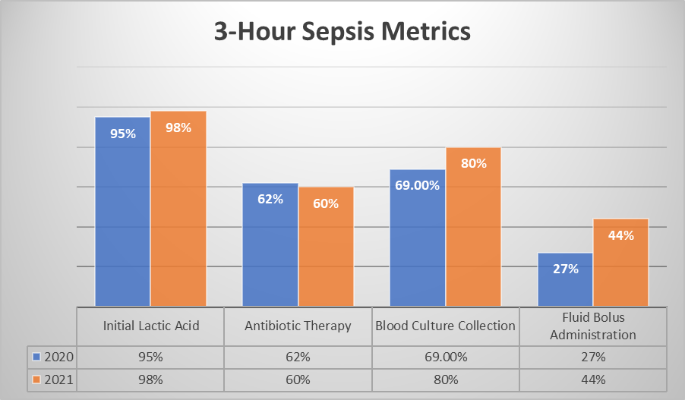
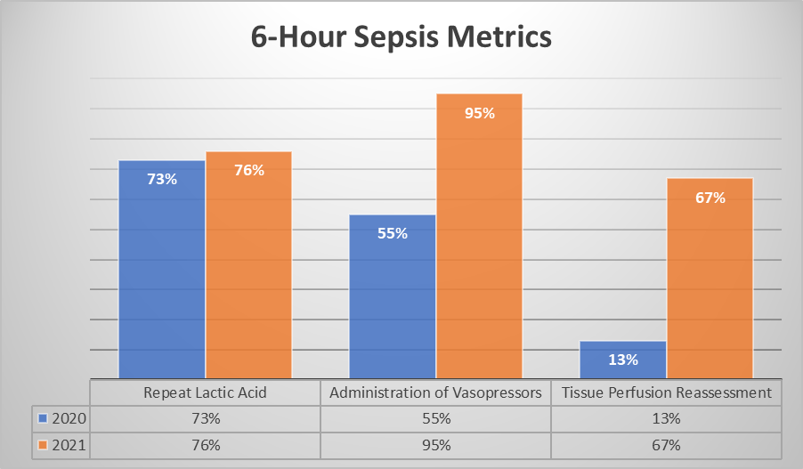

Appendix V
Department Sepsis Key Messages
SEPSIS KEY MESSAGES
SEPSIS RECOGNITION
Known or suspected infection + 2 SIRS criteria: THINK SEPSIS
KNOWN OR SUSPECTED INFECTION OR SURGERY IN THE LAST 30 DAYS: ● Has symptom(s) of Infection: fever, hypothermia, chills, cough, malaise, abdominal pain, vomiting, diarrhea, pain/burning with urination, headache, rash-localized, recent mental status changes
● Recent Procedure: Surgery, endoscopy, biopsy, needle aspiration, childbirth, etc.
● Chemotherapy or Immunocompromised
● Presence of Indwelling Urinary or IV Catheter (central/PICC/dialysis)
● Currently Taking Antibiotics or Reports Recent Infection or FLU ● Age > 60
SIRS Criteria:
● Temperature >100.9F (38.3C) OR <96.8F (36C)
● Heart Rate > 90
● Respiratory Rate > 20
● WBC < 4,000 OR >10% immature neutrophils OR > 12,000
Signs of organ Dysfunction:
● SBP < 90 OR decrease in SBP of > 40 points OR MAP < 65
● Lactate > 2 mmol/L
● Creatinine > 2 mg/dL or urine output < 0.5ml/kg/hr for > 2 hours
● Platelet count <100k/uL
● INR > 1.5 or a PTT > 60 sec
● Bilirubin > 2 mg/dL
● New need for ventilator or BiPAP
REQUIRED SEPSIS DOCUMENTATION
3 - Hour Bundle:
● Draw blood including LACTIC ACID
● Obtain blood cultures
○ 2 sets- The sets need to be 15 minutes apart and from two separate sites.
■ If unable to obtain a second set of blood cultures
documentation is needed.
■ Documentation is also required if the patient status
requires antibiotics to be started prior to the second set of blood cultures being drawn.
● Administer broad spectrum antibiotics (given after blood cultures are obtained)
○ ALL antibiotics need to be started within 3 hours of sepsis recognition.
● Fluid Administration
○ If lactic acid is >4 or patient is hypotensive (SBP <90; MAP <65mmHg; or decrease in SBP of >40), fluid bolus of NS or LR must be administered within 3 hours
■ 30ml per kg
■ Documentation must include type, fluid start time, completion time, and total amount received.
6- Hour Bundle:
● Repeat lactic acid
○ Draw upon completion of fluid bolus or prior to patient leaving the department-whichever comes first.
● Notify physician if hypotension persists after fluid bolus.
○ If hypotension persists anticipate the need for vasopressors
● Document vital signs
○ 2 sets MUST be documented with 1 hour of fluid bolus completion to demonstrate reperfusion.
SEPSIS DOCUMENTATION TOOL
● The tool is barcoded and is a permanent part of the patient chart.
● Is utilized in the resuscitation bay for any patient being worked up as suspected or confirmed sepsis.
● The front of the form includes the 3- and 6-hour bundle requirements
● The back of the form allows for documentation of vital signs and nursing notes.
○ RN must document at least 2 BP’s with 1 hour of fluid
administration to demonstrate reperfusion.
● This form is to be utilized like the “STEMI” form, used as an adjunct to the trauma flow sheet.
○ If it is documented on the sepsis form, it does not need to be re-documented on the resus trauma flow sheet.
● This form also has check boxes next to each requirement to verify all required treatment and documentation is complete.

Appendix VI
Sepsis Case Study 1
Associate Name:___________________________________ Department:_______Date:_____________

Mr. Jones is a 45-year-old male presenting to the Emergency Department for complaints of left leg pain and “not feeling well” for the past 3 days. Patient has a history of hypertension and is compliant with his medications. Patients vitals are as follows: BP 105/70, HR 98, RR 24, Temp 101.5, SP02 98%. Patient rates his pain 8/10.
- Identify the SIRS criteria this patient is presenting with; select all that apply.
- Heart Rate
- Respiratory Rate
- Blood Pressure
- Temperature
- SPO2
- All of the above
Mr. Jones is taken back to a room. Upon initial assessment, the nurse identifies a wound to the left leg. Mr. Jones tells the RN that he cut his leg on a machine at work 8 days ago but did not seek medical attention as “it was just a small cut”. Patient now complaining of pain to the left leg. The Patient's wound appears red, is warm to touch, and inflammation is noted.
- Which assessment findings are most concerning for infection?
- Redness
- Inflammation
- Pain
- Warmth
- All of the above

The team has identified that the patient has signs of infection and meets 3 SIRS criteria, indicating need for sepsis workup.

- Based on these findings, what orders need to be completed to meet the 3-hour sepsis bundle?
- Obtain Blood Work (including initial lactic acid)
- Obtain Blood Cultures
- Administer broad spectrum antibiotics
- Complete Fluid Resuscitation
- Administer Vasopressors
- Obtain repeat lactic acid if previous was 2.0 or greater

- True or False: If the initial lactic acid is greater than 4.0 or hypotension is present, the patient should receive a 30ml/kg bolus of NS or LR?
- True
- False
5.) The patient’s lactic acid comes back as 4.2. Patients vitals are as follows: BP 100/60, HR 102, RR 22, Temp 102.0, SP02 98%. Patient rates his pain 8/10. The patient weighs 181 pounds.
5.) Based on weight, what is the fluid bolus the patient should receive?
_______________ ml

The patient had blood work (including lactic acid and blood cultures drawn), antibiotics administered, and fluids completed.
6.) What additional items are required within 6 hours if applicable?
- Obtain Blood Work (including initial lactic acid)
- Obtain Blood Cultures
- Administer broad spectrum antibiotics
- Complete Fluid Resuscitation
- Administration of vasopressors if hypotension persist after fluid bolus
- Repeat lactic acid if previous was 2.0 or greater

The patient’s repeat lactic acid was completed upon bolus completion. The patient will be admitted and will continue to receive care.

7.) Upon completion of the fluid bolus, the RN should do which of the following:
- Repeat CBC
- Prepare for lumbar puncture
- Blood Pressure x 2 in one hour
- Obtain another set of blood cultures

Validator Signature:____________________________________________Date: _______________

Appendix VII
Google Classroom Sepsis Case Study 2
Mrs. Smith is an 88-year-old female sent via EMS to the Emergency Department for complaints of altered mental status. Patient has a history of dementia, hypertension, and a previous CVA. Staff at the nursing home told EMS the patient is more altered than normal. Patients vitals are as follows: BP 92/54, HR 103, RR 24, Temp 101.3, SPO2 97%. Please identify the SIRS criteria this patient is presenting with; select all that apply.
- Heart Rate
- Respiratory Rate
- Blood Pressure
- Sp02
- All of the above
The patient was moved to the resuscitation bay for potential stroke. Blood sugar is 98 and stat CT is negative for a bleed. Initial assessment found that Mrs. Smith is alert and oriented to person; she is unable to tell staff where she is, what month it is, or why she is there. Her lungs are clear to auscultation, abdomen soft, pulses present, no edema, skin dry, and some weakness to the left arm and leg (residual from previous stroke). Per a note from the nursing home, the patient was started on Bactrim by mouth 5 days prior for a UTI. Which assessment findings are most concerning for infection? Select all that apply.
- Altered Mental Status
- Left arm and leg weakness
- Age
- Current antibiotic use/diagnosis of recent infection
- Dry skin
The team has identified that the patient has signs of infection and meets 3 SIRS criteria, indicating need for sepsis workup. Based on these findings, what orders need to be completed to meet the 3-hour sepsis bundle? Select all that apply.
- Obtain blood work (including initial lactic acid)
- Obtain Blood Cultures
- Administer broad spectrum antibiotics
- Administer 30ml/kg crystalloid if lactic acid is >= 4 or hypotension is present (SBP < 90 OR decrease in SBP of > 40 OR MAP <65)
- Administer vasopressors
- Obtain repeat lactic acid if previous was 2.0 or greater
While waiting for the blood results to come back, the physician has ordered Rocephin IVPB and Vancomycin IVPB to be administered to Mrs. Smith. Which medication should the RN administer first?
- Rocephin
- Vancomycin
- It does not matter which is started first as long as both get hung
After starting the antibiotics, the RN receives a phone call that the lactic acid has come back as 4.6; vitals are as follows: BP 90/52, HR 106, RR 26, Temp 102.0, SpO2 98%. Patient denies any current pain. The patient weighs 120 pounds. Based on weight, what is the fluid bolus the patient should receive?
- 2,000 ml
- 1,355 ml
- 1,636 ml
- 1,780 ml
What MUST be documented related to the fluid bolus? Select all that apply.
- Start time of fluid bolus
- Stop time of fluid bolus
- Total amount of fluids the patient received
- Type of fluids (NS or LR)
- Fluid bolus does not need to be documented
Blood work has been sent, antibiotics administered, and fluids completed. What additional items are required within 6 hours if applicable?
- Obtain blood work (including initial lactic acid)
- Obtain Blood Cultures
- Administer broad spectrum antibiotics
- Completed Fluid Resuscitation
- Administration of vasopressors if hypotension persists after fluid bolus
- Repeat lactic acid if previous was 2.0 or greater
The patients repeat lactic acid was completed upon bolus completion and orders have been placed to admit the patient. What MUST be documented within 1 hour of fluid bolus completion?
- Update medication list
- Patient belongings
- 2 Blood Pressures
- Family Notification
True or False; The Sepsis Documentation Tool available in the resuscitation bay is barcoded and a permanent part of the patient chart?
- True
- False
True or False; If a repeat lactic acid is required it should be drawn upon fluid bolus completion or before the patient leaves the emergency department (whichever occurs first)?
- True
- False

Appendix VIII
Sepsis Pamphlet
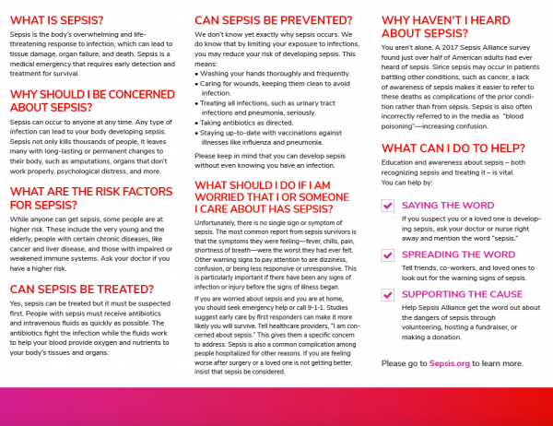
Appendix IX
Comparison of Pre and Post Survey Results
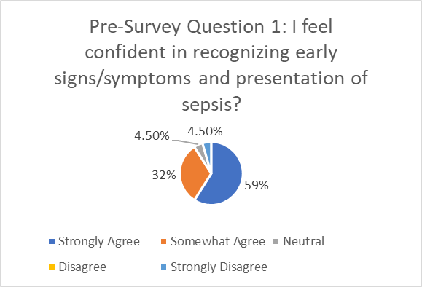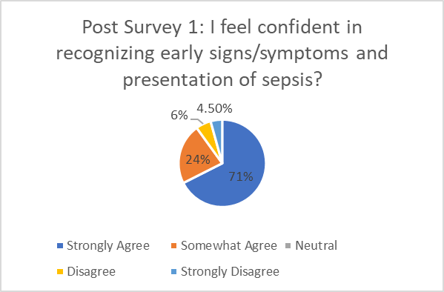
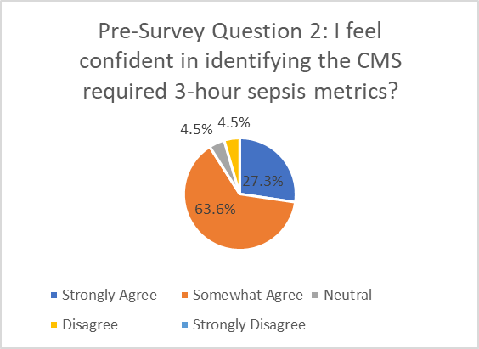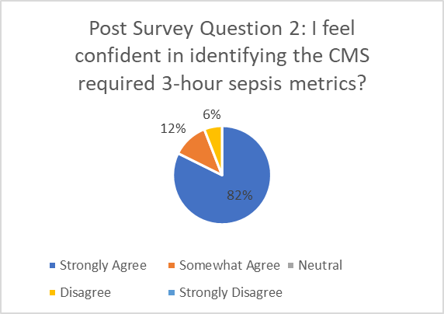
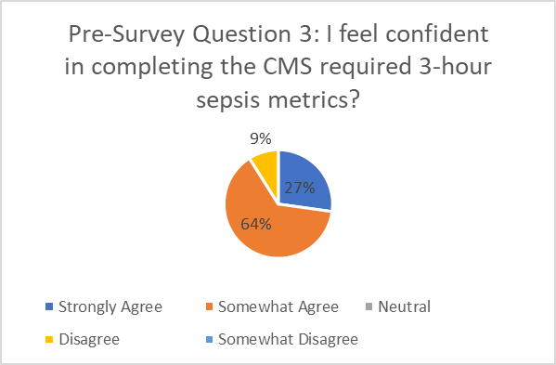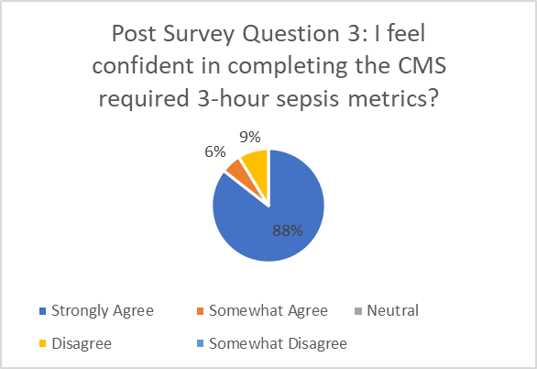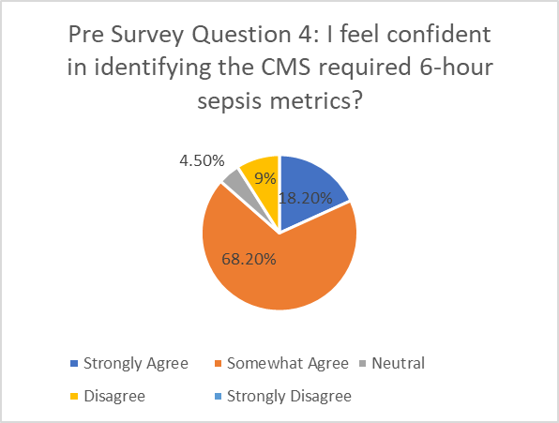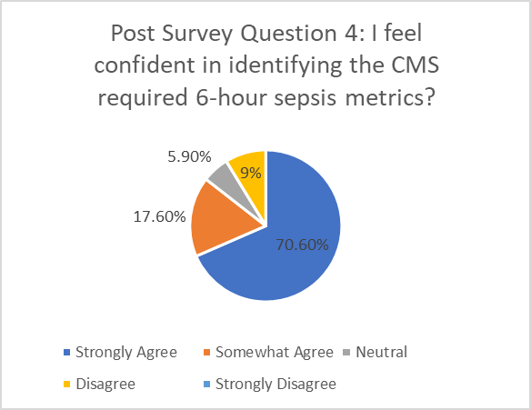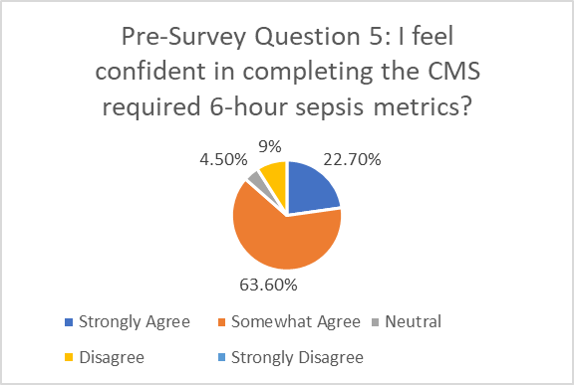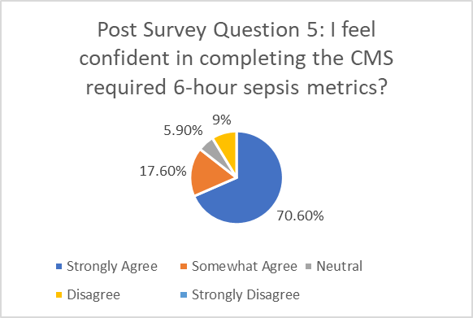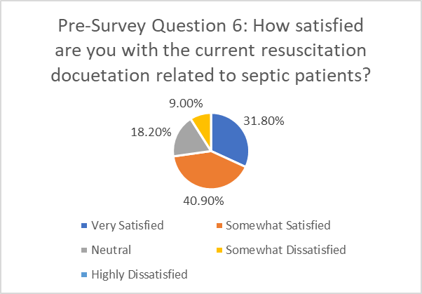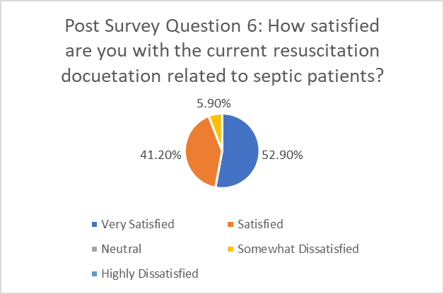

References
American College of Emergency Physicians. (2020). Quality Improvement and Patient Safety:
Sepsis CMS Core Measures (SEP-1) Highlights. Retrieved from
https://www.acep.org/how-we-serve/sections/quality-improvement--patient
safety/newsletters/march-2016/sepsis-cms-core-measure-sep-1-highlights/
Armen, S. B., Freer, C. V., Showalter, J. W., Crook, T., Whitener, C. J., West, C., Terndrup, T.
E., Grifasi, M., DeFlitch, C. J., & Hollenbeak, C. S. (2016). Improving Outcomes in Patients With Sepsis. American journal of medical quality : the official journal of the American College of Medical Quality, 31(1), 56–63.
https://doi.org/10.1177/1062860614551042
Buchman, Timothy G. PhD, MD1,2; Simpson, Steven Q. MD1,3; Sciarretta, Kimberly L. PhD1;
Finne, Kristen P. BA4; Sowers, Nicole MPP5; Collier, Michael BA5; Chavan, Saurabh MBBS, MPH5; Oke, Ibijoke MPA5; Pennini, Meghan E. PhD1; Santhosh, Aathira MA5; Wax, Marie MBA1; Woodbury, Robyn PhD1; Chu, Steve JD6; Merkeley, Tyler G. MS, MBA1; Disbrow, Gary L. PhD1; Bright, Rick A. PhD1; MaCurdy, Thomas E. PhD5,7,8,9; Kelman, Jeffrey A. MD, MMSc6 Sepsis Among Medicare Beneficiaries: 3. The Methods, Models, and Forecasts of Sepsis, 2012–2018*, Critical Care Medicine: March 2020 - Volume 48 - Issue 3 - p 302-318
doi: 10.1097/CCM.0000000000004225
Centers for Disease Control and Prevention. (2022). Covid-19 Integrated County View.
Retrieved from https://covid.cdc.gov/covid-data-tracker/#county-view?list_select_state=Michigan&data-type=Cases&list_select_county=26163&metric-cases=cases_per_100K_7_day_count_change
Centers for Disease Control and Prevention. (2020). I survived sepsis. What’s next? Retrieved
from https://www.cdc.gov/sepsis/life-after-sepsis/index.html
Centers for Disease Control and Prevention. (2020). Septicemia mortality by state. Retrieved
From https://www.cdc.gov/nchs/pressroom/sosmap/septicemia_mortality/septicemia.htm
Centers for Disease Control and Prevention. (2022). Trends in Number of COVID-19 Cases and
Deaths in the US Reported to CDC, by State/Territory. Retrieved from
https://covid.cdc.gov/covid-data-tracker/#trends_totalcases
Centers for Disease Control and Prevention. (2020). What is sepsis. Retrieved from
https://www.cdc.gov/sepsis/what-is-sepsis.html
Centers for Medicare and Medicaid Services. (2020). Core Measures. Retrieved from
https://www.cms.gov/Medicare/Quality-Initiatives-Patient-Assessment
Instruments/QualityMeasures/Core-Measures
Centers for Medicare and Medicaid Services. (2020). Severe Sepsis and Septic Shock:
Management Bundle (Composite Measure). Retrieved from
https://cmit.cms.gov/CMIT_public/ViewMeasure?MeasureId=1017
Centers for Medicare and Medicaid Services. (2021). Quality Measurement and Quality
Improvement. Retrieved from https://www.cms.gov/Medicare/Quality-Initiatives-Patient-Assessment-Instruments/MMS/Quality-Measure-and-Quality-Improvement-
Cleveland Clinic Journal of Medicine. (2020). Sepsis and septic shock: guideline-based
Management. Retrieved from https://www.ccjm.org/content/87/1/53
Colorado Hospital Association. (2019). Identifying Time Zero. Retrieved from
https://cha.com/wp-content/uploads/2019/04/6.6-Identifying-Time-Zero.pdf
Consumers Health Ratings. (2022). Inpatient- Average Cost, Typical Prices, Ballpark. Retrieved from https://www.debt.org/medical/hospital-surgery-
costs/#:~:text=Hospital%20costs%20averaged%20%242%2C607%20per%20day%20th
oughout%20the,distant%20second.%20If%20you%20stay%20overnight%2C%20costs% 20soar.
Grek, A., Booth, S., Festic, E., Maniaci, M., Shirazi, E., Thompson, K., Starbuck, A., Mcree, C.,
Naessens, J. M., & Moreno Franco, P. (2017). Sepsis and Shock Response Team: Impact of a Multidisciplinary Approach to Implementing Surviving Sepsis Campaign Guidelines and Surviving the Process. American Journal of Medical Quality, 32(5), 500–507. https://doi.org/10.1177/1062860616676887
Goodwin, A. J., & Ford, D. W. (2018). Readmissions Among Sepsis Survivors: Risk Factors and
Prevention. Clinical pulmonary medicine, 25(3), 79–83. https://doi.org/10.1097/CPM.0000000000000254
Healthcare Cost and Utilization Project. (2020) National Inpatient Hospital Costs: The Most
Expensive Conditions by Payer, 2017. Retrieved from
https://hcup-us.ahrq.gov/reports/statbriefs/sb261-Most-Expensive-Hospital-Conditions
2017.jsp
Hussain, S.L., Lei, S., Akram, T., Haider, M.J., Hussain, S.H., Ali, M. (2018). Kurt Lewin’s
Change Model: A Critical Review of the Role of Leadership and Employee Involvement
In Organizational Change. Journal of Innovation and Knowledge, 3(3), 123-127.
https://doi.org/10.1016/j.jik.2016.07.002
Institute for Healthcare Improvement. (2020). How to improve. Retrieved from
http://www.ihi.org/resources/Pages/HowtoImprove/default.aspx
Institute for Healthcare Improvement. (2020). The IHI triple aim. Retrieved from
http://www.ihi.org/engage/initiatives/TripleAim/Pages/default.aspx
Kassyap, C., Abraham, S., Krishnan, S., Palatty, B., & Rajeev, P. (2018). Factors affecting early
treatment goals of sepsis patients presenting to the emergency department. Indian Journal of Critical Care Medicine, 22(11), 797–800. https://doi.org/10.4103/ijccm.IJCCM_27_18
Kerrigan, S. W., Devine, T., Fitzpatrick, G., Thachil, J., & Cox, D. (2019). Early Host
Interactions That Drive the Dysregulated Response in Sepsis. Frontiers in
immunology, 10, 1748. https://doi.org/10.3389/fimmu.2019.01748
Kim, H. I., & Park, S. (2019). Sepsis: Early Recognition and Optimized Treatment. Tuberculosis
and respiratory diseases, 82(1), 6–14. https://doi.org/10.4046/trd.2018.0041
Mayr FB, Talisa VB, Balakumar V, Chang CH, Fine M, Yende S. Proportion and Cost of
Unplanned 30-Day Readmissions After Sepsis Compared with Other Medical Conditions. JAMA. 2017;317(5):530–531. doi:10.1001/jama.2016.20468
Michigan Department of Health and Human Services. (2018). Septicemia deaths and death rates
Michigan residents, 1989-2018. Retrieved from
https://www.mdch.state.mi.us/pha/osr/CHI/CRI/frame.asp
National Institute of General Medical Sciences. (2020). Sepsis. Retrieved from
https://www.nigms.nih.gov/education/factsheets/Pages/sepsis.aspx#:~:text=Severe%20s
psis%20strikes%20more%20than%20a%20million%20Americans,been%20on%20the%20rise%20in%20the%20United%20States.
Norman, B. C., Cooke, C. R., Ely, E. W., & Graves, J. A. (2017). Sepsis-Associated 30-Day Risk Standardized Readmissions: Analysis of a Nationwide Medicare Sample. Critical care medicine, 45(7), 1130–1137. https://doi.org/10.1097/CCM.0000000000002476
Nunnally ME, Ferrer R, Martin GS, et al. The Surviving Sepsis Campaign: research priorities for the administration, epidemiology, scoring and identification of sepsis. Intensive Care Med Exp. 2021;9(1):34. Published 2021 Jul 2. doi:10.1186/s40635-021-00400-z
Petiprin, A. (2020). Lewins Change Theory. Retrieved from
https://nursing-theory.org/theories-and-models/lewin-change-theory.php
Process improvements in the ED increase sepsis bundle compliance, reduce mortality.
(2015). Patient Safety Monitor Journal, 16(3), 5–7.
Rajan, J. J., & Rodzevik, T. (2021). Sepsis awareness to enhance early identification of sepsis in
emergency departments. The Journal of Continuing Education in Nursing, 52(1), 39-42. doi:http://dx.doi.org/10.3928/00220124-20201215-10
Sepsis Alliance. (2020). Readmission to hospital after sepsis: A Q&A with Dr. Hallie Prescott.
Retrieved from
https://www.sepsis.org/news/readmission-to-hospital-after-sepsis-a-qa-with-dr-hallie prescott/#:~:text=The%20mean%20%28average%29%20cost%20of%20each%20readmission%20after,has%20had%20sepsis%2C%20ask%20questions%20and%20be%20alert.
Sepsis Alliance. (2020). Risk Factors. Retrieved from
https://www.sepsis.org/sepsis-basics/risk factors/#:~:text=Those%20at%20the%20highest%20risk%20of%20developing%20sepsis,and%20those%20who%20have%20an%20impaired%20immune%20system.
Sepsis Alliance. (2020). Sepsis fact sheet. Retrieved from
file:///C:/Users/Sarah/Downloads/Sepsis-FactSheet-v4.pdf
Sepsis Alliance. (2020). Testing for Sepsis. Retrieved from
https://www.sepsis.org/sepsis-basics/testing-for-sepsis/
Sepsis Alliance. (2020). Treatment. Retrieved from
https://www.sepsis.org/sepsis-basics/treatment/
Schinkel, M., Nanayakkara, P., & Wiersinga, W. J. (2022). Sepsis Performance Improvement
Programs: From Evidence Toward Clinical Implementation. Critical care (London, England), 26(1), 77. https://doi.org/10.1186/s13054-022-03917-1
The Joint Commission. (2022). Reducing Sepsis Mortality). Retrieved from
https://www.centerfortransforminghealthcare.org/improvement-topics/reducing-sepsis
mortality/?_ga=2.158001401.212743754.1645876946-749670628.1645723573
The Joint Commission. (2020). Sepsis Introduction. Retrieved from
https://www.jointcommission.org/resources/patient-safety-topics/infection-prevention-andcontrol/sepsis/

U.S. Department of Health and Human Services. (2020). Largest Study of Sepsis Cases among

Medicare Beneficiaries Finds Significant Burden. Retrieved from

https://www.hhs.gov/about/news/2020/02/14/largest-study-sepsis-cases-among-medicare

beneficiaries-finds-significant-burden.html

U.S. Food and Drug Administration. (1998). Institutional review boards frequently asked

questions. Retrieved from

https://www.fda.gov/regulatory-information/search-fda-guidance-documents/institutional-review-boards-frequently-asked-questions#IRBProcedures

Wolters Kluwer. (2018). CMS sepsis core measures and hospitals compare: what you need to

know. Retrieved from

https://www.wolterskluwer.com/en/expert-insights/cms-sepsis-core-measures-hospital-compare-what-you-need-to-know

World Health Organization. (2020). Sepsis. Retrieved from

https://www.who.int/news-room/fact-sheets/detail/sepsis

World Health Organization. (2020). WHO Calls for Global Action on Sepsis- Cause of 1 in 5

Deaths Worldwide. Retrieved from

https://www.who.int/news/item/08-09-2020-who-calls-for-global-action-on-sepsis--

cause-of-1-in-5-deaths-worldwide

Yarbrough, N., Bloxam, M., Priano, J., Lynch, P. L., Hunt, L. N., & Elfman, J. (2019).

Pharmacist impact on sepsis bundle compliance through participation on an emergency department sepsis alert team. The American Journal of Emergency Medicine, 37(4), 762- 763. doi:http://dx.doi.org/10.1016/j.ajem.2018.08.009

